

INTEGRATED CODING EDUCATION & COMPETITIVE PROGRAMMING PLATFORM

Software Requirement Specification

Table Of Contents
Record of Changes 2
I: SYSTEM OVERVIEW 9
1. Introduction 9
1.1 Purpose 9
1.2 Scope 9
2. Product Overview 10
2.1 System Contest Diagram 10
3. User Requirements 11
3.1 Actor Characteristics 11
3.2 Use Case Diagrams 13
3.3 Use Case Description 23
4. Overall Functionalities 31
4.1 Screen flow 31
4.2 Screen description 33
4.3 Screen Authorization 41
4.4 Non-Screen Functions 46
5. System High Level Design 50
5.1 Entity Relationship Diagram 50
5.2 Entity Description 50
II: REQUIREMENT SPECIFICATIONS 53
1. Authentication & Common Features Subsystem 53
2. E-Learning & Course Management Subsystem 68
3. E-Commerce & Financial Transactions Subsystem 91
4. Online Judge & Competitive Programming Subsystem 112
III: DESIGN SPECIFICATIONS 156
1. Authentication 156
2. Guest UI 169
3. Customer UI 180
4. Instructor UI 217
5. Admin UI 239
IV: NON-FUNCTIONAL REQUIREMENTS 264
1. External Interfaces 264
2. Quality Attribute 265
V: REQUIREMENT APPENDIX 267
1. Business Rules 267
2. Application Messages List 272

Record of Changes

Date | A, M, D | In charge | Change Description
15/05/2026 | A | Ngọc Thanh | Create template and document outline
20/05/2026 | A | Ngọc Thanh | Add project introduction (Purpose, Scope...)
25/05/2026 | A | Ngọc Thanh | Add Use Case diagrams and Actor specification
25/05/2026 | A | Duy Phương | Add Use Case diagrams and Actor specification
25/05/2026 | A | Văn Quang | Add Use Case diagrams and Actor specification
25/05/2026 | A | Sĩ Tấn | Add Use Case diagrams and Actor specification
25/05/2026 | A | Thiên Bảo | Add Use Case diagrams and Actor specification
01/06/2026 | A | Duy Phương | Add System Context Diagram
05/06/2026 | A | Sĩ Tấn | Add Screen Flow for Guest and Customer
10/06/2026 | A | Văn Quang | Add Screen Flow for Instructor
10/06/2026 | A | Thiên Bảo | Add Screen Flow for Admin
13/06/2026 | A | Văn Quang | Add Non-Functional Requirements
14/06/2026 | M | Sĩ Tấn | Modify Screen Authorization
15/06/2026 | A | Ngọc Thanh | Add Entity Relationship Diagram (ERD) and Entity Description
17/06/2026 | A | Sĩ Tấn | Add Use Case Specifications for Authentication & Common Features Subsystem
18/06/2025 | A | Văn Quang | Add Use Case Specifications for Authentication & Common Features Subsystem
18/06/2025 | A | Thiên Bảo | Add Use Case Specifications for Authentication & Common Features Subsystem
20/06/2026 | M | Ngọc Thanh | Modify Use Case Diagram
20/06/2026 | A | Ngọc Thanh | Add Use Case Description
22/06/2026 | M | Ngọc Thanh | Modify Entity Relationship Diagram and Entity Description
14/07/2026 | A | Thiên Bảo | Add Screen Flow Description for Admin
14/07/2026 | A | Thiên Bảo | Add Design Specifications for Admin
14/07/2026 | A | Văn Quang | Add Design Specifications for Authentication
14/07/2026 | A | Văn Quang | Add Design Specifications for Instructor
14/07/2026 | A | Văn Quang | Add Design Specifications for Guest
14/07/2026 | A | Sĩ Tấn | Add Design Specifications for Customer
14/07/2026 | A | Duy Phương | Add Requirement Specification for Online Judge & Competitive Programming Subsystem
19/07/2026 | M | Ngọc Thanh | Update ERD diagram with additional entities
19/07/2026 | A | Duy Phương | Add Swimlane Diagram for Browse & Search Problems, Join Contest and Create Contest
19/07/2026 | A | Duy Phương | Add State Diagram for Contest Status
20/07/2026 | A | Ngọc Thanh | Add new actor AI Service
20/07/2026 | M | Ngọc Thanh | Modify Use case diagram and Use case specification for AI

I: SYSTEM OVERVIEW

1. Introduction

1.1 Purpose
This Software Requirements Specification (SRS) document defines in detail, clearly, and comprehensively all functional and non-functional requirements for the "Integrated Coding Education & Competitive Programming Platform". The document serves as a technical blueprint, aligning the development team's vision to design the architecture, build the database, and develop the core modules. Furthermore, it acts as an official technical commitment and the basis for acceptance between the student group, the Advisor, and the Thesis Defense Committee at FPT University, establishing a standardized benchmark to evaluate the actual product quality and ensuring complete synchronization regarding the system's scope, boundaries, and operational mechanisms before source code implementation begins.

1.2 Scope
The project focuses on developing a Web Application operating on a unique hybrid model that combines an online course marketplace (Udemy model) with a coding practice and competitive programming platform (LeetCode/Codeforces model).
The system comprises the following core functional modules:
- E-learning Module (Online Management & Learning): Provides a digital space that allows Instructors to manage and publish courses, upload visual video lectures and theoretical PDF documents, and create quizzes to assess student performance at each stage.
- Online Judge Module (Automated Grading System): Integrates a web-based Integrated Development Environment (IDE) supporting multiple programming languages (C++, Java, Python, etc.). This module connects directly to the open-source sandbox system Judge0 to securely execute the Customer's source code, perform testing based on predefined Test Cases, and return real-time results.
- Community & Contest Module: Builds an interactive space through Question & Answer (Q&A) sections under each lesson and an algorithm-sharing forum. It also hosts online programming contests with strict time limits, automated scoring, and a real-time Live Leaderboard.
- Administration Module (System Management): Provides centralized management tools for Admins to control user accounts, approve/remove Instructor courses, manage the global question bank, configure payment systems, and monitor revenue/profit statistics dashboards.

2. Product Overview

2.1 System Contest Diagram
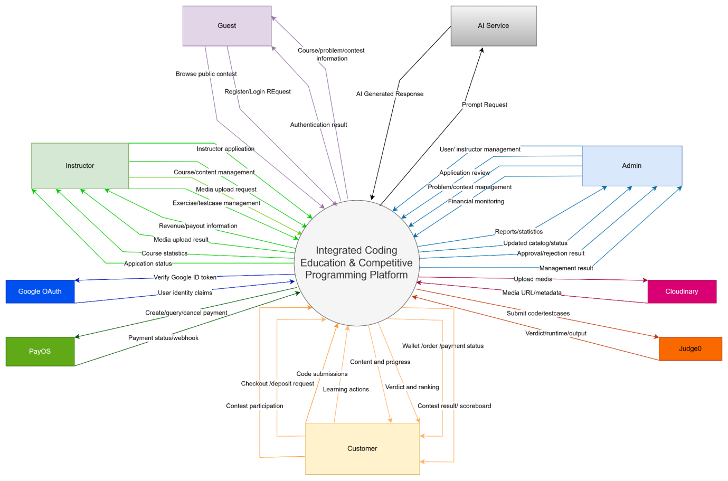

3. User Requirements

3.1 Actor Characteristics
# | Actor | Description
1 | Guest | Classification: Unauthenticated User  Role & Privileges: Represents anonymous visitors exploring the platform. Guests are authorized to view the home page, search the course catalog, browse public coding problems, and search content. They cannot purchase courses, join contests, or submit code. The system's primary objective is to convert Guests into registered Customers.
2 | Customer | Classification: Authenticated User (Primary Actor)  Role & Privileges: Represents registered students/learners on the platform. Customers manage a digital wallet, deposit credits, and purchase courses via their wallet balance. They can study lessons (watch videos, read documents, do quizzes), write and submit code to the sandbox compiler, join contests, participate in forum Q&A, and view global leaderboard rankings.
3 | Instructor | Classification: Partner User (Primary Actor)  Role & Privileges: Represents educators and content creators. Instructors are granted a dedicated workspace where they can create course drafts, manage syllabus structures, upload videos/theory documents, configure practice quizzes, and design coding problems with custom testcases (including auto-generating testcases via script). They can also submit courses for Admin review, monitor student enrollment statistics, track sales history, and view payout reports.
4 | Admin | Classification: Platform Administrator (Primary Actor)  Role & Privileges: Holds administrative authority to govern the entire marketplace. Admins do not directly create courses, but they moderate the system by locking/unlocking user accounts, reviewing and approving/rejecting instructor applications, moderating submitted courses, configuring contests, managing the global problem bank, and reviewing platform financial audit logs.
5 | Judge0 API | Classification: External Automated System (Secondary Actor)  Role & Privileges: Acts as a secure, sandboxed code execution and compilation engine. It receives code submission parameters (source code, language ID, and testcase inputs), executes compilation and runs the code under strict CPU time limits and RAM memory limits, evaluates output correctness, and asynchronously returns code execution verdicts (AC, WA, TLE, RE, CE) to the main server.
6 | PayOS | Classification: Third-party System (Secondary Actor)  Role & Privileges: Serves as the platform's external financial gateway. PayOS registers deposit transactions, generates secure bank transfer QR checkout links, and processes bank payments. Upon successful transfer, PayOS acts as an automated webhook trigger, calling the server API to verify transaction signatures, log records, and instantly credit virtual funds to the user's wallet.
7 | AI Service | Classification: Third-party System (Secondary Actor)  Role & Privileges: Serves as the platform's intelligent natural language processing and generative AI engine (e.g., Google Gemini / Spring AI). It assists the backend system by performing two advanced automated tasks. First, it acts as a strict content moderator, evaluating instructor-submitted course materials (video transcripts, theories, quizzes) against safety guidelines and returning structured JSON violation reports. Second, it functions as an AI Tutor, analyzing coding problem descriptions and testcases to dynamically generate algorithmic explanations, time complexity analysis, and interactive HTML visual simulations.
8 | Google API | Classification: Third-party System (Secondary Actor)  Role & Privileges: Acts as an Identity Provider via OAuth2. It enables secure Single Sign-On (SSO), allowing users to register or log in quickly. It handles independent authentication and returns basic profile data (email, name, avatar) to the platform for session management.
9 | Cloudinary | Classification: Third-party System (Secondary Actor)  Role & Privileges: Serves as a cloud-based media management and CDN service. It securely stores, optimizes, and delivers static assets like course videos, thumbnails, and user avatars. This ensures fast media streaming and significantly reduces storage and bandwidth loads on the main server.

3.2 Use Case Diagrams

3.2.1 Use Case Overview
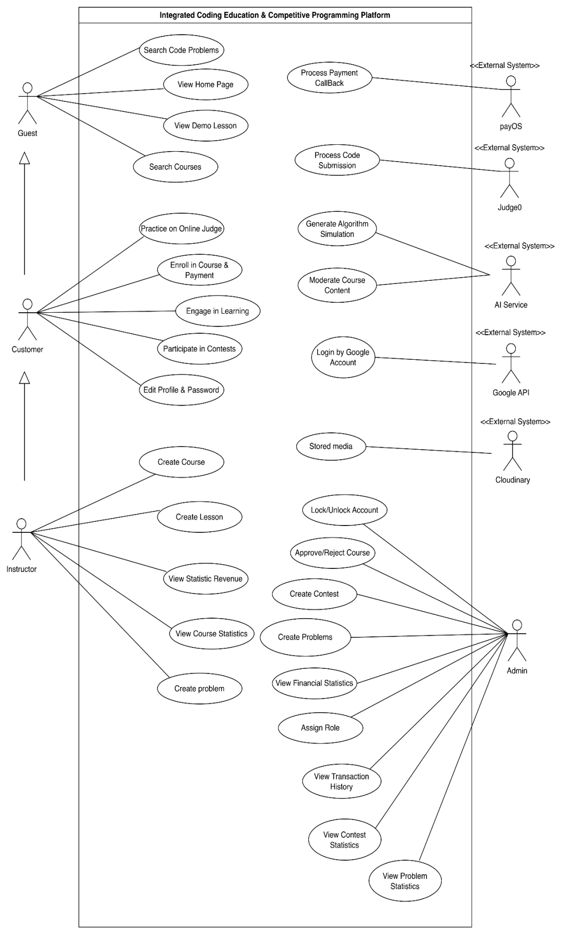
Hình 2.1 Use Case Diagram Overview

3.2.2 Use Case for Authentication

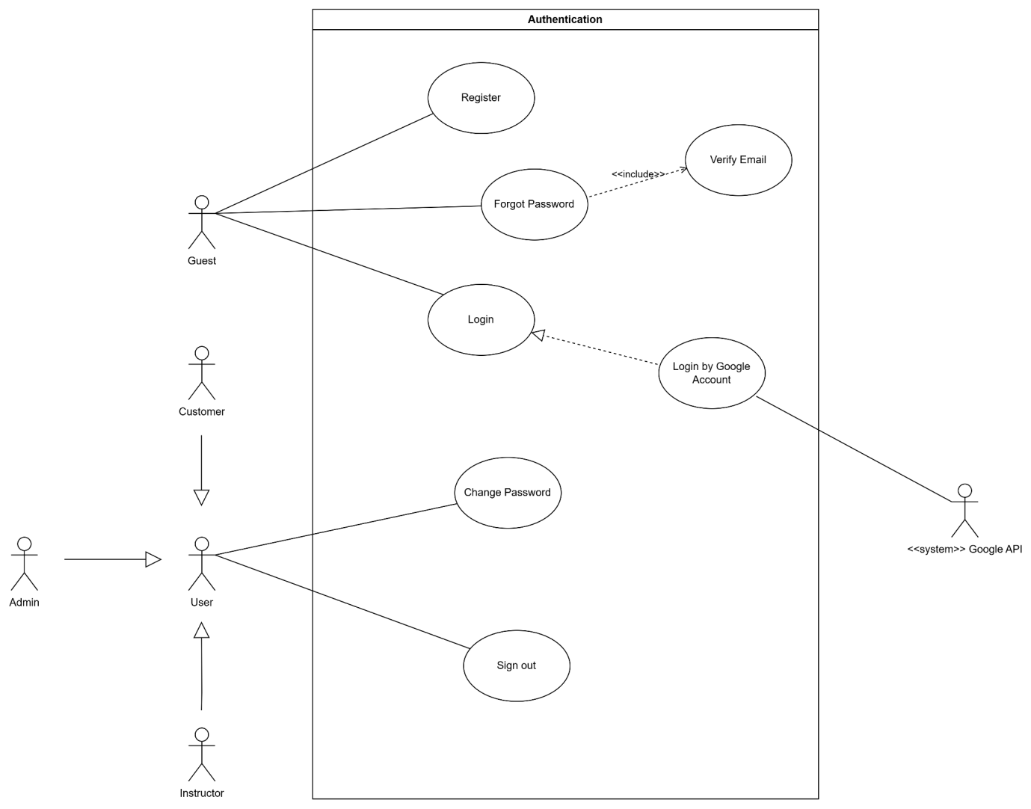
Hình 2.2 Use Case Diagram for Authentication

3.2.3 Use Case for Guest
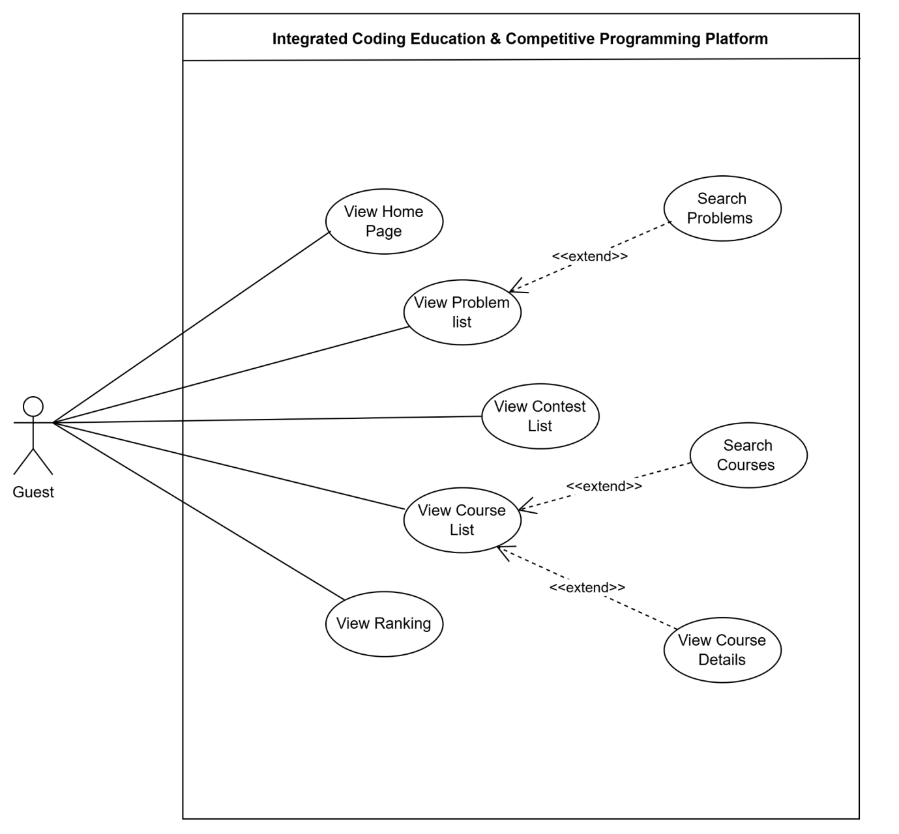
Hình 2.3 Use Case Diagram for Guest

3.2.4 Use Case for Customer
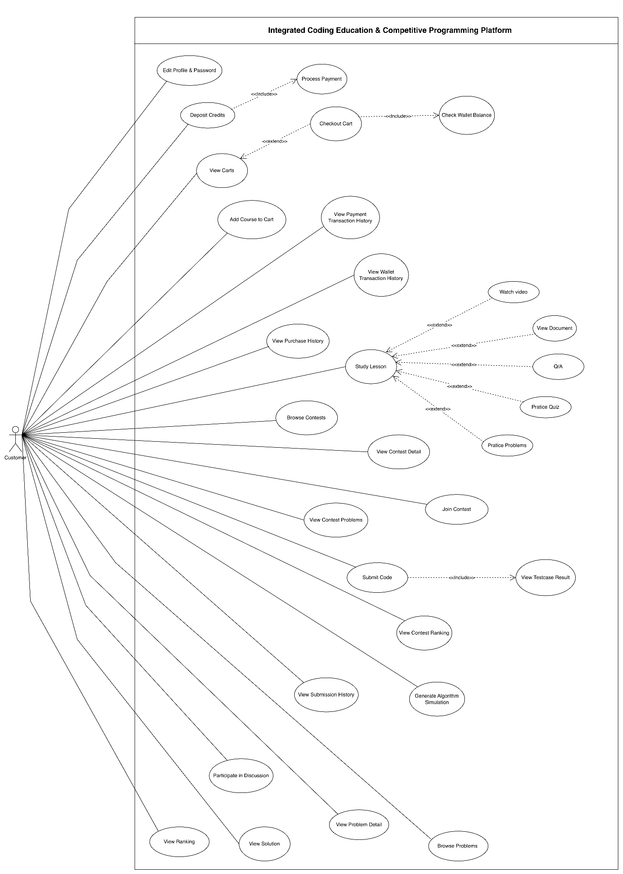
Hình 2.4 Use Case Diagram for Customer

3.2.5 Use Case for Instructor
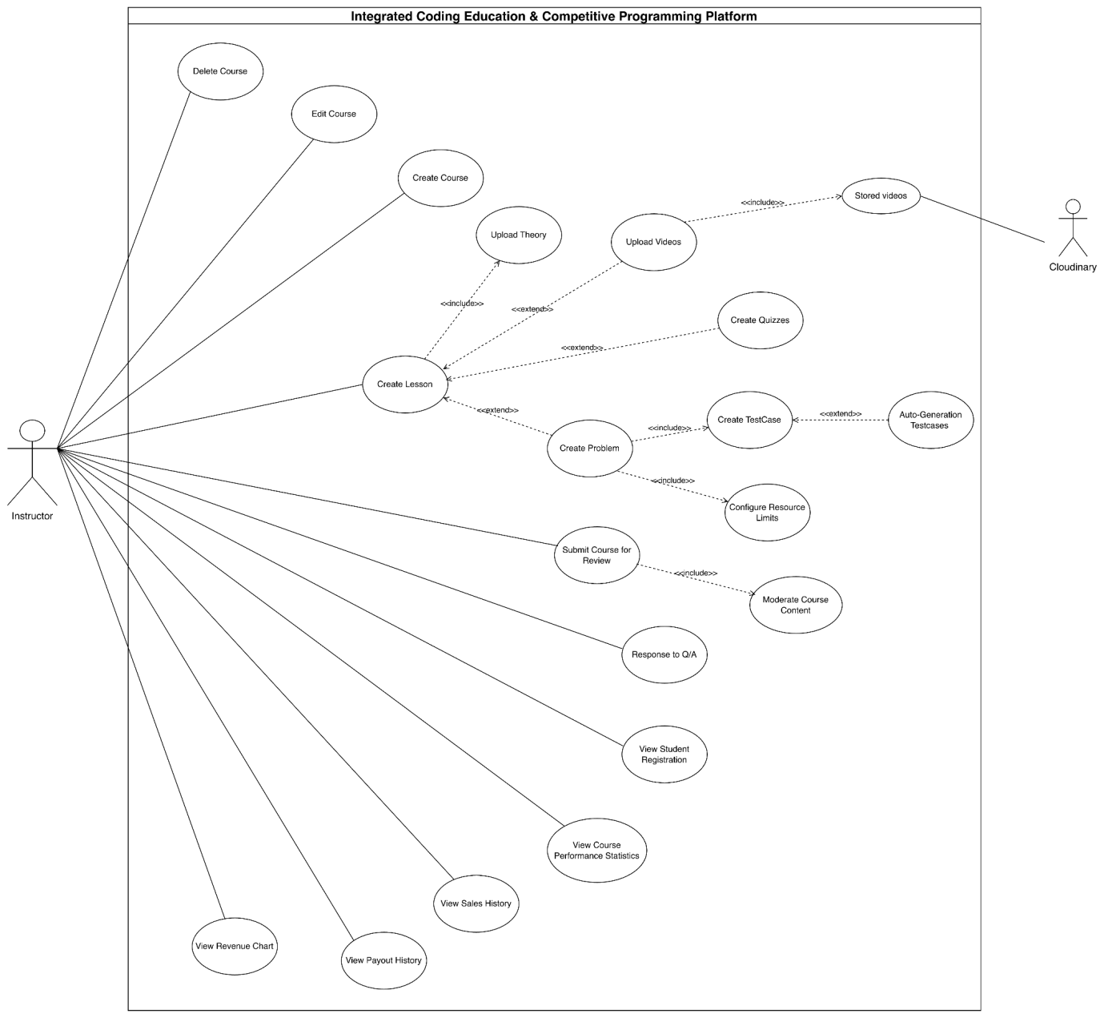
Hình 2.5 Use Case Diagram for Instructor

3.2.6 Use Case for Admin

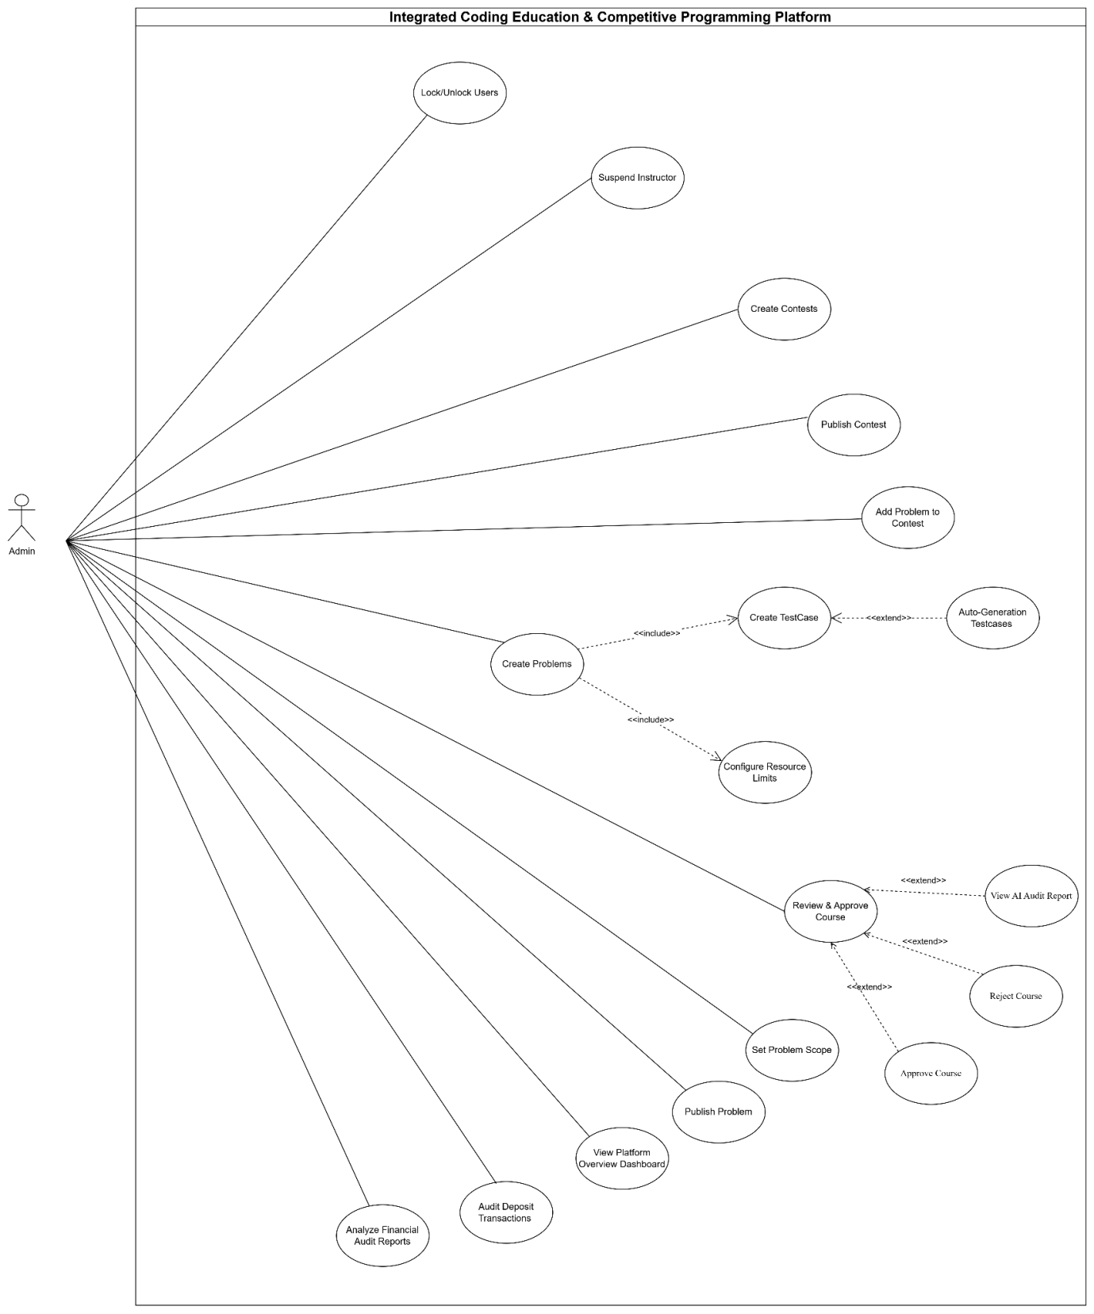
Hình 2.6 Use Case Diagram for Admin

3.2.7 Use Case for Judge0
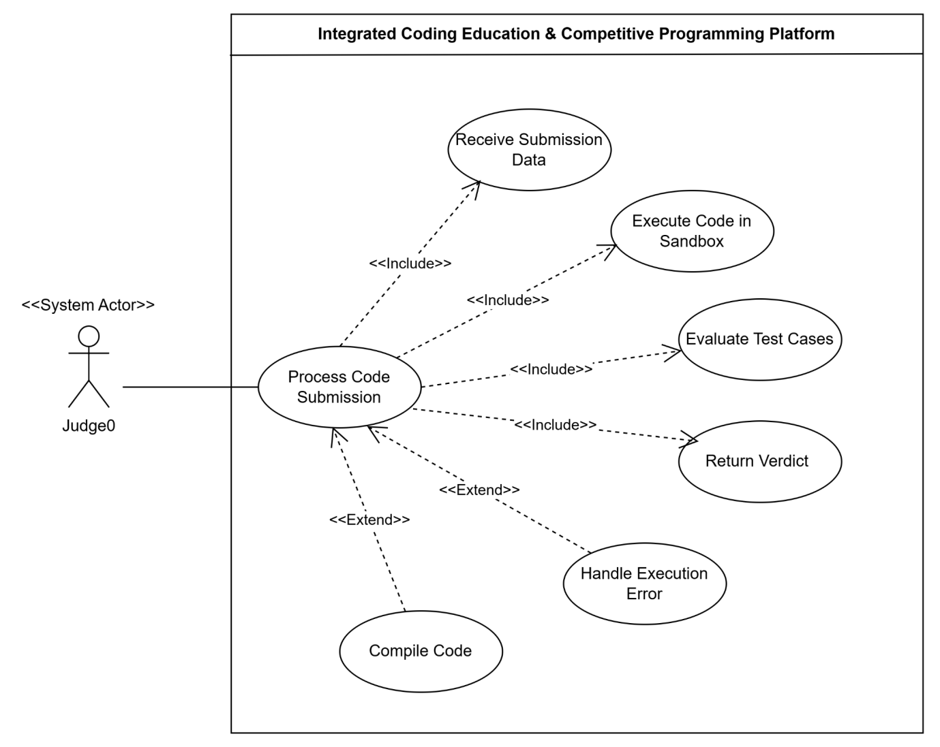
Hình 2.7 Use Case Diagram for Judge0

3.2.8 Use Case for payOS
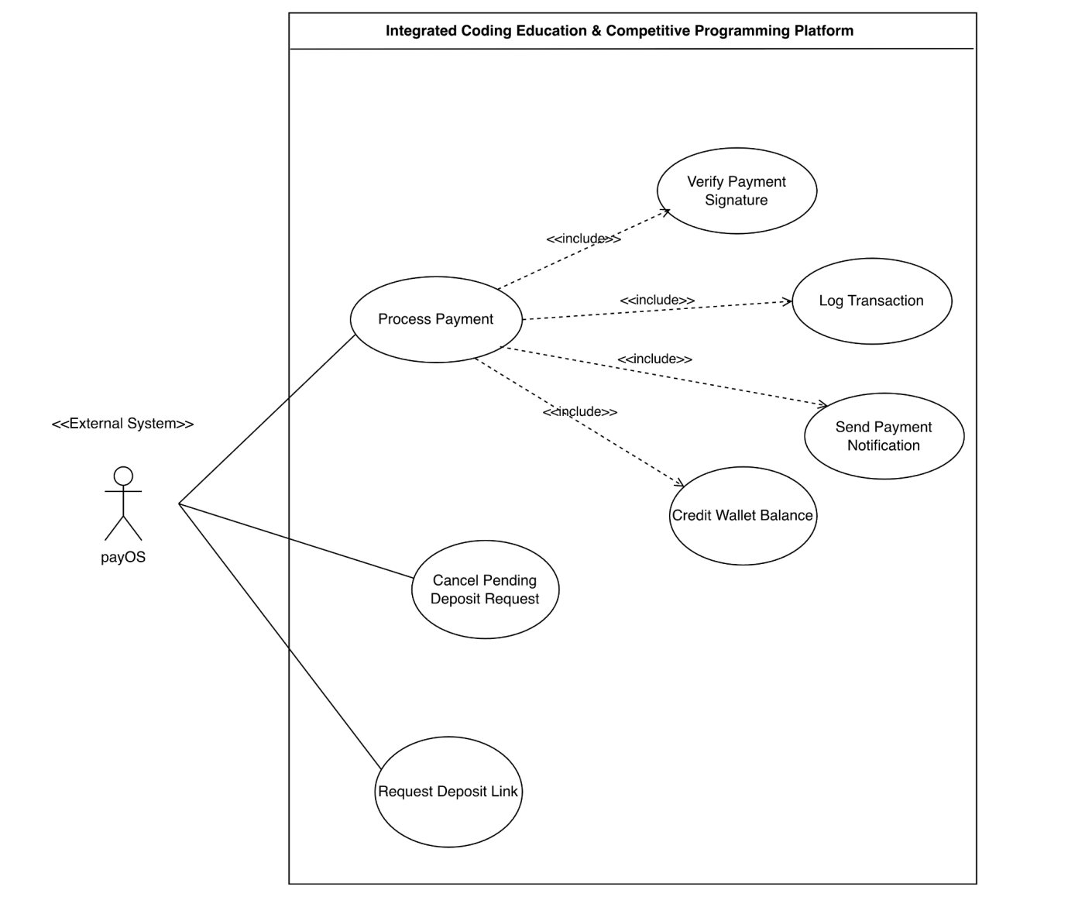

Hình 2.8 Use Case Diagram for Judge0

3.2.9 Use Case for AI Service
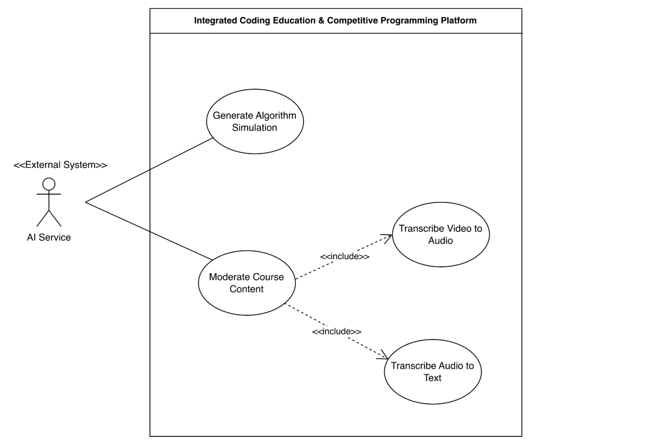
Hình 2.9 Use Case Diagram for AI Service

3.3 Use Case Description
ID | Use Case | Actors | Use Case Description
UC-ADM-01 | View Control Dashboard | Admin | Accesses the administrative dashboard to monitor overall platform activities, statistics, and system status.
UC-ADM-02 | Review & Approve Course | Admin | Reviews submitted course content together with AI-generated audit reports before making an approval decision.
UC-ADM-03 | Create Problem | Admin | Creates a new programming problem by providing its details, constraints, test cases, and metadata.
UC-ADM-04 | Edit Problem | Admin | Updates the information, content, or configuration of an existing programming problem.
UC-ADM-05 | View History Problem | Admin | Views the revision history and previous modifications of a programming problem.
UC-ADM-06 | Clone Problem | Admin | Duplicates an existing programming problem to quickly create a similar one.
UC-ADM-07 | Delete Problem | Admin | Removes a programming problem from the platform when it is no longer needed.
UC-ADM-08 | Create Contest | Admin | Creates and configures a new programming contest, including its schedule, rules, and associated problems.
UC-ADM-09 | View Detail Contest | Admin | Displays detailed information, settings, and problem structure of a contest.
UC-ADM-10 | Delete Contest | Admin | Deletes a contest from the platform.
UC-ADM-11 | View Platform Instructor | Admin | Views the list and details of instructors registered on the platform.
UC-ADM-12 | Suspend Instructor | Admin | Temporarily suspends an instructor's account to restrict platform access.
UC-ADM-13 | Activate Instructor | Admin | Reactivates a previously suspended instructor account.
UC-ADM-14 | View User Account | Admin | Views the list of user accounts and their detailed information.
UC-ADM-15 | Lock User Account | Admin | Locks a user account that violates platform policies or requires administrative action.
UC-ADM-16 | Unlock User Account | Admin | Restores access by unlocking a previously locked user account.
UC-ADM-17 | View Financial Statistics | Admin | Views financial reports, revenue statistics, and transaction summaries of the platform.
UC-ADM-18 | View AI Audit Report | Admin | Views AI-generated content moderation reports for submitted courses and learning materials.
UC-ADM-19 | Approve Course | Admin | Approves a submitted course after completing the review process, making it available on the platform.
UC-ADM-20 | Reject Course | Admin | Rejects a submitted course and records the reason for rejection.
UC-AIS-01 | Generate Algorithm Simulation | AI Service | Allows customers to input problem constraints to automatically generate the algorithm name, time complexity, and an HTML-based animation visualizing the execution process via AI.
UC-AUTH-01 | Login | Guest | Allows visitors to authenticate using their registered email and password to start an active session and access the platform.
UC-AUTH-02 | Login by Google Account | Guest, Google API | Allows visitors to authenticate quickly and securely using OAuth2 integration with their Google accounts.
UC-AUTH-03 | Register | Guest | Allows new visitors to create a user account by providing necessary registration details (e.g., name, email, password). .
UC-AUTH-04 | Sign Out | Customer, Instructor, Admin | Terminates the current authenticated user session, clears cookies, and invalidates the authentication tokens. .
UC-AUTH-05 | Forgot Password | Guest | Allows unauthenticated visitors to request a password reset process by submitting their registered email address.
UC-AUTH-06 | Verify Email | Guest | Allows the system to verify the user's identity via an OTP or verification link sent to their email (Included by Forgot Password & Register).
UC-AUTH-07 | Change Password | Customer, Instructor, Admin | Allows authenticated users to securely update their current password by providing the old password and a new one.
UC-CUST-01 | Edit Profile & Password | Customer | Updates personal profile information (display name, avatar URL) or changes account password.
UC-CUST-02 | Deposit Credits | Customer | Initiates a deposit request to add funds into the internal wallet via PayOS integration.
UC-CUST-03 | View Carts | Customer | Views the list of courses currently added to the shopping cart before purchase.
UC-CUST-04 | Checkout Cart | Customer | Deducts course prices from the user's wallet to purchase all courses in the cart, adding them to "My Learning".
UC-CUST-05 | Checkout Wallet Balance | Customer | Verifies that the wallet has enough funds during checkout. (Included in the Checkout Cart).
UC-CUST-06 | Add Course to Cart | Customer | Adds a selected course to the cart from the course catalog or details page.
UC-CUST-07 | View Payment Transaction History | Customer | Views the list of external deposits made via PayOS and their status (Pending, Success, Cancelled).
UC-CUST-08 | View Wallet Transaction History | Customer | Views internal wallet ledger showing deposits added (+amount) and courses purchased (-amount).
UC-CUST-09 | View Purchase History | Customer | Views receipts of previously purchased courses.
UC-CUST-10 | Study Lesson | Customer | Navigates through chapters and studies lessons of enrolled courses.
UC-CUST-11 | Watch Video | Customer | Play the video lecture uploaded for the current lesson.
UC-CUST-12 | View Document | Customer | Read the theory document/markdown content of the current lesson.
UC-CUST-13 | Q/A | Customer | Views discussion comments or posts questions related to the specific lesson content.
UC-CUST-14 | Practice Quiz | Customer | Submits answers for multiple-choice quizzes inside lessons and views instant score results.
UC-CUST-15 | Practice Problems | Customer | Codes and practices programming tasks attached to lessons.
UC-CUST-16 | Browse Contests | Customer | Views lists of coding contests and checks their times and registration status.
UC-CUST-17 | View Contest Details | Customer | Views description, rules, schedule, and registration page of a specific contest.
UC-CUST-18 | Join Contest | Customer | Registers to participate in an upcoming or ongoing contest.
UC-CUST-19 | View Contest Problems | Customer | Accesses the list of coding problems assigned to an ongoing contest (requires registration).
UC-CUST-20 | Submit Code | Customer | Selects language, writes code in the editor, and submits it to Judge0 for testcase execution.
UC-CUST-21 | View Testcase Result | Customer | Views detailed input, expected output, and actual stdout/stderr for each testcase immediately after submit.
UC-CUST-22 | View Submission History | Customer | Views past submissions list, including code snapshot, submit date, and overall verdict.
UC-CUST-23 | View Contest Ranking | Customer | Accesses the scoreboard showing penalty time, score, and standings of all contest participants.
UC-CUST-24 | Participate in Discussion | Customer | Posts comments, answers questions, or replies to others in the problem's discussion tab.
UC-CUST-25 | Browse Problems | Customer | Views list of public practice problems showing their completion status (Solved, Attempted, Unsolved).
UC-CUST-26 | View Problem Detail | Customer | Opens the coding workspace containing description, constraints, and starter templates.
UC-CUST-27 | View Solution | Customer | View the official solution code. (Precondition: Requires an ACCEPTED submission for the problem).
UC-CUST-28 | View Ranking | Customer | Views the global leaderboard rankings of all platform users based on points/problems solved.
UC-GST-01 | View Problem List | Guest | Allows visitors to browse the comprehensive list of available coding problems on the platform.
UC-GST-02 | View Home Page | Guest | Allows visitors to access the landing page to see an overview of the platform, featured courses, and recent activities.
UC-GST-04 | View Contest List | Guest | Allows visitors to view the schedule and details of upcoming, ongoing, and past competitive programming contests.
UC-GST-04 | View Contest List | Guest | Allows visitors to browse the catalog of available educational coding courses offered on the platform.
UC-GST-05 | Search Problems | Guest | Allows visitors to search or filter the problem list by keywords, difficulty levels, or tags (Extends View Problem List).
UC-GST-06 | View Ranking | Guest | Allows visitors to view the global leaderboard and rankings of users based on their performance and solved problems.
UC-GST-07 | Search Courses | Guest | Allows visitors to search or filter the course catalog by topic, instructor, or specific keywords (Extends View Course List).
UC-GST-08 | View Course Details | Guest | Allows visitors to click on a specific course from the list to view its detailed description, syllabus, and instructor info (Extends View Course List).
UC-INST-01 | Delete Course | Instructor | Deletes a course draft from the system.
UC-INST-02 | Edit Course | Instructor | Updates course details, configures chapters, and modifies lessons/problems.
UC-INST-03 | Set Discount | Instructor | Applies a discount price or promotional percentage to a course. (Extends Edit Course).
UC-INST-04 | Create Course | Instructor | Creates a new course draft with initial metadata (title, short description, category).
UC-INST-05 | Create Lesson | Instructor | Adds a new lesson structure to a specific course chapter.
UC-INST-06 | Upload Theory | Instructor | Uploads markdown documents/theory files for a lesson. (Included in Create Lesson).
UC-INST-07 | Upload Videos | Instructor | Uploads lecture videos to Cloudinary and connects them to a lesson.
UC-INST-08 | Create Quizzes | Instructor | Configures multiple-choice questions, options, and correct answers inside a lesson.
UC-INST-09 | Create Problem | Instructor | Configures a coding problem description, starter templates, time limits, and memory limits.
UC-INST-10 | Create TestCase | Instructor | Configures input and expected output data to grade a coding problem. (Included in Create Problem).
UC-INST-11 | Configure Resource Limits | Instructor | Sets CPU time limit (ms) and RAM memory limit (KB) for coding problems based on programming languages.
UC-INST-12 | Auto-Generation Testcase | Instructor | Automatically generates input/output testcases using a custom testcase generator script.
UC-INST-13 | Submit Course for Review | Instructor | Submits a completed course draft to Admin for approval. (Precondition: Requires at least 1 lesson).
UC-INST-14 | Response to Q/A | Instructor | Replies to questions or comments posted by students in lesson discussions.
UC-INST-15 | View Student Registration | Instructor | Views list of students enrolled in their courses and tracks recent registrations.
UC-INST-16 | View Course Performance Statistics | Instructor | Accesses analytics showing enrollment count, rating scores, and lesson completion rates per course.
UC-INST-17 | View Sales history | Instructor | Views detailed transactional records of students who purchased their courses.
UC-INST-18 | View Payout History | Instructor | Views records of payments disbursed from the platform to the instructor's bank account.
UC-INST-19 | View Revenue Chart | Instructor | Analyzes charts showing monthly revenue trends and course-by-course revenue breakdown.
UC-JDG-01 | Process Code Submission | Judge0 System | Receives code submission data, sets up limits, and triggers batch grading.
UC-JDG-02 | Receive Submission Data | Judge0 System | Accepts source code, programming language ID, and stdin inputs from the main backend.
UC-JDG-03 | Execute Code in Sandbox | Judge0 System | Spawns a sandbox environment, compiles, and executes the user's code under limits.
UC-JDG-04 | Evaluate Test Cases | Judge0 System | Compares program output stdout against the expected output for each testcase.
UC-JDG-05 | Return Verdict | Judge0 System | Sends callback requests containing verdicts (Accepted, Wrong Answer, TLE, etc.) back to our backend.
UC-JDG-06 | Handle Execution Error | Judge0 System | Captures runtime errors or compilation errors and returns detailed logs.
UC-JDG-07 | Compile Code | Judge0 System | Compiles compiled languages (C++, Java, Go) before sandboxed execution.
UC-PAY-01 | Process Payment Callback | PayOS Gateway | Receives webhook from PayOS containing payment confirmation details.
UC-PAY-02 | Verify Payment Signature | PayOS Gateway | Validates PayOS checksum signatures in the payload to ensure request authenticity.
UC-PAY-03 | Log Transaction | PayOS Gateway | Saves transaction logs in the database. (Included in Process Payment Callback).
UC-PAY-04 | Send Payment Notification | PayOS Gateway | Sends alerts to users verifying that their deposit request was completed successfully.
UC-PAY-05 | Credit Wallet Balance | PayOS Gateway | Credits the amount to the user's internal wallet balance.
UC-PAY-06 | Cancel Pending Deposit Request | PayOS Gateway | Calls PayOS to cancel a pending deposit link, updating state to CANCELLED.
UC-PAY-07 | Request Deposit Link | PayOS Gateway | Calls PayOS APIs to register invoice details and returns the checkout URL.
UC-AIS-01 | Generate Algorithm Simulation | AI Service | Generates the algorithm name, time complexity, and an HTML animation based on user input.
UC-AIS-02 | Moderate Course Content | AI Service | Scans course materials for violations (e.g., inappropriate language) and outputs a JSON audit report.
UC-AIS-03 | Transcribe Video to Audio | System | Extracts audio tracks from uploaded lecture videos.
UC-AIS-04 | Transcribe Audio to Text | AI Service | Converts extracted audio tracks into text transcripts using AI.

4. Overall Functionalities

4.1 Screen flow

4.1.1 Screen flow of guest
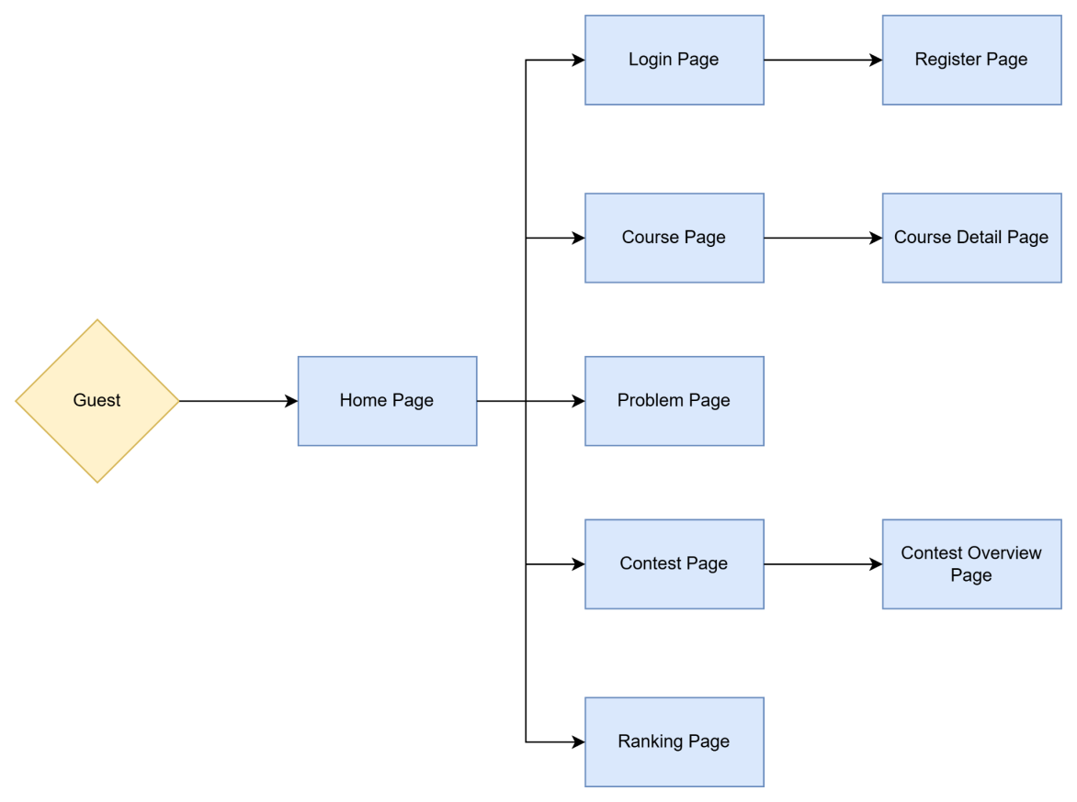

4.1.2 Screen flow of customer
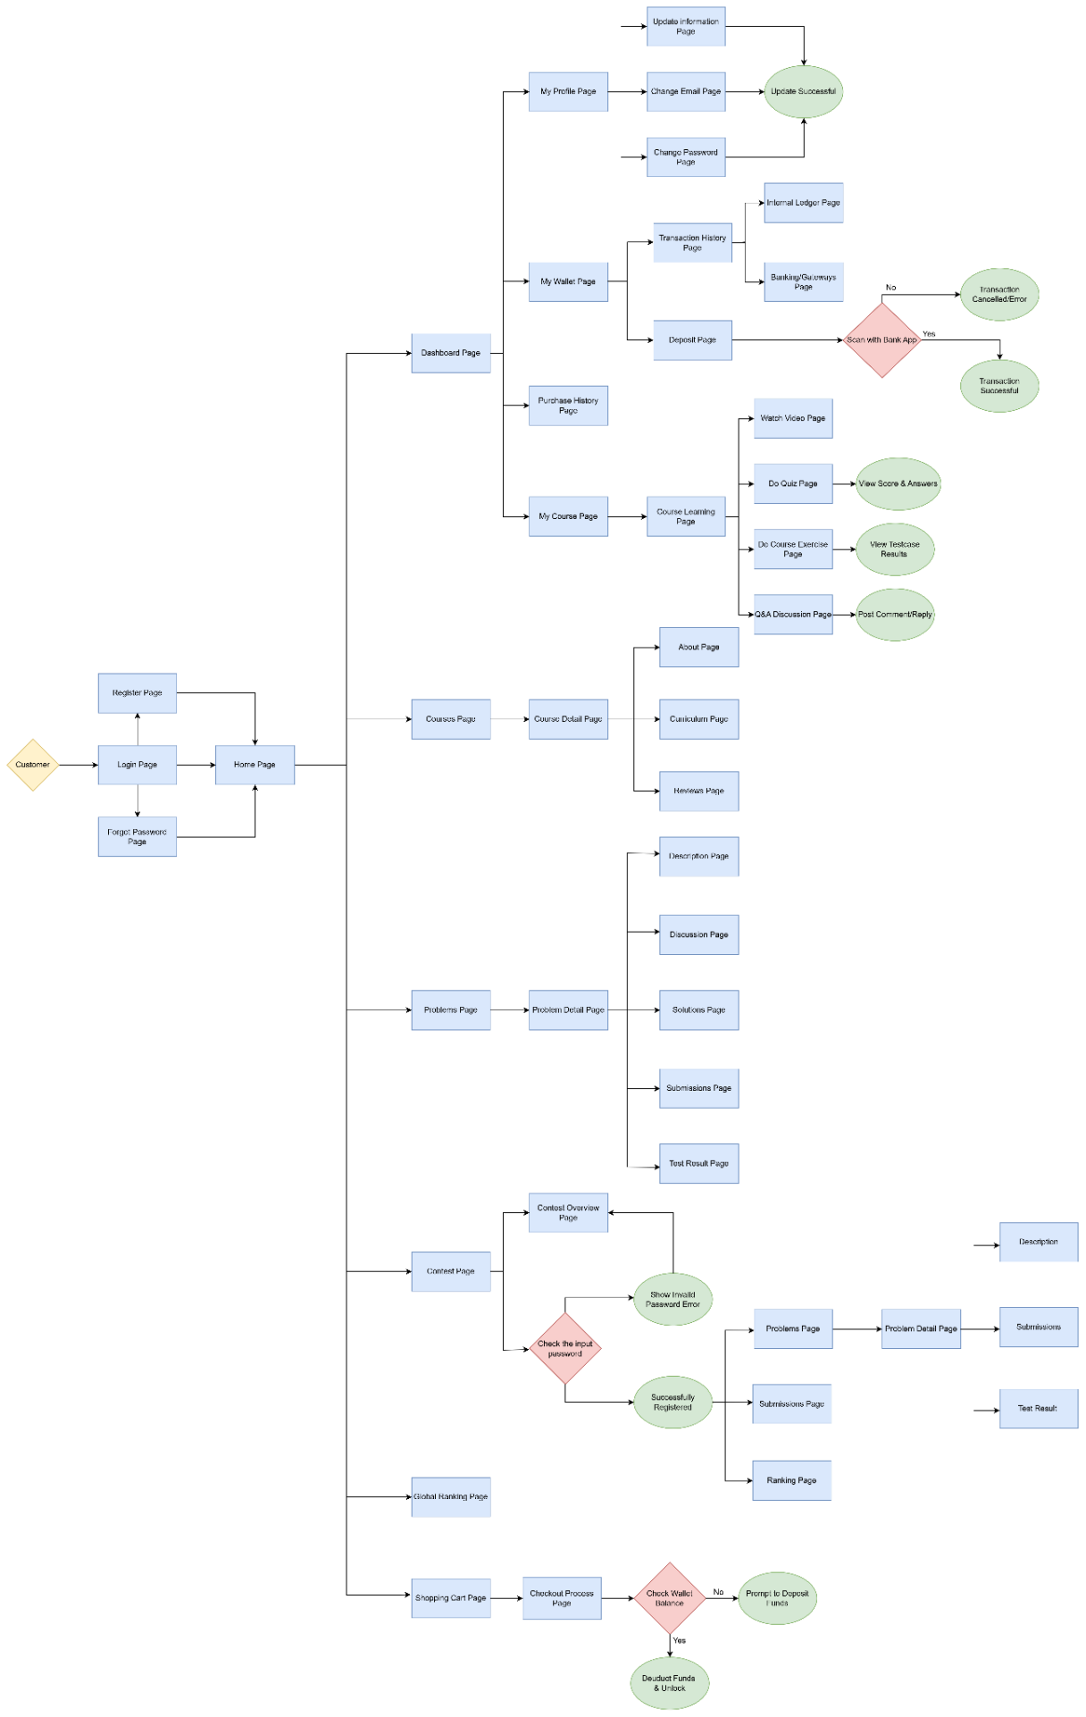

4.1.3 Screen flow of instructor
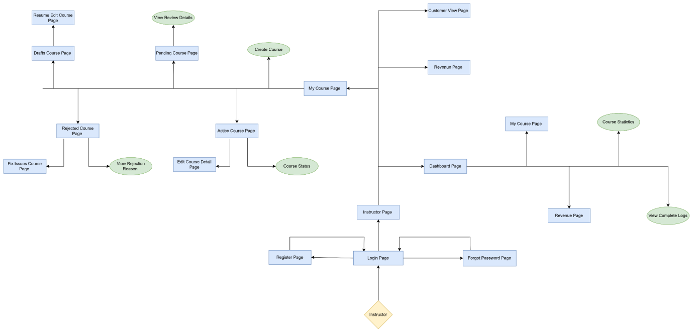

4.1.4 Screen flow of admin
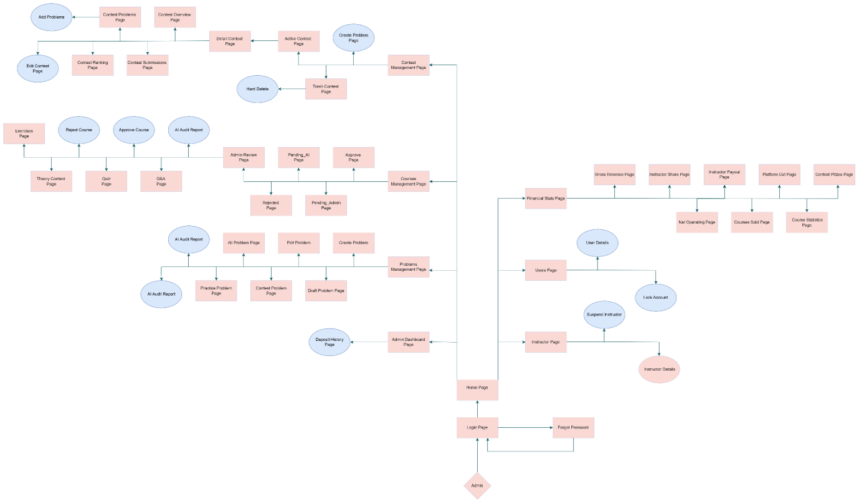

4.2 Screen description

STT | Feature | Screen | Description
1 | Home / Landing | Home Page | The main landing page showing the platform introduction and navigation links.
2 | Account Login | Login Page | Allows users to log into the platform using email/password or Google SSO.
3 | Account Registration | Register Page | The screen for new users to sign up and create an account.
4 | Password Recovery | Forgot Password Page | The screen to recover access if a password is forgotten.
5 | Course Exploration | Course Page | Displays a searchable and filterable list of all available courses.
6 | Course Details | Course Detail Page | Shows specific course info (syllabus, price, instructor) for review before purchasing.
7 | Problem Exploration | Problem Page | Displays the library of available programming problems and coding challenges.
8 | Contest Exploration | Contest Page | Lists all upcoming, ongoing, and past programming contests.
9 | Contest Details | Contest Overview Page | Shows the rules, schedule, and prize information for a specific contest.
10 | Global Leaderboard | Ranking Page | Displays the global ranking of users based on their performance and scores.
11 | Dashboard | Dashboard Page | The central hub linking to the user's profile, wallet, and courses.
12 | Profile Overview | My Profile Page | Displays the user's current personal information and account settings.
13 | Profile Editing | Update information Page | The screen to edit personal details like name or bio.
14 | Email Update | Change Email Page | The screen dedicated to updating the account's email address.
15 | Password Change | Change Password Page | The screen to securely change the current account password.
16 | Notification | Update Successful | Shows a success message after updating profile or email.
17 | Wallet Overview | My Wallet Page | Displays the current wallet balance and financial options.
18 | Wallet Deposit | Deposit Page | The screen to scan a QR code with a Bank App to add funds.
19 | Payment Failure | Transaction Cancelled/Error | Displays an error if the deposit transaction fails.
20 | Payment Success | Transaction Successful | Shows a success message when the deposit is completed.
21 | Transaction Tracking | Transaction History Page | Lists all past financial transactions of the user.
22 | Internal Ledger View | Internal Ledger Page | Shows detailed internal system transaction records.
23 | Gateway Records | Banking/Gateways Page | Shows external payment gateway records.
24 | Purchase Tracking | Purchase History Page | Displays the history of all successfully purchased courses.
25 | Enrolled Courses | My Course Page | Lists all the courses the customer currently owns/has purchased.
26 | Course Workspace | Course Learning Page | The main interactive interface for studying a specific course.
27 | Video Player | Watch Video Page | The screen to play and watch video lectures.
28 | Quiz Taking | Do Quiz Page | The screen to take multiple-choice quizzes and view scores.
29 | Quiz Results | View Score & Answers | Displays the final score and correct answers after a quiz.
30 | Coding Practice | Do Course Exercise Page | The screen to write code, submit it, and view test case results.
31 | Test Case Results | View Testcase Results | Shows whether the submitted code passed or failed the test cases.
32 | Course Q&A | Q&A Discussion Page | The screen to ask questions and reply to peers or instructors.
33 | Post Interaction | Post Comment/Reply | Action to submit a new question or reply.
34 | Course Catalog | Courses Page | Displays a searchable list of all available courses on the platform.
35 | Course Details | Course Detail Page | Shows specific course info (curriculum, instructor) before buying.
36 | Course Information | About Page | Displays general details, learning objectives, and instructor information for the course.
37 | Course Syllabus | Curriculum Page | Shows the detailed breakdown of chapters, lessons, and quizzes included in the course.
38 | Course Feedback | Reviews Page | Displays the ratings and comments left by students who have taken the course.
39 | Problem Catalog | Problems Page | Lists all available programming problems and algorithmic challenges.
40 | Problem Solving | Problem Detail Page | Shows problem descriptions, test results, and a code editor.
41 | Problem Information | Description Page | Action/Tab to view the problem's description.
42 | Problem Interaction | Discussion Page | Action/Tab to view discussions of the problem.
43 | Editorial / Hints | Solutions Page | Action/Tab to view solutions or hints for the problem.
44 | History Review | Submissions Page | Action/Tab to view past submissions for the problem.
45 | Execution Results | Test Result Page | Action/Tab to view the testcase results of a submission.
46 | Contest Listing | Contest Page | Lists all upcoming, ongoing, and past programming contests.
47 | Contest Information | Contest Overview Page | Shows the specific rules, details, and schedules of a contest.
48 | Auth Error | Show Invalid Password Error | Displays an error if the contest entry password is wrong.
49 | Auth Success | Successfully Registered | Displays a success message upon successfully entering the contest.
50 | Code Submissions | Submissions Page | Displays the history of code submissions made within a contest.
51 | Contest Leaderboard | Ranking Page | Shows the specific leaderboard for a contest.
52 | Global Leaderboard | Global Ranking Page | Displays the overall ranking of all users based on their scores.
53 | Shopping Cart | Shopping Cart Page | Shows courses added to the cart waiting for payment.
54 | Checkout & Payment | Checkout Process Page | The screen to confirm purchase, verify balance, and deduct funds.
55 | Insufficient Funds | Prompt to Deposit Funds | Asks the user to top up their wallet if the balance is low.
56 | Successful Payment | Deduct Funds & Unlock | Confirms the deduction and unlocks the course for the user.
57 | Instructor Navigation | Instructor Page | The main dashboard shell for instructor, providing navigation to core tabs such as Dashboard, My Course, and Revenue.
58 | Overview Dashboard | Dashboard Instructor Page | Displays a high-level summary of the instructor's performance, student metrics, and recent activities.
59 | Course Management | My Course Page | Access to the course list from within the Dashboard.
60 | Course Analytics | Course Statistics | Feature to view detailed statistical metrics of a course.
61 | Interaction Logs | View Complete Logs | Feature to view detailed interaction logs and student history.
62 | Revenue Tracking | Revenue Page | Access to revenue reports from within the Instructor Dashboard.
63 | Course Management | My Course Page | The central screen listing all courses managed by the instructor.
64 | Course Creation | Create Course | Feature to initialize and build a new course.
65 | Manage Active Courses | Active Course Page | The screen displaying published and live courses.
66 | Edit Course Details | Edit Course Detail Page | The screen to edit course content and details.
67 | Course Status | Course Status | Feature to view or update the current visibility status of a course.
68 | Track Pending Courses | Pending Course Page | The screen listing courses submitted and waiting for Admin approval.
69 | Admin Review Feedback | View Review Details | Feature to view Admin feedback or review progress.
70 | Handle Rejected Courses | Rejected Course Page | The screen listing courses rejected by the Admin.
71 | Issue Course Resolution | Fix Issues Course Page | The screen to correct issues in a rejected course.
72 | Rejection Details | View Rejection Reason | Feature to read the specific rejection reasons provided by the Admin.
73 | Manage Drafts | Drafts Course Page | The screen listing incomplete, drafted courses.
74 | Draft Editing | Resume Edit Course Page | The screen to continue editing an incomplete draft.
75 | Revenue Tracking | Revenue Page | The main screen for financial reports and earnings overview.
76 | Course Preview | Customer View Page | The screen to preview the course from a student's perspective.
77 | Course Exploration | Course Page | Displays a searchable and filterable list of all available courses on the platform.
78 | Course Details | Course Detail Page | Shows specific course info (syllabus, price, instructor, reviews) for review before purchasing.
79 | Theory Content | Theory Content Page | Displays the textual and reading material of a specific lesson in a course.
80 | Quiz | Quiz Page | The interactive screen where students can answer multiple-choice questions for course quizzes.
81 | Q&A | Q&A Page | A discussion board where students can ask questions and get replies from instructors or other students.
82 | Contest Exploration | Contest Page | Lists all upcoming, ongoing, and past programming contests.
83 | Contest Standing | Contest Standing Page | Shows the real-time leaderboard (standings) of a specific contest.
84 | Contest Submission | Contest Submission Page | Displays the history of code submissions for a contest, showing status and results.
85 | Contest Problem | Contest Problem Page | The workspace where users view a specific contest programming challenge and submit their code.
86 | Admin Dashboard | Admin Dashboard | An administrative dashboard to monitor overall platform activities, statistics, and system performance.
87 | Courses Management | Courses Management Panel | An administrative workspace to manage submitted courses and their approval status.
88 | Admin Review | Course Review Panel | An administrative page to review course content before making approval decisions.
89 | Pending_AI | Pending AI Review Panel | A page to display courses awaiting AI content analysis.
90 | Pending_Admin | Pending Admin Review Panel | A page to display courses waiting for administrative review.
91 | Admin Approve | Approved Courses Panel | A page to display courses that have been approved and published.
92 | Admin Rejected | Rejected Courses Panel | A page to display courses that have been rejected by administrators.
93 | AI Audit Report | AI Audit Report | A report page to display AI-generated content moderation results for a course.
94 | Admin Problems Management | Problems Management Panel | An administrative workspace to manage programming problems on the platform.
95 | AI Problem | AI Problem Review Panel | A page to display AI evaluation results for programming problems.
96 | Admin Practice Problem | Practice Problems Panel | A page to manage problems available in the practice section.
97 | Admin Contest Problem | Contest Problems Panel | A page to manage problems assigned to programming contests.
98 | Draft Problem | Draft Problems Panel | A workspace to manage programming problems saved as drafts.
99 | Admin Create Problem | Create Problem Page | A page to create a new programming problem.
100 | Admin Edit Problem | Edit Problem Page | A page to modify the information and content of an existing programming problem.
101 | Contest Management | Contest Management Panel | An administrative workspace to manage programming contests.
102 | Contest Overview | Contest Overview Page | A page to display general information and settings of a contest.
103 | Admin Contest Problems | Contest Problems Page | A page to manage problems included in a contest.
104 | Contest Ranking | Contest Ranking Page | A page to display participant rankings and contest standings.
105 | Contest Submissions | Contest Submissions Page | A page to display code submissions made during a contest.
106 | Detail Contest | Contest Details Page | A page to display detailed information about a contest.
107 | Active Contest | Active Contest Panel | An administrative panel to monitor currently running contests.
108 | Trash Contest | Trash Contest Panel | A workspace to manage deleted contests before permanent removal.
109 | Financial Stats | Financial Statistics Page | A page to display financial reports, revenue statistics, and transaction summaries.
110 | Gross Revenue | Gross Revenue Page | A page to display the platform's total revenue.
111 | Instructor Share | Instructor Share Page | A page to display revenue allocated to instructors.
112 | Instructor Payout | Instructor Payout Page | A page to manage instructor payment records.
113 | Platform Cut | Platform Revenue Page | A page to display the platform's commission from course sales.
114 | Contest Prizes | Contest Prizes Page | A page to display prize distributions for programming contests.
115 | Net Operating | Net Operating Page | A page to display the platform's net operating income.
116 | Courses Sold | Courses Sold Page | A page to display statistics on courses sold.
117 | Course Statistics | Course Statistics Page | A page to display statistical information about course performance.
118 | Users Information | Users Management Panel | An administrative workspace to manage user accounts.
119 | User Details | User Details Page | A page to display detailed information about a user account.
120 | Instructor Information | Instructors Management Panel | An administrative workspace to manage instructor accounts.
121 | Instructor Details | Instructor Details Page | A page to display detailed information about an instructor.

4.3 Screen Authorization

STT | Screen | Guest | Student | Instructor | Admin
1 | Register Page | X
2 | Login Page | X
3 | Forgot Password | X
4 | Home Page | X | X | X | X
5 | Student Dashboard Page |  | X | X | X
6 | My Profile Page |  | X | X | X
7 | Update information Page |  | X | X | X
8 | Change Email Page |  | X | X | X
9 | Change Password Page |  | X | X | X
10 | My Wallet Page |  | X | X | X
11 | Deposit Page |  | X | X | X
12 | Transaction History Page |  | X | X | X
13 | Internal Ledger Page |  | X | X | X
14 | Banking/Gateways Page |  | X | X | X
15 | Purchase History Page |  | X | X | X
16 | My Course Page |  | X | X | X
17 | Course Learning Page |  | X | X | X
18 | Watch Video Page |  | X | X | X
19 | Do Quiz Page |  | X | X | X
20 | Do Course Exercise Page |  | X | X | X
21 | Q&A Discussion Page |  | X | X | X
22 | Courses Page | X | X | X | X
23 | Course Detail Page | X | X | X | X
24 | About Page | X | X | X | X
25 | Curriculum Page | X | X | X | X
26 | Reviews Page | X | X | X | X
27 | Problems Page | X | X | X | X
28 | Problem Detail Page |  | X | X | X
29 | Contest Page | X | X | X | X
30 | Contest Overview Page | X | X | X | X
31 | Submissions Page |  | X | X | X
32 | Ranking Page | X | X | X | X
33 | Global Ranking Page |  | X | X | X
34 | Shopping Cart Page |  | X | X | X
35 | Checkout Process Page |  | X | X | X
36 | Admin Dashboard |  |  |  | X
37 | Courses Management |  |  |  | X
38 | Admin Review |  |  |  | X
39 | Pending_AI |  |  |  | X
40 | Pending_Admin |  |  |  | X
41 | Admin Approve |  |  |  | X
42 | Admin Rejected |  |  |  | X
43 | AI Audit Report |  |  |  | X
44 | Admin Problems Management |  |  |  | X
45 | AI Problem |  |  |  | X
46 | Admin Practice Problem |  |  |  | X
47 | Admin Contest Problem |  |  |  | X
48 | Draft Problem |  |  |  | X
49 | Admin Create Problem |  |  |  | X
50 | Admin Edit Problem |  |  |  | X
51 | Contest Management |  |  |  | X
52 | Contest Overview |  |  |  | X
53 | Admin Contest Problems |  |  |  | X
54 | Contest Ranking |  |  |  | X
55 | Contest Submissions |  |  |  | X
56 | Detail Contest |  |  |  | X
57 | Active Contest |  |  |  | X
58 | Trash Contest |  |  |  | X
59 | Financial Stats |  |  |  | X
60 | Gross Revenue |  |  |  | X
61 | Instructor Share |  |  |  | X
62 | Instructor Payout |  |  |  | X
63 | Platform Cut |  |  |  | X
64 | Contest Prizes |  |  |  | X
65 | Net Operating |  |  |  | X
66 | Courses Sold |  |  |  | X
67 | Course Statistics |  |  |  | X
68 | Users Information |  |  |  | X
69 | User Details |  |  |  | X
70 | Instructor Information |  |  |  | X
71 | Instructor Details |  |  |  | X
72 | Admin Dashboard |  |  |  | X
73 | Courses Management |  |  |  | X
74 | Admin Review |  |  |  | X
75 | Dashboard Instructor Page |  |  | X
76 | My Course Page |  |  | X
77 | Course Statistics |  |  | X
78 | View Complete Logs |  |  | X
79 | Revenue Page |  |  | X
80 | Create Course |  |  | X
81 | Active Course Page |  |  | X
82 | Edit Course Detail Page |  |  | X
83 | Course Status |  |  | X
84 | Pending Course Page |  |  | X
85 | View Review Details |  |  | X
86 | Rejected Course Page |  |  | X
87 | Fix Issues Course Page |  |  | X
88 | View Rejection Reason |  |  | X
89 | Drafts Course Page |  |  | X
90 | Resume Edit Course Page |  |  | X
91 | Customer View Page |  |  | X

4.4 Non-Screen Functions

STT | Feature | System Function | Description
1 | Authentication | Validate Credentials | Checks the entered email and password against the database to authenticate the user and issue a secure session token.
2 | Account Creation | Hash Password & Save User | Encrypts the user's chosen password and inserts a new account record into the database during registration.
3 | Password Recovery | Send Reset Email | Generates a secure, time-limited recovery token and sends a password reset link to the user's email address.
4 | Access Control | Verify Auth Session | Intercepts requests to protected actions (e.g., Add to Cart, Join Contest, Solve Problem) to ensure the user is logged in. Redirects Guests to the Login page.
5 | Wallet Deposit | Process Gateway Callback | Listens for webhooks/API responses from the external Banking App to verify if the deposit transaction was successful before updating the balance.
6 | Course Checkout | Verify Wallet Balance | Queries the database to check if the user's current wallet balance is sufficient to cover the total cost of the items in the Shopping Cart.
7 | Course Checkout | Deduct Funds & Unlock Course | Automatically subtracts the purchase amount from the wallet, records the transaction in the internal ledger, and grants the user access to the purchased courses.
8 | Quiz Evaluation | Grade Quiz Submission | Compares the user's submitted quiz answers with the correct system answers in the database and calculates the final score.
9 | Code Evaluation | Run Code against Testcases | Compiles the user's submitted code in a secure, isolated environment (Sandbox), executes it against hidden testcases, and returns the result (Pass/Fail, execution time).
10 | Contest Entry | Validate Contest Password | Checks the password entered by the user against the contest's configured private password to authorize entry into a restricted contest.
11 | Admin Security | Password Reset Email | The system sends a password reset validation code to the admin's email when requested.
12 | Problem Evaluation | Sandboxed Grading Job | The system compiles and executes submitted program files inside a Judge0 sandbox container, comparing outputs with test cases.
13 | Contest Standing | ICPC Scoreboard Calculator | The system dynamically recalculates solved problems and penalty minutes, pushing scoreboard updates via Server-Sent Events (SSE).
14 | Contest Lifecycle | State Transition Job | A background cron task scans scheduled contests every minute and shifts status based on the current system UTC clock.
15 | Course Moderation | AI Content Scanning | A background process sends course titles, descriptions, and quiz texts to text moderation algorithms to check for violations.
16 | Payment Auditing | Financial Split Job | When MOMO/VNPay payment webhook succeeds, the system splits gross revenue (2% Gateway, 30% Platform, 70% Instructor) and credits wallets.
17 | Data Integrity | Cascade Deletion Handler | When a contest is deleted, the database transaction automatically resets the scope of associated problems to PRACTICE.
18 | Instructor Security | Password Reset Email | The system sends a password reset validation code to the instructor's email when requested via the Forgot Password page.
19 | Course Moderation | AI Content Scanning | A background process sends course materials to AI moderation algorithms. The results automatically update the course status to Active or Rejected (providing rejection reasons for the Instructor).
20 | Media Processing | Video Transcoding Job | When an instructor uploads video lessons (Create / Edit Course), a background FFmpeg service transcodes the media into optimal streaming formats (HLS/DASH) and generates thumbnails.
21 | Payment & Revenue | Financial Split Job | When a user purchases a course, the system splits gross revenue (crediting 70% to the Instructor) and updates the balance shown on the Revenue Page.
22 | Data Analytics | Statistics Aggregation Job | A background cron task aggregates course enrollments, student interactions, and logs to populate the Course Statistics and View Complete Logs sections on the Dashboard.

5. System High Level Design

5.1 Entity Relationship Diagram

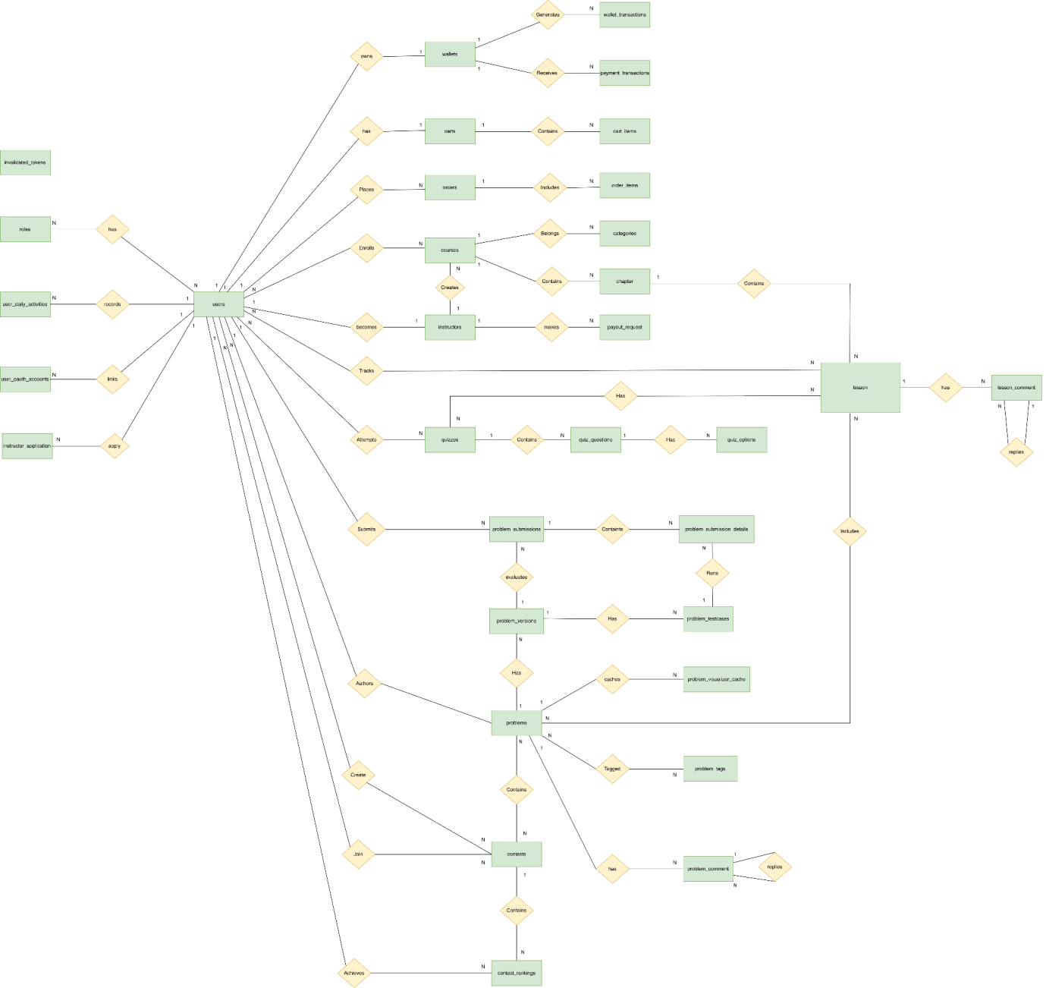

5.2 Entity Description
ID | Entity | Description
1 | users | The primary user entity stores core authentication credentials (username, email, password), account status (active, locked), total score, and profile metadata for all system users (Customers, Instructors, Admins).
2 | roles | Defines the specific role-based groups (ROLE_USER, ROLE_INSTRUCTOR, ROLE_ADMIN) used to enforce Role-Based Access Control (RBAC) across API endpoints and frontend views.
3 | user_daily_activities | Records daily coding activities, submissions count, and continuous study streaks (streak) for each user (used to draw Git-like heatmaps on profiles).
4 | instructor_applications | Stores submission portfolios (CV links, biography, status, and reviewer feedback) from regular users applying to become instructors, pending Admin approval.
5 | instructors | Stores public profiles and biography metadata of approved instructors, linking them to their corresponding user accounts.
6 | wallets | Manages the internal virtual balance of users, holding funds used for purchasing courses (by Customers) or receiving revenue shares (by Instructors).
7 | wallet_transactions | Serves as an immutable financial ledger tracking all internal balance modifications, recording transaction amount, transaction type (DEPOSIT, BUY_COURSE, PAYOUT), and timestamps.
8 | payment_transactions | Logs all external top-up transactions initiated through the PayOS payment gateway, storing transaction codes, checkout links, and payment states (PENDING, SUCCESS, CANCELLED).
9 | carts | Represents a user's active shopping cart, linked 1-to-1 with a user account to manage selections prior to purchasing courses.
10 | cart_items | Defines the relationship mapping specific courses currently added to a user's active shopping cart.
11 | orders | Represents the official purchase invoice created upon successful checkout, capturing the total order amount, date, and order status.
12 | order_items | Details the specific courses included within an order, capturing the exact price at the time of purchase to ensure historical auditing integrity.
13 | categories | Categorizes courses (e.g., Web Development, Algorithms, Database Systems) to enable structured browsing, filtering, and searching.
14 | courses | The central course entity, storing title, pricing, thumbnail, average rating, status (DRAFT, PENDING, APPROVED, REJECTED), and instructor association.
15 | chapters | Organizes lessons and problems into structured syllabus chapters under a specific course.
16 | lessons | The granular learning unit belongs to a chapter, supporting different types of content (Video lectures, markdown documents, or practice coding assignments).
17 | quizzes | Stores multiple-choice assessment structures associated with lessons for quick user knowledge evaluation.
18 | quiz_questions | Houses the question bank (question text, ordering) linked to a specific quiz.
19 | quiz_options | Stores the possible answer choices (options A, B, C, D) for each question, including a boolean flag to indicate the correct answer.
20 | problems | Stores algorithmic coding problem specifications, including problem descriptions, constraints, and sandbox execution resource limits (CPU time limit in ms, RAM limit in KB).
21 | problem_tags | Tagging metadata used to classify problems by topic (e.g., Dynamic Programming, Array, Sorting) for targeted practice.
22 | problem_testcases | Contains inputs and expected outputs used by the sandbox compiler (Judge0) to evaluate the correctness of student code submissions.
23 | problem_submissions | Stores top-level code submission metadata made by students (source code, language, overall verdict, time/memory maximums, and timestamp).
24 | problem_submission_details | Logs execution outputs (stdout, stderr, compile error, status) for each individual test case run under a specific submission.
25 | contest | Manages time-bound programming tournaments, defining contest schedules, scoring configurations (e.g., ICPC, IOI), password protection, and problem sets.
26 | contest_rankings | Holds standings metadata, accumulated scores, and penalty times for users participating in a specific contest (used to render scoreboards).

II: REQUIREMENT SPECIFICATIONS

1. Authentication & Common Features Subsystem

1.1 UC-COM-01_Login

UC SPECIFICATION
Use Case Name | Login
Use Case ID | UC-COM-01
Primary Actor | Guest (Unauthenticated User)
Secondary Actor | System, Google Authentication System
Description | Allows an unauthenticated user to access the system using a valid registered account (Email and Password) or via a third-party Single Sign-On (Google SSO).
Trigger | The user accesses the home page and clicks the "Login" button.
Preconditions | The user has a valid account on the system, and the account is active (not locked or banned).
Post conditions | The user is successfully authenticated, a session is created, and the user is redirected to the home page or a role-specific Dashboard.
Main Flow | - The user selects the "Login" function.  - The system displays the login form requesting an Email and Password.  - The user enters their credentials and clicks "Login".  - The system validates the entered credentials against the database.  - The system successfully authenticates the user.  - The system creates a session/token and redirects the user to the appropriate home page/Dashboard based on their role.
Alternative Flow A (Login with Google SSO) | - At step 2 of the Main Flow, the user selects "Login with Google".  - The system redirects the user to the Google OAuth2 authentication page.  - The user logs into their Google account and grants the necessary permissions.  - Google successfully authenticates the user and returns their information (Email, Name, Avatar) to the system.  - The system checks if the Email exists in the database. If the Email does not exist (new user): The system automatically creates a new account. If the Email exists (existing user): The system checks the account's lock status.  - Continue from step 6 of the Main Flow.
Exception | - Invalid Credentials: At step 4 of the Main Flow, if the Email or Password is incorrect, the system displays an error message "Incorrect email or password" and allows the user to try again.  - Account Locked: If the account is marked as "Banned/Locked", the system denies access and displays "Your account has been locked. Please contact the administrator."  - SSO Permission Denied: At step 3 of Alternative Flow A, if the user denies permission, the login process is aborted, and the user is redirected back with a "Login failed" message.
Priority | High
Frequency Of Use | Very High (Every time a user needs to access secured features).
Business Rules | - [BR-COM-01] Username Length Constraint: Minimum 8 characters.  - [BR-COM-02] Password Length Constraint: Minimum 8 characters.  - [BR-COM-03] Password Match Verification: Password and confirmation must match exactly.  - [BR-COM-04] Username Uniqueness: Must be unique across the entire database.  - [BR-COM-05] Email Uniqueness: Must be unique across the entire database.  - [BR-COM-06] Password Encryption: Must be hashed using BCrypt before database insertion.

1.2 UC-COM-02_Register

UC SPECIFICATION
Use Case Name | Register
Use Case ID | UC-COM-02
Primary Actor | Guest (Unauthenticated User)
Secondary Actor | Email System (System)
Description | Allows a guest to create a new account on the platform to become a registered user Customer.
Trigger | The user clicks the "Register" button on the home page or login page.
Preconditions | The user is not logged into the system. The provided email does not already exist in the database.
Post conditions | A new account is created with an "Unverified" (or "Active") status, and a confirmation email is sent to the user.
Main Flow | - The user selects the "Register" function.  - The system displays the registration form (Full Name, Email, Password, Confirm Password).  - The user enters the required information and clicks "Register".  - The system validates the input data (e.g., email format, password strength, matching passwords).  - The system verifies that the Email does not already exist in the database.  - The system saves the new account information into the database with the default role of "Customer".  - The system sends an email containing an activation link to the user's email address.  - The system displays a success message and prompts the user to check their email.
Exception | - Invalid Data: At step 4 of the Main Flow, if the data is invalid (e.g., password too short), the system displays an error message next to the corresponding field.  - Email Already Exists: At step 5 of the Main Flow, if the email is already registered, the system displays "This email is already in use. Please choose another email or log in."
Priority | High
Frequency Of Use | Medium
Business Rules | - [BR-COM-10] Token Blacklisting on Logout: Logging out invalidates the active Access Token by adding it to the invalidated_tokens blacklist repository to prevent reuse before expiration.

1.3 UC-COM-03_Sign Out

UC SPECIFICATION
Use Case Name | Sign Out
Use Case ID | UC-COM-03
Primary Actor | User (Any role: Customer, Instructor, Admin)
Secondary Actor | System
Description | Allows a logged-in user to securely end their session and log out of the system.
Trigger | The user clicks the "Sign Out" button from the account menu.
Preconditions | The user is currently logged into the system.
Post conditions | The user's session is destroyed, and they become a Guest.
Main Flow | - The user selects "Sign Out" from their personal menu.  - The system confirms the logout request.  - The system destroys the current user's session (clears session/cookies/tokens).  - The system redirects the user to the guest home page.
Exception | - Network Loss During Logout: If the client-side token is cleared but the server hasn't invalidated it yet, the system must have a robust token expiration mechanism (e.g., JWT short lifespan).
Priority | High
Frequency Of Use | High
Business Rules | - [BR-COM-02] Password Length Constraint: The new password must be at least 8 characters.  - [BR-COM-03] Password Match Verification: The new password and confirmation must match exactly.  - [BR-COM-06] Password Encryption: The new password must be hashed using BCrypt.

1.4 UC-COM-04_Forgot Password

UC SPECIFICATION
Use Case Name | Forgot Password
Use Case ID | UC-COM-04
Primary Actor | Guest
Secondary Actor | Email System
Description | Allows users to reset their password if they have forgotten it (applicable for traditional accounts).
Trigger | The user clicks the "Forgot Password?" link on the Login form.
Preconditions | The user has a registered traditional account on the system.
Post conditions | The user's password is successfully updated, and they can log in with the new password.
Main Flow | - The user selects "Forgot Password?".  - The system displays a form requesting the registered Email.  - The user enters their Email and clicks "Submit".  - The system verifies the existence of the Email in the database.  - The system generates a time-limited OTP or password reset link (e.g., valid for 15 minutes).  - The system sends an email containing the OTP/link to the user.  - The system notifies the user to check their email.  - The user clicks the link in the email or enters the OTP on the platform.  - The system validates the link/OTP and displays the "Create New Password" form.  - The user enters and confirms their new password.  - The system updates the database with the new password and displays a success message.
Exception | - Email Not Found: At step 4, if the email doesn't exist, the system should still display a generic message like "If the email is valid, a reset link will be sent" to prevent email enumeration attacks.  - Link/OTP Expired: At step 9, if the link/OTP has expired, the system displays an error and prompts the user to request a new one.
Priority | High
Frequency Of Use | Medium
Business Rules | - [BR-COM-08] Locked Account Access Restrictions: Accounts flagged as LOCKED or DISABLED are still permitted to view the home page.  - [BR-COM-09] Secure Session Token Handling: Authentication uses short-lived Access Tokens and Http-Only/Secure Refresh Tokens.  - [BR-COM-15] Daily Active Learning Streak: If authenticated, viewing the page counts as an activity to calculate/increment the learning streak.

1.5 UC-COM-05_View Home Page

UC SPECIFICATION
Use Case Name | View Home Page
Use Case ID | UC-COM-05
Primary Actor | Any (Guest, Customer, Instructor, Admin)
Secondary Actor | System
Description | Allows users to view the platform's home page, which displays introductory information, featured courses, recent announcements, or a general overview.
Trigger | The user navigates to the root URL of the website.
Preconditions | The user navigates to the root URL of the website.
Post conditions | The home page is fully rendered with content tailored to the user's authentication status.
Main Flow | - The user navigates to the system's home page.  - The system checks the user's authentication status (Session/Token).  - The system fetches the necessary data (featured courses, statistics, banners, etc.).  - The system renders the home page interface. If Guest: Displays Login/Register buttons and marketing content. If Authenticated User: Displays a brief personal profile (Avatar, Name) and personalized content (enrolled courses, recommendations).
Exception | - Data Load Failure: If the system cannot fetch the featured courses from the database, it displays a fallback layout or a "Unable to load data at this time" message.
Priority | Medium
Frequency Of Use | Very High
Business Rules | - [BR-COM-06] Password Encryption: The new password must be hashed using BCrypt.  - [BR-COM-07] Password Change Validation: Requires correct old password. New password must be >= 8 characters, differ from old password, and match the new confirmation.

1.6 UC-COM-06_Edit Profile & Password

UC SPECIFICATION
Use Case Name | Edit Profile & Password
Use Case ID | UC-COM-06
Primary Actor | User (Customer, Instructor, Admin)
Secondary Actor | System
Description | Allows users to update their personal information (name, avatar, bio) and change their current password.
Trigger | The user accesses the "Profile" page and selects "Edit Profile" or "Change Password".
Preconditions | The user is logged into the system.
Post conditions | The user's personal data and/or password are updated in the database.
Main Flow | The user selects the "Edit Profile" function.  The system displays a form populated with the user's current data.  The user modifies the information (e.g., Name, Phone Number, uploads a new Avatar) and clicks "Save".  The system validates the input data.  The system saves the changes to the database.  The system displays a success message and reloads the updated information.
Alternative Flow A (Change Password) | - The user navigates to the "Change Password" tab.  - The system requires the Current Password, New Password, and Confirm New Password.  - The user inputs the data and clicks "Change Password".  - The system verifies that the "Current Password" is correct.  - The system verifies that the "New Password" meets complexity requirements.  - The system updates the password, optionally logs out other active sessions, and displays a success message.
Exception | - Incorrect Current Password: At step 4 of Alternative Flow A, if the current password is wrong, the system displays an error.  - Invalid File Upload: At step 4 of the Main Flow, if the uploaded avatar exceeds the file size limit or is in an unsupported format, the system displays an appropriate error.  - SSO Account Restrictions: If the user registered exclusively via Google SSO, the "Change Password" option might be hidden or disabled.
Priority | Medium
Frequency Of Use | Low - Medium
Business Rules | - [BR-COM-08] Locked Account Access Restrictions: Accounts flagged as LOCKED or DISABLED are blocked from executing this API.

1.7 UC-COM-07_Participate in Discussion

UC SPECIFICATION
Use Case Name | Participate in Discussion
Use Case ID | UC-COM-07
Primary Actor | User (Customer, Instructor)
Secondary Actor | System
Description | Allows users to participate in forums or Q&A sections within a specific course or a general forum by creating posts, commenting, or replying to others.
Trigger | The user navigates to the Discussion section of a course/lesson and clicks "Create Post" or "Comment".
Preconditions | The user is logged in. If it is a course-specific discussion, the user must be enrolled in that course.
Post conditions | - The new post or comment is saved in the system and becomes visible to other users.
Main Flow | - The user accesses the discussion space.  - The user inputs the content of their post/comment into the text editor.  - The user clicks "Post/Submit".  - The system moderates the content (optional: filtering prohibited words).  - The system saves the content to the database along with the author's details and timestamp.  - The system displays the new post/comment on the interface immediately.  - (Optional) The system sends notifications to relevant users (e.g., the Instructor or the original post creator).
Alternative Flow A (Edit/Delete Comment) | The user chooses to edit or delete their own comment.  The system updates the data or marks it as deleted (soft delete).
Alternative Flow B | N/A
Exception | - Community Standards Violation: At step 4 of the Main Flow, if prohibited words are detected, the system rejects the post and displays an error message.  - Network Loss: If a connection error occurs during submission, the system displays "Unable to post comment, please try again."
Priority | Medium
Frequency Of Use | High
Business Rules | - [BR-COM-08] Locked Account Access Restrictions: Locked accounts are blocked from business APIs, except viewing the home page and submitting appeal requests.  - [BR-COM-10] Token Blacklisting on Logout/Lock: Active Access Tokens of the locked user are immediately added to the blacklist to terminate their current sessions.

1.8 UC-COM-08_Lock & Unlock Users

UC SPECIFICATION
Use Case Name | Lock & Unlock Users
Use Case ID | UC-COM-08
Primary Actor | Admin
Secondary Actor | System
Description | Allows the Admin to lock (temporarily suspend) or unlock a user's account (Customer/Instructor) upon detecting violations or after resolving an issue.
Trigger | The Admin navigates to the "User Management" page, selects a user, and clicks "Lock" or "Unlock".
Preconditions | The Admin is logged in and possesses account management privileges. The target user exists in the system.
Post conditions | The target user's account status is updated to Banned/Locked (if locked) or Active (if unlocked). Locked users are prevented from logging in.
Main Flow | - The Admin navigates to the user list.  - The Admin searches for and selects the target user.  - The Admin chooses the "Lock Account" action.  - The system prompts for confirmation and (optionally) requests a reason for the lock.  - The Admin confirms the action.  - The system updates the account status to "Locked".  - (Optional) The system sends an email to the user explaining the lock and the reason.  - If the user is currently logged in, the system immediately invalidates their active session.
Alternative Flow A | - At step 3 of the Main Flow, the Admin selects the "Unlock" action for a locked account.  - The system requests confirmation.  - The Admin confirms. The system updates the status to "Active" and displays a success message.
Exception | - Cannot Lock Admin: If the selected account holds a Super Admin role, the system denies the action and displays "Cannot lock a high-level administrator account."
Priority | High
Frequency Of Use | Low
Business Rules | - [BR-COM-17] Suspended Instructor Policy: Customer who have already purchased a course from a suspended Instructor must retain access to the course materials. A suspended Instructor cannot create new courses and their revenue withdrawal is frozen until the issue is resolved.

1.9 UC-COM-09_Suspend Instructor

UC SPECIFICATION
Use Case Name | Suspend Instructor
Use Case ID | UC-COM-09
Primary Actor | Admin
Secondary Actor | System
Description | Allows the Admin to suspend an Instructor's teaching privileges. Unlike fully locking an account, suspending an Instructor restricts them from creating new courses, while their existing courses may still operate (or be hidden depending on policy).
Trigger | The Admin accesses the "Instructor Management" page, selects an Instructor, and clicks "Suspend".
Preconditions | The Admin is logged in with top-level privileges. The target Instructor is currently Active.
Post conditions | The Instructor's role status is changed to "Suspended". They lose access to instructor-specific functions (e.g., creating courses, withdrawing revenue).
Main Flow | - The Admin navigates to the Instructors list.  - The Admin selects an Instructor who has violated policies (e.g., copyright infringement, severe negative feedback).  - The Admin selects the "Suspend Instructor" action.  - The system displays a confirmation popup, asks how to handle the Instructor's current courses (e.g., Hide courses, or allow existing customers to continue), and requires a reason.  - The Admin fills in the details and clicks "Confirm".  - The system updates the Instructor's privileges to "Suspended".  - The system applies the chosen actions to the Instructor's courses (from step 4).  - The system sends an official notification email to the Instructor detailing the suspension and the reason.
Alternative Flow A (Remove Suspension) | - The Admin selects the "Un-suspend" action for a suspended Instructor.  - The system restores their teaching privileges and sends a notification.
Exception | - Instructor Not Found / Already Suspended: The system displays an appropriate error message.
Priority | High
Frequency Of Use | Very Low (Used only for severe violations).
Business Rules | - [BR-COM-16] Suspended Instructor Restrictions: A suspended Instructor is immediately blocked from creating new courses and their revenue withdrawal features are frozen until the suspension is lifted.  - [BR-COM-17] Suspended Course Availability: Customer who have already purchased or enrolled in a course from a suspended Instructor must permanently retain access to the course materials to protect learners' rights (unless explicitly revoked by the Admin for legal reasons).

2. E-Learning & Course Management Subsystem

2.1 UC-EDU-01_Browse & Search Courses

UC SPECIFICATION
Use Case Name | Browse & Search Courses
Use Case ID | UC-EDU-01
Primary Actor | Guest, Customer, Instructor, Admin
Secondary Actor | None
Description | Allows users to browse the catalog of available courses, search by keywords, and filter results.
Trigger | User navigates to the Courses Page or enters a search query.
Preconditions | None
Post conditions | The system displays a paginated list of courses matching the search criteria.
Main Flow | 1. User accesses the Courses Page.  2. System retrieves and displays a list of APPROVED courses.  3. User inputs a search keyword or selects a filter.  4. System processes the query and updates the course list.
Alternative Flow A (Remove Suspension) | None
Exception | - No courses match the search query -> System displays message: "No courses found matching your criteria."
Priority | High
Frequency Of Use | High
Business Rules | BR-ECO-01: API listing pagination must have a page index greater than or equal to 0, and the maximum allowed page size is capped at 20 items per page (page_size <= 20).  BR-ECO-05: Courses are only eligible for checkout if they are currently in the APPROVED (active) status.

2.2 UC-EDU-02_View Course Details

UC SPECIFICATION
Use Case Name | View Course Details
Use Case ID | UC-EDU-02
Primary Actor | Guest, Customer
Secondary Actor | Instructor
Description | Allows users to view detailed information about a specific course, including the syllabus (curriculum) and reviews.
Trigger | User clicks on a specific course card from the catalog.
Preconditions | The course must be in APPROVED status (unless accessed by its author or an Admin).
Post conditions | System successfully displays the Course Detail Page.
Main Flow | 1. User selects a course.  2. System retrieves course details.  3. System renders the About, Curriculum, and Reviews tabs.
Alternative Flow A (Remove Suspension) | None
Exception | - The course does not exist or has been removed -> System displays message: "This course does not exist."
Priority | High
Frequency Of Use | High
Business Rules | BR-ECO-05: Courses are only eligible for checkout if they are currently in the APPROVED (active) status.

2.3 UC-EDU-03_Study Lesson

UC SPECIFICATION
Use Case Name | Study Lesson
Use Case ID | UC-EDU-03
Primary Actor | Customer
Secondary Actor | None
Description | Allows an enrolled customer to access and read the theoretical content of a lesson and mark it as completed.
Trigger | Customer clicks on a lesson from the course curriculum.
Preconditions | Customer must have an active enrollment record for the course.
Post conditions | The system updates the customer's learning progress.
Main Flow | 1. Customer selects a lesson.  2. System verifies course enrollment.  3. System retrieves and displays the lesson's theoretical text.  4. Customer clicks "Mark as Completed".  5. System saves progress and displays message: "Lesson completed."
Alternative Flow A (Remove Suspension) | Alternative Flow A (Trial Access): If the lesson is marked as a trial, an unauthenticated Guest can access the content without enrollment.
Exception | - Customer is not enrolled -> System displays message: "You must purchase or enroll in this course to view lessons."  - Lesson is inactive -> System displays message: "This lesson is currently unavailable."
Priority | High
Frequency Of Use | High
Business Rules | BR-EDU-01: Users cannot mark a lesson progress status as COMPLETED unless they have an active enrollment record for the corresponding course.  BR-EDU-02: Users are blocked from viewing details or watching videos of lessons flagged as INACTIVE or PENDING_UPDATE.  BR-EDU-04: Unauthenticated guests can only view lesson content and resources if the lesson has the trial flag set to true (is_trial = true).

2.4 UC-EDU-04_Watch Video

UC SPECIFICATION
Use Case Name | Watch Video
Use Case ID | UC-EDU-04
Primary Actor | Customer
Secondary Actor | None
Description | Allows an enrolled customer to stream and watch a video lecture associated with a lesson.
Trigger | Customer clicks the "Play" button on the video player inside a lesson.
Preconditions | Customer must be enrolled (or lesson is trial) and the lesson must be active.
Post conditions | The video streams successfully to the customer's device.
Main Flow | 1. Customer navigates to the lesson.  2. System initializes the video player.  3. Customer clicks Play.  4. System streams the video content.
Alternative Flow A (Remove Suspension) | None
Exception | - Video file fails to load -> System displays message: "Unable to load video. Please try again later."  - Customer is not enrolled -> System displays message: "You must purchase or enroll in this course to view lessons."
Priority | High
Frequency Of Use | High
Business Rules | BR-EDU-02: Users are blocked from viewing details or watching videos of lessons flagged as INACTIVE or PENDING_UPDATE.  BR-EDU-04: Unauthenticated guests can only view lesson content and resources if the lesson has the trial flag set to true (is_trial = true).

2.5 UC-EDU-05_View Document

UC SPECIFICATION
Use Case Name | View Document
Use Case ID | UC-EDU-05
Primary Actor | Customer
Secondary Actor | None
Description | Allows a customer to view or download attached supplementary documents for a lesson.
Trigger | Customer clicks on a document resource link inside a lesson.
Preconditions | Customer must be enrolled in the course (or lesson is trial).
Post conditions | The document is successfully opened or downloaded.
Main Flow | 1. Customer clicks on the attached document.  2. System verifies access rights.  3. System retrieves the document URL and opens/downloads it.
Alternative Flow A (Remove Suspension) | None
Exception | - Document file is missing or deleted -> System displays message: "Resource document not found."
Priority | Medium
Frequency Of Use | Medium
Business Rules | BR-EDU-02: Users are blocked from viewing details or watching videos of lessons flagged as INACTIVE or PENDING_UPDATE.  BR-EDU-04: Unauthenticated guests can only view lesson content and resources if the lesson has the trial flag set to true (is_trial = true).

2.6 UC-EDU-06_Q/A

UC SPECIFICATION
Use Case Name | Q/A
Use Case ID | UC-EDU-06
Primary Actor | Customer
Secondary Actor | Instructor
Description | Allows a customer to post questions, ask for clarifications, or reply to existing comments in a lesson.
Trigger | Customer types a comment and clicks "Post".
Preconditions | Customer must be enrolled in the course.
Post conditions | The comment is saved, displayed in the thread, and the Instructor is notified.
Main Flow | 1. Customer navigates to the Q/A section of a lesson.  2. Customer enters text and submits.  3. System validates the text.  4. System saves the comment and displays message: "Comment posted successfully."
Alternative Flow A (Remove Suspension) | Alternative Flow A (Delete Comment): Customer selects their own comment and clicks Delete. System removes it and displays message: "Comment removed successfully."
Exception | - Empty comment text -> System displays message: "All fields are required."  - Attempting to reply to a sub-comment -> System displays message: "Replies are only allowed on primary comments."
Priority | Medium
Frequency Of Use | High
Business Rules | BR-EDU-08: Comments on lesson materials allow a maximum nesting depth of 1 level (replies can only be added to root comments).

2.7 UC-EDU-07_Practice Quiz

UC SPECIFICATION
Use Case Name | Practice Quiz
Use Case ID | UC-EDU-07
Primary Actor | Customer
Secondary Actor | None
Description | Allows an enrolled customer to take a multiple-choice quiz, submit answers, and receive an automated grade.
Trigger | Customer clicks "Start Quiz" or "Submit Quiz".
Preconditions | Customer must be enrolled in the course.
Post conditions | The quiz submission is graded by the system, and the score is recorded.
Main Flow | 1. Customer accesses the quiz.  2. System displays questions (masking correct answers).  3. Customer selects answers and clicks Submit.  4. System grades the quiz and calculates the score.  5. System displays the final score and message: "Quiz submitted successfully."
Alternative Flow A (Remove Suspension) | None
Exception | - Error fetching previous stats -> System displays message: "Failed to load quiz statistics. Please try again."
Priority | High
Frequency Of Use | High
Business Rules | BR-EDU-10: Prior to a student's initial quiz submission, the API must hide all correct answer indicators (isCorrect = null) from quiz retrieval payloads.  BR-EDU-11: The quiz score is automatically graded out of 100 points based on correct answers: Score = (Correct Answers / Total Questions) * 100.

2.8 UC-EDU-08_Manage Courses

UC SPECIFICATION
Use Case Name | Manage Courses
Use Case ID | UC-EDU-08
Primary Actor | Instructor
Secondary Actor | None
Description | Allows an instructor to create new course drafts, edit details, or delete them.
Trigger | Instructor clicks "Create New Course" or "Save Changes" on the course form.
Preconditions | Instructor account must be active and not suspended.
Post conditions | Course information is saved to the database as a DRAFT.
Main Flow | 1. Instructor enters course metadata (Title, Description, Price).  2. Instructor clicks Save.  3. System validates input.  4. System saves course with default DRAFT status and displays message: "Course draft saved successfully."
Alternative Flow A (Remove Suspension) | Alternative Flow A (Delete Course): Instructor selects a draft course and clicks Delete. System deletes it and displays message: "Course deleted successfully."
Exception | - Empty mandatory fields -> System displays message: "All fields are required."  - Instructor is suspended -> System blocks action.
Priority | High
Frequency Of Use | Medium
Business Rules | BR-COM-16: A suspended Instructor is immediately blocked from creating new courses and their revenue withdrawal features are frozen until the suspension is lifted.  BR-EDU-05: Newly created courses are initialized with the DRAFTS status by default.

2.9 UC-EDU-09_Manage Lesson Content

UC SPECIFICATION
Use Case Name | Manage Lesson Content
Use Case ID | UC-EDU-09
Primary Actor | Instructor
Secondary Actor | None
Description | Allows an instructor to add, edit, reorder, or lock lessons within a course curriculum.
Trigger | Instructor clicks "Add Lesson", "Save Lesson", or drags to reorder.
Preconditions | Course must be editable (DRAFTS status) and not locked under review.
Post conditions | Lesson data and ordering are updated in the database.
Main Flow | 1. Instructor navigates to Course Curriculum.  2. Instructor adds/edits a lesson's title and theory content.  3. System saves the changes.  4. Instructor drag-and-drops to reorder.  5. System updates indices and displays message: "Lesson order updated."
Alternative Flow A (Remove Suspension) | None
Exception | - Lesson title is empty -> System displays message: "Lesson title cannot be empty."  - Theory content is empty -> System displays message: "Theory content is required before saving."  - Course is locked/active -> Modification blocked.
Priority | High
Frequency Of Use | High
Business Rules | BR-EDU-03: Every created lesson must contain a non-empty title and a non-empty theoretical text body.  BR-EDU-14: Lessons that are inactive or locked under review cannot have their associated media files modified by instructors.

2.10 UC-EDU-10_Create Quizzes

UC SPECIFICATION
Use Case Name | Create Quizzes
Use Case ID | UC-EDU-10
Primary Actor | Instructor
Secondary Actor | None
Description | Allows an instructor to create quizzes, add multiple-choice questions, and configure correct answers.
Trigger | Instructor clicks "Add Quiz" and saves the quiz draft.
Preconditions | Course must be editable.
Post conditions | Quiz and its questions are saved into the curriculum.
Main Flow | 1. Instructor creates a new quiz module.  2. Instructor adds questions and multiple options.  3. Instructor marks at least one option as correct.  4. Instructor clicks Save.  5. System validates and saves the draft, displaying message: "Quiz draft saved."
Alternative Flow A (Remove Suspension) | None
Exception | - Quiz has no questions -> System displays message: "Cannot publish a quiz. A quiz must have at least one question."  - A question has no correct option marked -> System displays message: "Each question must have at least one correct option."
Priority | High
Frequency Of Use | Medium
Business Rules | BR-EDU-09: A quiz must contain at least one question, and each question must have at least one option configured as the correct answer (is_correct = true).

2.11 UC-EDU-11_Submit Course for Review

UC SPECIFICATION
Use Case Name | Submit Course for Review
Use Case ID | UC-EDU-11
Primary Actor | Instructor
Secondary Actor | Admin
Description | Submits a draft course for system moderation and manual Admin approval.
Trigger | Instructor clicks "Submit for Review".
Preconditions | Course must be in DRAFT status and have valid content.
Post conditions | Course status is updated to PENDING_REVIEW or REJECTED.
Main Flow | 1. Instructor clicks Submit for Review.  2. System evaluates the text and audio components.  3. System passes the course.  4. System forwards it to the Admin queue and displays message: "Course submitted for review. AI evaluation in progress..."
Alternative Flow A (Remove Suspension) | None
Exception | - System detects >90% text similarity -> System rejects course and displays message: "Course rejected: Content similarity with existing courses exceeds 90%."  - System detects bad audio quality -> System rejects course and displays message: "Course rejected: Audio speech quality is too low or contains errors."
Priority | High
Frequency Of Use | Low
Business Rules | BR-EDU-06: A course is only published and displayed for sale after its status is updated to APPROVED following an AI automated evaluation and manual admin validation.  BR-EDU-12: Course videos containing bad audio quality or speech errors trigger automated rejection of the course review submission.  BR-EDU-13: Textual course descriptions are vectorized using gemini-embedding-001. If the cosine similarity with any existing course exceeds 90%, it is automatically rejected.

2.12 UC-EDU-12_Response to Q/A

UC SPECIFICATION
Use Case Name | Response to Q/A
Use Case ID | UC-EDU-12
Primary Actor | Instructor
Secondary Actor | Customer
Description | Allows an instructor to monitor, manage, and reply to customer questions across their courses.
Trigger | Instructor types a reply in the Q/A section and clicks "Reply".
Preconditions | Must be the author/instructor of the course.
Post conditions | The reply is posted to the discussion thread and the Customer is notified.
Main Flow | 1. Instructor navigates to the Q/A dashboard.  2. Instructor selects a customer's question.  3. Instructor types the answer and submits.  4. System saves the reply and displays message: "Comment posted successfully."
Alternative Flow A (Remove Suspension) | Alternative Flow A (Delete Comment): Instructor deletes an inappropriate comment. System removes it and displays message: "Comment removed successfully."
Exception | - Empty reply text -> System displays message: "All fields are required."  - Replying to a nested sub-comment -> System displays message: "Replies are only allowed on primary comments."
Priority | Medium
Frequency Of Use | High
Business Rules | BR-EDU-08: Comments on lesson materials allow a maximum nesting depth of 1 level (replies can only be added to root comments).

2.13 UC-EDU-13_View Student Registration

UC SPECIFICATION
Use Case Name | View Customer Registration
Use Case ID | UC-EDU-13
Primary Actor | Instructor
Secondary Actor | None
Description | Allows an instructor to view a list of all customers who have enrolled in their courses.
Trigger | Instructor clicks on "Customers" or "Enrollments" tab.
Preconditions | Must be the author/instructor of the course.
Post conditions | A paginated list of enrolled customers is displayed.
Main Flow | 1. Instructor accesses the customer registration view.  2. System queries for ACTIVE/COMPLETED enrollments for the instructor's courses.  3. System displays a paginated list of customers.
Alternative Flow A (Remove Suspension) | None
Exception | - No customers have enrolled yet -> System displays message: "No customers have enrolled in this course yet."
Priority | Low
Frequency Of Use | Low
Business Rules | BR-ECO-01: API listing pagination must have a page index greater than or equal to 0, and the maximum allowed page size is capped at 20 items per page (page_size <= 20).

2.14 UC-EDU-14_View Course Performance Statistics

UC SPECIFICATION
Use Case Name | View Course Performance Statistics
Use Case ID | UC-EDU-14
Primary Actor | Instructor
Secondary Actor | None
Description | Allows an instructor to view analytics regarding their courses, including enrollment counts and calculated revenue.
Trigger | Instructor accesses the "Statistics" or "Revenue" dashboard.
Preconditions | Must be the author/instructor of the courses.
Post conditions | Analytical charts and revenue data are displayed.
Main Flow | 1. Instructor navigates to the Statistics dashboard.  2. System aggregates successful transactions for the instructor's courses.  3. System calculates the 70% revenue share.  4. System displays the data visually.
Alternative Flow A (Remove Suspension) | None
Exception | - No sales data available -> System displays message: "No performance data available yet."
Priority | Medium
Frequency Of Use | Medium
Business Rules | BR-ECO-10: Upon a successful course sale, the author instructor receives a 70% share (Instructor Share), and the system retains a 30% share as a platform fee (Platform Cut).

2.15 UC-EDU-15_Moderate Course Content

UC SPECIFICATION
Use Case Name | Moderate Course Content
Use Case ID | UC-EDU-15
Primary Actor | Instructor
Secondary Actor | AI Service
Description | The system automatically moderates a submitted course using the AI Service. It packages course metadata, lesson theories, video transcripts, and quiz questions, sends them to the AI Service, parses the returned JSON containing safety and relevance violations, and determines if the course can proceed to Admin review or must be returned to draft for corrections.
Trigger | The Instructor clicks the "Submit Course for Review" button on the course builder interface.
Preconditions | - The Course is in DRAFT status.  - The Course contains at least one lesson.  - All video materials uploaded by the Instructor have been transcribed successfully to text (using VideoTranscriptionService).
Post conditions | - If no violations are found (isClean == true), the course status is updated to PENDING_REVIEW and queue'd for final Admin approval.  - If violations are detected (isClean == false), the course remains in DRAFT status (or updated to REJECTED) with a detailed list of violations recorded and displayed to the Instructor.
Main Flow | 1. The Instructor clicks the "Submit Course for Review" button on the workspace.  2. The system initiates the automated moderation process.  3. The system compiles the moderation payload, gathering course information, lesson titles, theories, video transcripts, and quiz contents.  4. The system constructs a moderation instruction prompt containing evaluation guidelines.  5. The system sends the prompt and payload via a JSON HTTP POST request to the AI Service API.  6. The AI Service processes the content and returns a JSON response matching the requested schema.  7. The system parses the response into a ModerationResult object.  8. The system verifies that the isClean flag is true.  9. The system updates the course status to PENDING_REVIEW and logs the successful auto-moderation.  10. The system notifies the Instructor that the course has successfully passed automated moderation and is awaiting final Admin approval.
Alternative Flow A | 1. At step 8, the system detects that the isClean flag is false.  2. The system saves the violations lists (courseViolations and lessonViolations) to the database.  3. The system keeps the course status in DRAFT (or sets it to REJECTED).  4. The system presents the list of violations (e.g., missing theories, bad audio quality, profanity) on the Instructor's dashboard, prompting them to correct the issues.
Alternative Flow B | 1. At step 5, the system detects that the Gemini API key is missing or empty.  2. The system logs a warning, bypasses the actual API request, and generates a mock successful ModerationResult (isClean = true).  3. The flow proceeds directly to step 8 (Main Flow).
Exception | Service Unavailable/Rate Limit (E-01): The AI Service returns HTTP 429 (Too Many Requests) or HTTP 503 (Service Unavailable). The system automatically retries the API request up to 3 times, waiting 5s, 10s, and 20s respectively. If all retries fail, the system flags it as a system moderation error (isClean = false), logging the event.  JSON Parsing Failure (E-02): The AI Service returns output that does not conform to the required JSON structure. The system logs a parsing failure and treats it as a system moderation error (isClean = false).
Priority | High
Frequency Of Use | Low to Moderate (triggered only when instructors submit a draft course for review).
Business Rules | BR-EDU-15 (Integrity - Theory Check): Every lesson must contain a non-empty theory document. Empty theory is flagged as a MISSING_THEORY violation.  BR-EDU-16 (Relevance Check): The video transcripts and lesson theories must be relevant to the lesson and course titles. Unrelated or purely entertaining content is flagged as an IRRELEVANT_CONTENT violation.  BR-EDU-17 (Audio Quality Check): Transcripts containing system errors ([SYSTEM_ERROR: AUDIO_QUALITY_TOO_BAD]) or senseless repetitive phrases are flagged as a BAD_AUDIO violation.  BR-EDU-18 (Compliance & Safety): Course content, video transcripts, and quiz questions must not contain profanities, political issues, or inappropriate materials. Violations are flagged as PROFANITY.

3. E-Commerce & Financial Transactions Subsystem

3.1 UC-ECO-01_Deposit Credits via payOS

UC SPECIFICATION
Use Case Name | Deposit Credits via payOS
Use Case ID | UC-ECO-01
Primary Actor | Student
Secondary Actor | payOS Payment Gateway
Description | A Student requests to deposit a specified amount of money into their personal virtual wallet on the platform via the payOS payment gateway by scanning a VietQR code.
Trigger | The Student clicks the "Deposit" button in the personal wallet management page.
Preconditions | The Student is logged into the platform. The account status is active (not locked/suspended).
Post conditions | A pending deposit transaction is created in the database, and the Student is redirected to the payOS checkout URL.
Main Flow | 1. The Student enters the deposit amount (VND).  2. The Student clicks the "Confirm Deposit" button.  3. The system validates the entered amount (BR-01).  4. The system invokes the payOS API to generate a VietQR payment link.  5. The system saves the transaction details with status PENDING along with the unique transactionCode.  6. The system redirects the Student to the payOS checkout page.
Alternative Flow A (Remove Suspension) | Student Cancels Payment at payOS Checkout Page:  1. The Student clicks "Cancel Payment" or closes the browser window on the payOS checkout page.  2. payOS redirects the user back to the configured cancel-url of the platform.  3. The system updates the deposit transaction status to CANCELLED and displays a cancellation message to the Student.
Exception | Connection Failure to Payment Gateway (E-01): At step 4, the system fails to connect to the payOS API or receives an error response. The system displays a failure message: "Failed to connect to the payment gateway. Please try again later." No transaction record is created.
Priority | High
Frequency Of Use | Daily, depending on the purchasing demands of students.
Business Rules | BR-01 (Deposit Limits): The minimum deposit amount per transaction is 2,000 VND, and the maximum is 50,000,000 VND.  BR-02 (Link Expiration): The payOS payment link is valid for 15 minutes. If unpaid within this period, the transaction status automatically transitions to expired/failed.

3.2 UC-ECO-02_Process payOS Payment

UC SPECIFICATION
Use Case Name | Process payOS Payment
Use Case ID | UC-ECO-02
Primary Actor | payOS Payment Gateway
Secondary Actor | Student
Description | The system receives an asynchronous payment notification (Webhook) from payOS after the student successfully scans the VietQR code, verifies the signature, updates the transaction, and credits the student's wallet balance.
Trigger | The Student completes the bank transfer, and payOS detects the payment and invokes the webhook of the platform.
Preconditions | A corresponding deposit transaction exists in the database with status PENDING.
Post conditions | The transaction status is updated to COMPLETED, and the Student's virtual wallet balance is increased by the deposited amount.
Main Flow | 1. payOS sends a POST request containing transaction details and a cryptographic signature (signature) to the /payment/webhook endpoint.  2. The system receives the request.  3. The system validates the signature using the configured checksum-key to ensure authenticity (BR-01).  4. The system checks the orderCode / transactionCode in the database.  5. The system updates the transaction status from PENDING to COMPLETED.  6. The system increases the Student's virtual wallet balance by the deposited amount.  7. The system registers a new wallet transaction log with type DEPOSIT.  8. The system responds with HTTP status 200 OK to payOS to acknowledge successful processing.
Alternative Flow A (Remove Suspension) | None. (Automated Server-to-Server flow).
Exception | Signature Verification Failure (E-01): At step 3, the payload signature does not match the computed hash. The system rejects the request, raises a security exception, and logs a warning.  Transaction Not Found (E-02): At step 4, the transaction code does not exist in the database. The system returns HTTP status 404 to payOS.
Priority | High
Frequency Of Use | Triggered automatically upon every successful transfer by a student.
Business Rules | BR-01 (Webhook Security): All webhook requests must be validated using HMAC-SHA256 signature checking using the payOS Checksum Key.  BR-02 (Idempotency): The webhook must handle duplicate requests safely. If a transaction is already COMPLETED, the system must not add credits again.

3.3 UC-ECO-03_View Carts

UC SPECIFICATION
Use Case Name | View Carts
Use Case ID | UC-ECO-03
Primary Actor | Student
Secondary Actor | None
Description | The Student accesses the shopping cart screen to review added courses, view the total checkout price, and modify cart items if necessary.
Trigger | The Student clicks on the "Cart" icon in the navigation bar.
Preconditions | The Student is logged into the platform.
Post conditions | Displays the list of courses in the cart and the total amount.
Main Flow | 1. The Student requests to view the cart.  2. The system queries the database for active courses in the Student's cart.  3. The system computes the total price based on individual course pricing and active discounts.  4. The system returns the list of courses (Thumbnail, Title, Instructor, Price) and the total sum.  5. The Student views the itemized list on the screen.
Alternative Flow A (Remove Suspension) | Remove Course from Cart:  1. On the cart screen, the Student clicks the "Remove" button next to a course.  2. The system deletes the course from the Student's cart database.  3. The system recalculates the total checkout price and updates the UI cart badge.
Exception | Cart is Empty (E-01): If the cart contains no courses, the system displays the message "Your cart is empty" along with a shortcut to browse courses.
Priority | Medium
Frequency Of Use | High, whenever a student prepares to purchase courses.
Business Rules | Shows active, current pricing of courses, reflecting any changes made since the item was added.

3.4 UC-ECO-04_Add Course to Cart

UC SPECIFICATION
Use Case Name | Add Course to Cart
Use Case ID | UC-ECO-04
Primary Actor | Student
Secondary Actor | None
Description | The Student adds a selected course to their shopping cart for later consolidated checkout.
Trigger | The Student clicks "Add to Cart" on the course detail page or browse page.
Preconditions | The Student is logged into the platform. The target course is active and published (isPublic = true).
Post conditions | The course is stored in the student's cart, and the cart badge count increases by 1.
Main Flow | 1. The Student clicks "Add to Cart" on a course card/details page.  2. The system receives the request with the courseId.  3. The system checks if the Student already owns the course (BR-01).  4. The system checks if the course is already in the Student's cart (BR-02).  5. The system records the course ID in the Student's shopping cart list.  6. The system returns a success message and updates the cart badge count.
Alternative Flow A (Remove Suspension) | None.
Exception | Course Already Owned (E-01): The Student has already purchased the course. The system rejects the add request and displays: "You already own this course."  Course Already in Cart (E-02): The course is already in the cart. The system displays: "Course is already in your cart."
Priority | High
Frequency Of Use | High, whenever students browse and choose courses.
Business Rules | BR-01 (Ownership Restriction): Purchased courses cannot be added to the cart.  BR-02 (Unique Constraint): A course can appear only once in the cart for a specific student.

3.5 UC-ECO-05_Checkout Cart

UC SPECIFICATION
Use Case Name | Checkout Cart
Use Case ID | UC-ECO-05
Primary Actor | Student
Secondary Actor | None
Description | The Student checks out and purchases all courses in their cart using their virtual wallet balance.
Trigger | The Student clicks the "Proceed to Checkout" or "Pay Now" button in the cart page.
Preconditions | The Student is logged into the platform. The cart has at least one valid course.
Post conditions | Wallet balance is deducted, purchase records are created, courses are unlocked for the student, and the cart is emptied.
Main Flow | 1. The Student clicks to pay for the cart items.  2. The system retrieves the cart items and calculates the total price.  3. The system checks the Student's current wallet balance (BR-01).  4. The system deducts the total price from the Student's wallet balance.  5. The system creates an Order record with status SUCCESS and logs a wallet transaction of type PAYMENT.  6. The system unlocks the courses for the Student.  7. The system splits the revenue shares between the Instructors (70%) and the Platform (30%) (BR-02).  8. The system calls clearCart to empty the shopping cart.  9. The system sends an email confirmation invoice to the Student.
Alternative Flow A (Remove Suspension) | None.
Exception | Insufficient Wallet Balance (E-01): The wallet balance is lower than the total cart price. The system rejects the checkout, returns the INSUFFICIENT_BALANCE error, and prompts the student to deposit funds.
Priority | High
Frequency Of Use | High, whenever students buy courses.
Business Rules | BR-01 (Concurrency Locking): Wallet balance must be write-locked during checkout processing to prevent double spending / negative balances.  BR-02 (Revenue Split): The gross sales amount (after discount) is split: 70% to the course Instructor (instantly credited to their earnings balance) and 30% retained as platform fees.

3.6 UC-ECO-06_View Payment Transaction History

UC SPECIFICATION
Use Case Name | View Payment Transaction History
Use Case ID | UC-ECO-06
Primary Actor | Student / Instructor / Admin
Secondary Actor | None
Description | Users view the history of deposit or withdrawal requests made between their external bank accounts/payOS and their system wallets.
Trigger | The User clicks the "Payment History" or "Bank Transactions" tab in their dashboard.
Preconditions | The User is logged into the platform.
Post conditions | Displays a chronological paginated list of deposit/withdrawal transactions and their status.
Main Flow | 1. The User selects the payment history tab.  2. The system queries the database for Deposit or Withdrawal transactions associated with the logged-in User.  3. The system returns the transaction list including: Code, Gateway (payOS/Bank Transfer), Amount, Type (Nạp/Rút), Date, and Status (PENDING, COMPLETED, CANCELLED).  4. The UI displays the transactions in a clean table format.
Alternative Flow A (Remove Suspension) | Filter by Status:  1. The User selects a status filter (e.g., "COMPLETED").  2. The system filters the records and refreshes the table.
Exception | None. If no records exist, the UI displays: "No transactions found."
Priority | Medium
Frequency Of Use | Medium, when users check if their banking transfers succeeded.
Business Rules | Users can only see their own external bank/gateway transactions. Only Admin can view all platform records.

3.7 UC-ECO-07_View Wallet Transaction History

UC SPECIFICATION
Use Case Name | View Wallet Transaction History
Use Case ID | UC-ECO-07
Primary Actor | Student / Instructor / Admin
Secondary Actor | None
Description | Users inspect the ledger of virtual wallet transactions, showing every debit and credit action.
Trigger | The User clicks the "Wallet Transactions" or "Balance Logs" tab in their wallet panel.
Preconditions | The User is logged into the platform.
Post conditions | Renders a real-time list of balance changes.
Main Flow | 1. The User selects the wallet logs tab.  2. The system queries the WalletTransactionEntity table for records belonging to the User.  3. The system retrieves and formats the log entries.  4. The system returns the history containing: Balance Before, Balance After, Amount Change (+/-), Transaction Type (DEPOSIT, PAYMENT, PAYOUT, REFUND, REVENUE_SHARE), Timestamp, and description.  5. The UI renders the ledger table.
Alternative Flow A (Remove Suspension) | Filter by Transaction Type:  1. The User filters by type (e.g., PAYMENT to see only purchases).  2. The system filters the records and updates the UI.
Exception | None.
Priority | High
Frequency Of Use | High, providing transparent financial accountability for system virtual currencies.
Business Rules | Any changes to user wallet balances must result in a permanent record in the transaction history. Modification of history records is strictly prohibited.

3.8 UC-ECO-08_View Purchase History

UC SPECIFICATION
Use Case Name | View Purchase History
Use Case ID | UC-ECO-08
Primary Actor | Student
Secondary Actor | None
Description | Students check their history of course orders that were checked out successfully, including date, order number, and final prices.
Trigger | The Student selects the "Purchase History" or "Billing History" menu option.
Preconditions | The Student is logged into the platform.
Post conditions | Lists successfully purchased courses with billing details.
Main Flow | 1. The Student requests the purchase history.  2. The system retrieves successful Order records associated with the Student.  3. The system returns: Order Code (UUID), Purchase Date, Course List, and Total Price Paid.  4. The UI displays the list. The Student can click an order row to view its receipt.
Alternative Flow A (Remove Suspension) | None.
Exception | None. If no courses have been purchased, displays: "You have not purchased any courses yet."
Priority | Medium
Frequency Of Use | Low/Medium, when users want to check receipt details.
Business Rules | Only orders with status SUCCESS are displayed in the Student's purchase history.

3.9 UC-ECO-09_Set Discount

UC SPECIFICATION
Use Case Name | Set Discount
Use Case ID | UC-ECO-09
Primary Actor | Instructor / Admin
Secondary Actor | None
Description | An Instructor or Admin configures a discount campaign (percentage discount) on a published course to boost sales.
Trigger | The Instructor clicks "Set Discount" in the course management panel.
Preconditions | The User is logged in. The Instructor must own the target course, or the User is an Admin. The course is not suspended.
Post conditions | The discount percentage is applied. The platform catalog renders the discount tag and adjusted price.
Main Flow | 1. The Instructor selects the target course.  2. The Instructor clicks to configure a discount.  3. The Instructor inputs the discount percentage (%), start date, and end date.  4. The system validates the inputs (BR-01, BR-02).  5. The system stores the discount schedule in the database.  6. The system notifies the Instructor of successful activation.
Alternative Flow A (Remove Suspension) | Cancel Active Discount:  1. The Instructor clicks "Cancel Discount" on an ongoing campaign.  2. The system removes the discount schedule, restoring the original course price.
Exception | Invalid Discount Range (E-01): The user enters a percentage higher than 100% or lower than 0%. The system displays a validation error: "Discount percentage must be between 0% and 100%."
Priority | Medium
Frequency Of Use | Occasional, during marketing campaigns.
Business Rules | BR-01 (Max Discount Limit): The maximum allowed discount is 90% of the original price to protect the platform pricing ecosystem.  BR-02 (Date Check): The discount end date must be at least 1 day after the start date.

3.10 UC-ECO-10_View Sales History

UC SPECIFICATION
Use Case Name | View Sales History
Use Case ID | UC-ECO-10
Primary Actor | Instructor
Secondary Actor | None
Description | Instructors inspect the transaction logs of students purchasing their courses, verifying transaction dates, course sales, and revenue shares.
Trigger | The Instructor clicks the "Sales History" tab in their Instructor Dashboard.
Preconditions | The User is logged in as an Instructor.
Post conditions | Renders a table detailing sales events and net instructor revenue.
Main Flow | 1. The Instructor requests the sales history.  2. The system queries the InstructorRevenueEntity table for entries matching the Instructor's ID.  3. The system returns: Sale Date, Course Name, Buyer name, Sale Price, Share Rate (70%), and net Instructor Revenue (BR-01).  4. The UI displays the logs.
Alternative Flow A (Remove Suspension) | Filter by Course:  1. The Instructor filters sales by a specific course.  2. The system updates the records table to show entries only for that course.
Exception | None.
Priority | High
Frequency Of Use | Daily, as instructors monitor course performance and earnings.
Business Rules | BR-01 (Revenue Distribution): Instructors receive exactly 70% of the final checkout price (after any active discount) paid by the student.

3.11 UC-ECO-11_View Payout History

UC SPECIFICATION
Use Case Name | View Payout History
Use Case ID | UC-ECO-11
Primary Actor | Instructor
Secondary Actor | None
Description | Instructors review the history of payout/withdrawal requests made to transfer virtual earnings to their bank accounts.
Trigger | The Instructor clicks "Payout History" or "Withdrawal Logs" in their income panel.
Preconditions | The User is logged in as an Instructor.
Post conditions | Displays a list of payout requests and their processing status.
Main Flow | 1. The Instructor accesses the payout history.  2. The system retrieves PayoutRequest records associated with the Instructor's account.  3. The system returns: Request ID, Request Date, Destination Bank Details, Amount, Fees, and Status (PENDING, APPROVED, REJECTED with reason).  4. The UI displays the logs.
Alternative Flow A (Remove Suspension) | None.
Exception | None.
Priority | Medium
Frequency Of Use | Monthly/Weekly, when checking withdrawal flows.
Business Rules | BR-01 (Withdrawal Limit): A payout can only be requested when the instructor's virtual earnings wallet balance is at least 100,000 VND. Maximum of 1 request per day.

3.12 UC-ECO-12_View Revenue Chart

UC SPECIFICATION
Use Case Name | View Revenue Chart
Use Case ID | UC-ECO-12
Primary Actor | Instructor / Admin
Secondary Actor | None
Description | Displays interactive charts reflecting revenue growth (personal for Instructors, platform-wide for Admins) over selectable date ranges.
Trigger | The User accesses the "Revenue Charts" or "Financial Stats" tab in their dashboard.
Preconditions | The User is logged in with the Instructor or Admin role.
Post conditions | Renders analytical charts (bar/line) showing sales and revenue trends.
Main Flow | 1. The User accesses the revenue chart screen.  2. The system defaults to querying the last 30 days of sales statistics for the Instructor's courses (or platform-wide sales if Admin).  3. The system aggregates earnings by day, week, or month.  4. The system outputs the JSON payload structure.  5. The client web application renders charts showing income trends and volumes.
Alternative Flow A (Remove Suspension) | Change Chart Granularity/Range:  1. The User changes the period (e.g. "This Quarter", "This Year", or custom dates).  2. The system computes the new datasets and updates the charts.
Exception | No Sales Data (E-01): If zero sales occurred during the chosen period, the system renders blank axes with the message: "No revenue records found for this period."
Priority | Medium
Frequency Of Use | High, for business analysis and revenue reporting.
Business Rules | BR-01 (Data Isolation): Instructors must never see sales data from courses owned by other instructors. Admins have access to global, unrestricted platform metrics.

3.13 UC-ECO-13_View Platform Overview Dashboard

UC SPECIFICATION
Use Case Name | View Platform Overview Dashboard
Use Case ID | UC-ECO-13
Primary Actor | Admin
Secondary Actor | None
Description | The Admin views the primary administration console dashboard presenting financial KPIs, cash flow health, and overall platform performance indices.
Trigger | The Admin logs in or clicks "Overview Dashboard" on the sidebar navigation.
Preconditions | The User is logged in with the Admin role.
Post conditions | Displays financial KPI summaries and visual cash flow charts.
Main Flow | 1. The Admin enters the overview dashboard.  2. The system runs real-time aggregation queries on transaction databases (BR-01).  3. The system calculates: Total payOS deposits, Total course sales volume, Total platform commission earnings (30%), Total wallet liability, and pending payout count.  4. The UI displays metrics in prominent KPI indicator cards with comparison percentages.
Alternative Flow A (Remove Suspension) | None.
Exception | None.
Priority | High
Frequency Of Use | Daily, giving admins overview metrics of platform financial status.
Business Rules | BR-01 (Caching Policy): Aggregated metrics must be cached for up to 5 minutes to prevent heavy SQL aggregation queries from overloading the production DB on consecutive page refreshes.

3.14 UC-ECO-14_Audit Deposit Transactions

UC SPECIFICATION
Use Case Name | Audit Deposit Transactions
Use Case ID | UC-ECO-14
Primary Actor | Admin
Secondary Actor | None
Description | The Admin audits and matches all deposit logs across the platform to resolve payment discrepancies, banking audits, and handle customer complaints.
Trigger | The Admin clicks the "Deposit Auditing" tab in the administrative menu.
Preconditions | The User is logged in with the Admin role.
Post conditions | Renders the complete, filterable ledger of platform deposits.
Main Flow | 1. The Admin clicks the deposit audit section.  2. The system queries the DepositTransaction table for all platform records, sorted by date in descending order.  3. The system returns: Transaction ID, payOS Order ID, Student Username, Deposit Amount, Created Date, and final Status.  4. The UI displays the data in a table format.
Alternative Flow A (Remove Suspension) | Advanced Search & Verification:  1. The Admin inputs a transaction code or student username.  2. The system queries the matched data and displays it on the table.
Exception | None.
Priority | High
Frequency Of Use | Regular, during administrative audits.
Business Rules | Admins are granted view permissions only. They cannot modify or manipulate transaction values or credit balances directly to ensure a strict, unalterable audit trail.

3.15 UC-ECO-15_Analyze Financial Audit Reports

UC SPECIFICATION
Use Case Name | Analyze Financial Audit Reports
Use Case ID | UC-ECO-15
Primary Actor | Admin
Secondary Actor | None
Description | The Admin reviews generated financial reports detailing monthly/quarterly income distributions, platform profits, tax balances, and payouts.
Trigger | The Admin clicks "Financial Reports" in the admin dashboard navigation menu.
Preconditions | The User is logged in with the Admin role.
Post conditions | Renders balance sheets and exports report documents (Excel/PDF).
Main Flow | 1. The Admin enters the reports section.  2. The Admin selects the target period (e.g. June 2026).  3. The system queries monthly cash flows (Total cash received, sales, payout payouts, platform commissions, outstanding liabilities).  4. The system presents the audit balance sheet on the UI.  5. The Admin clicks the "Export Report" button.  6. The system compiles and triggers a file download of the sheet in Excel/PDF format (BR-01).
Alternative Flow A (Remove Suspension) | None.
Exception | File Generation Error (E-01): The system fails to construct the PDF/Excel file due to system resources. The system displays: "Report generation failed. Please try again later." Static HTML tables are provided as fallback.
Priority | High
Frequency Of Use | Monthly/Quarterly.
Business Rules | BR-01 (Data Integrity): Exported reports must include a checksum/hash stamp verifying that the file matches system records at the exact export timestamp, protecting against offline document tampering.

4. Online Judge & Competitive Programming Subsystem

4.1 UC-OJ-01_Browse & Search Problems
UC SPECIFICATION
Use Case Name | Browse & Search Problems
Use Case ID | UC-OJ-01
Primary Actor | Customer / Guest
Secondary Actor | None
Description | Allows Customers or Guests to browse the list of available coding problems, search by title, and filter by difficulty, tags, or completion status to find a problem to solve.
Trigger | The Customer or Guest selects the "Problems" option in the header navigation menu.
Preconditions | None (For guest browsing) or Customer is logged in.
Post conditions | The system displays the filtered list of problems matching the search criteria.
Main Flow | 1. The Customer or Guest selects the "Problems" option in the header navigation menu.  2. The system displays the problem list page, including difficulty filters, tags, and a search box.  3. The Customer or Guest enters a search query in the search box or selects difficulty/tag filters.  4. The system validates the search parameters.  5. The system filters the problem database and displays the matching problems.
Alternative Flow A (Remove Suspension) | Customer or Guest clears all search filters:  1. The Customer or Guest clicks the "Reset Filters" button.  2. The system resets all filter options and displays the default list of all coding problems.
Exception | No matching problems found (E-01): At step 5, no problems match the filter criteria. The system displays a notification message: "No problems found matching your criteria."
Priority | High
Frequency Of Use | Daily, high frequency.
Business Rules | BR-01 (Scope Visibility): Only problems with problemScope set to PUBLIC are displayed to Customers and Guests in the public problems list.

4.2 UC-OJ-02_View Problem Details
UC SPECIFICATION
Use Case Name | View Problem Details
Use Case ID | UC-OJ-02
Primary Actor | Customer
Secondary Actor | None
Description | A Customer views the complete details of a specific coding problem, including the problem description, resource limits, input/output formats, and starter templates.
Trigger | The Customer clicks on a specific problem in the problem list.
Preconditions | The Customer is logged into the platform. The target problem exists and is active.
Post conditions | The system displays the problem details and loads the default code editor environment.
Main Flow | 1. The Customer selects a problem from the problem list.  2. The system retrieves the problem details, including constraints, example inputs/outputs, and starter code templates.  3. The system displays the problem description page along with the code editor.  4. The system loads the starter code template for the default language.
Alternative Flow A (Remove Suspension) | Customer switches the programming language:  1. The Customer selects a different programming language from the editor dropdown menu.  2. The system retrieves and displays the starter template corresponding to the newly selected language.
Exception | Problem Not Found (E-01): At step 2, the requested problem ID does not exist or has been deleted. The system displays an error message: "Problem not found."
Priority | High
Frequency Of Use | Daily.
Business Rules | BR-01 (Scope Restrictions): If the problem's scope is CONTEST, COURSE, or LESSON, it can only be viewed if the Customer has authorized access (e.g., enrolled in the course or registered in the contest).

4.3 UC-OJ-03_Practice Problems
UC SPECIFICATION
Use Case Name | Practice Problems
Use Case ID | UC-OJ-03
Primary Actor | Customer
Secondary Actor | None
Description | A Customer writes code in the online editor, executes it against the sample test cases, and views the console outputs to test correctness before submitting.
Trigger | The Customer clicks the "Run Code" button in the coding workspace.
Preconditions | The Customer has opened the problem details page. The Customer account status is active.
Post conditions | The code is executed synchronously, and run results are displayed to the Customer.
Main Flow | 1. The Customer enters their solution code in the editor workspace.  2. The Customer clicks the "Run Code" option.  3. The system validates that the code content is not empty.  4. The system submits the source code and language details to the Judge0 system for synchronous evaluation.  5. The system receives the execution output from Judge0.  6. The system displays the console execution output, run time, and verdict.
Alternative Flow A (Remove Suspension) | Customer modifies custom input:  1. The Customer selects the "Custom Input" option.  2. The system displays a text area for input data.  3. The Customer enters custom input data.  4. The Customer clicks "Run Code" and the system evaluates the code against the custom input.
Exception | Empty Code Submission (E-01): At step 3, the code content is empty. The system displays a warning: "Please write some code before running."  Compilation Error (E-02): At step 5, the code fails to compile. The system displays the compiler's error output.
Priority | High
Frequency Of Use | Daily.
Business Rules | BR-01 (Limits Enforcement): Execution during practice is subject to the problem's time limit and memory limit.

4.4 UC-OJ-04_Submit Code
UC SPECIFICATION
Use Case Name | Submit Code
Use Case ID | UC-OJ-04
Primary Actor | Customer
Secondary Actor | None
Description | A Customer submits their completed solution code for official evaluation against all hidden test cases.
Trigger | The Customer clicks the "Submit" button in the coding workspace.
Preconditions | The Customer has opened the problem details page and has written code in the editor.
Post conditions | A new submission record is created in the database with status PENDING, and the code is enqueued for evaluation.
Main Flow | 1. The Customer clicks the "Submit" option.  2. The system validates that the code is not empty.  3. The system creates a new problem submission record in the database with a PENDING status.  4. The system enqueues the submission into the RabbitMQ queue.  5. The system displays a "Submitting..." status indicator to the Customer.
Alternative Flow A (Remove Suspension) | None
Exception | Empty Code Submission (E-01): At step 2, the editor code is empty. The system displays an error: "Cannot submit empty code."
Priority | High
Frequency Of Use | Daily.
Business Rules | BR-01 (Rate Limiting): Customers are restricted from submitting code more than once every 10 seconds to prevent system flooding.

4.5 UC-OJ-05_View Testcase Result
UC SPECIFICATION
Use Case Name | View Testcase Result
Use Case ID | UC-OJ-05
Primary Actor | Customer
Secondary Actor | None
Description | A Customer views the results of their code submission, including detailed pass/fail status and execution metrics for each individual testcase.
Trigger | The system completes the evaluation and pushes the verdict to the UI via WebSocket, or the Customer checks the submission list.
Preconditions | The Customer has submitted code, and the system has processed the results.
Post conditions | The detailed testcase grading results are displayed to the Customer.
Main Flow | 1. The Customer clicks on a submission entry in the submissions list.  2. The system retrieves the submission detail record, including execution details for each testcase.  3. The system displays the final verdict (Accepted, Wrong Answer, etc.) and execution statistics.  4. The system lists each testcase along with its run time, memory used, and status.
Alternative Flow A (Remove Suspension) | None
Exception | Submission Details Restrictive (E-01): At step 2, the details cannot be loaded. The system displays: "Unable to retrieve submission details."
Priority | High
Frequency Of Use | Daily.
Business Rules | BR-01 (Hidden Test Cases): For security and integrity, only input and expected output of sample test cases are shown. For hidden test cases, only execution time, memory, and verdict are displayed.

4.6 UC-OJ-06_View Submission History
UC SPECIFICATION
Use Case Name | View Submission History
Use Case ID | UC-OJ-06
Primary Actor | Customer
Secondary Actor | None
Description | A Customer views a list of all their past submissions for a specific coding problem.
Trigger | The Customer selects the "Submissions" tab on the problem details page.
Preconditions | The Customer is logged into the platform. The target problem exists.
Post conditions | The system displays the list of past submissions for the specific problem by the current Customer.
Main Flow | 1. The Customer selects the "Submissions" tab.  2. The system retrieves all submission records associated with the current Customer and the current problem.  3. The system displays a list showing submission ID, submission date, programming language, status/verdict, and execution time.
Alternative Flow A (Remove Suspension) | None
Exception | No Submissions Found (E-01): The Customer has no prior submissions. The system displays: "You have not submitted any solutions for this problem yet."
Priority | High
Frequency Of Use | Daily.
Business Rules | BR-01 (User Bound): A Customer can only view their own submission history. Access to other users' code submissions is blocked.

4.7 UC-OJ-07_View Solution
UC SPECIFICATION
Use Case Name | View Solution
Use Case ID | UC-OJ-07
Primary Actor | Customer
Secondary Actor | None
Description | A Customer views the model reference solution code and explanation for a problem.
Trigger | The Customer selects the "Solution" tab on the problem details page.
Preconditions | The Customer is logged into the platform and has unlocked the solution.
Post conditions | The system displays the official solution text, reference code, and time/space complexity notes.
Main Flow | 1. The Customer selects the "Solution" tab.  2. The system checks if the Customer meets the criteria to view the solution.  3. The system retrieves the solution text and code from the database.  4. The system displays the solution code and explanation.
Alternative Flow A (Remove Suspension) | None
Exception | Solution Locked (E-01): At step 2, the Customer has not solved the problem yet. The system displays a message: "You must solve this problem to unlock the official solution."
Priority | Medium
Frequency Of Use | Daily.
Business Rules | BR-01 (Unlock Criteria): Solutions are locked until the Customer receives an "Accepted" verdict on the problem, or spends points to unlock it.

4.8 UC-OJ-08_View Ranking
UC SPECIFICATION
Use Case Name | View Ranking
Use Case ID | UC-OJ-08
Primary Actor | Customer / Guest
Secondary Actor | None
Description | A Customer or Guest views the global leaderboard showing user rankings based on points, difficulty counts, or solved problems.
Trigger | The Customer or Guest selects the "Rankings" option in the header navigation menu.
Preconditions | None.
Post conditions | The system displays the global user rankings.
Main Flow | 1. The Customer or Guest selects the "Rankings" option.  2. The system retrieves user ranking data from the database, grouped by score.  3. The system displays the leaderboard list including user avatar, display name, rank, total score, and solved count.
Alternative Flow A (Remove Suspension) | Filtering Rankings:  1. The Customer or Guest selects a ranking filter option (e.g. daily, weekly, or monthly).  2. The system retrieves and displays the ranking scores corresponding to the selected time filter.
Exception | None
Priority | Medium
Frequency Of Use | Daily.
Business Rules | BR-01 (Ranking Calculation): Global ranking is computed by aggregating points from all solved public problems. Tie-breaks are determined by total submission attempts or timestamp of the latest accepted submission.

4.9 UC-OJ-09_View Contest List
UC SPECIFICATION
Use Case Name | View Contest List
Use Case ID | UC-OJ-09
Primary Actor | Customer / Guest
Secondary Actor | None
Description | A Customer or Guest views the directory of upcoming, active, and ended coding contests.
Trigger | The Customer or Guest selects the "Contests" option in the main navigation menu.
Preconditions | None (For guest browsing) or Customer is logged in.
Post conditions | The system displays a list of contests sorted chronologically.
Main Flow | 1. The Customer or Guest selects the "Contests" option.  2. The system retrieves contest records, grouped by status (Upcoming, Ongoing, Ended).  3. The system displays the list of contests including title, schedule, duration, and status.
Alternative Flow A (Remove Suspension) | None
Exception | No Contests Scheduled (E-01): There are no contests. The system displays: "No contests found."
Priority | High
Frequency Of Use | Daily.
Business Rules | BR-01 (Contest Statuses): Contests automatically transition statuses: UPCOMING (before startTime), ONGOING (between startTime and endTime), and ENDED (after endTime).

4.10 UC-OJ-10_View Contest Details
UC SPECIFICATION
Use Case Name | View Contest Details
Use Case ID | UC-OJ-10
Primary Actor | Customer
Secondary Actor | None
Description | A Customer views details of a specific contest, including rules, duration, prize info, and registration guidelines.
Trigger | The Customer selects a contest from the contest list.
Preconditions | The Customer is logged into the platform. The contest exists.
Post conditions | The system displays details of the contest and registration status.
Main Flow | 1. The Customer selects a contest from the contest list.  2. The system retrieves the contest details and the current Customer's registration status.  3. The system displays the contest description page with rules, duration, and a "Register" button.
Alternative Flow A (Remove Suspension) | None
Exception | Contest Not Found (E-01): The contest ID does not exist. The system displays: "Contest not found."
Priority | High
Frequency Of Use | Daily.
Business Rules | BR-01 (Rule Types): Scoring rules must be declared (ACM/ICPC, IOI, or custom rules).

4.11 UC-OJ-11_Join Contest
UC SPECIFICATION
Use Case Name | Join Contest
Use Case ID | UC-OJ-11
Primary Actor | Customer
Secondary Actor | None
Description | A Customer registers for a scheduled contest to participate and submit code solutions during the contest duration.
Trigger | The Customer clicks the "Register" or "Join" button on the contest details page.
Preconditions | The Customer is logged into the platform. The contest is upcoming or ongoing and allows registration.
Post conditions | The Customer is recorded as a contest participant.
Main Flow | 1. The Customer clicks the "Register" or "Join" button.  2. The system validates that the registration window is open and the Customer has not registered.  3. The system records the Customer as a registered participant in the contest database.  4. The system displays a confirmation message: "Registered successfully."
Alternative Flow A (Remove Suspension) | None
Exception | Registration Closed (E-01): At step 2, the registration deadline has passed. The system displays: "Registration for this contest is closed."
Priority | High
Frequency Of Use | Weekly/Monthly depending on contest schedules.
Business Rules | BR-01 (Enrollment constraints): Customers must have active account status to register for contests.

4.12 UC-OJ-12_View Contest Problems
UC SPECIFICATION
Use Case Name | View Contest Problems
Use Case ID | UC-OJ-12
Primary Actor | Customer
Secondary Actor | None
Description | A Customer registered in a contest accesses the list of coding tasks allocated for the active contest.
Trigger | The Customer clicks the "Enter Contest" button or the "Problems" tab on the contest lobby page.
Preconditions | The contest is ONGOING. The Customer is registered for the contest.
Post conditions | The system displays the list of contest tasks with alias indicators (e.g. Problem A, Problem B).
Main Flow | 1. The Customer selects the contest problems option.  2. The system checks if the contest has started and if the Customer is registered.  3. The system retrieves all problems linked to the contest.  4. The system displays the problem list showing status (solved/unsolved), points, and aliases.
Alternative Flow A (Remove Suspension) | None
Exception | Contest Not Started (E-01): At step 2, the contest has not started yet. The system displays: "The contest has not started. Please wait."  Unregistered Customer Access (E-02): At step 2, the Customer has not joined the contest. The system displays: "You must join this contest to view its problems."
Priority | High
Frequency Of Use | High during contest periods.
Business Rules | BR-01 (Scope Isolation): Contest problems are locked from public view and cannot be browsed or searched in the public problem repository while the contest is active.

4.13 UC-OJ-13_View Contest Ranking
UC SPECIFICATION
Use Case Name | View Contest Ranking
Use Case ID | UC-OJ-13
Primary Actor | Customer
Secondary Actor | None
Description | A Customer views the live contest scoreboard, showing current standings, solved problem counts, and elapsed time/penalty scores.
Trigger | The Customer clicks the "Scoreboard" tab on the contest workspace.
Preconditions | The contest has started.
Post conditions | The system displays the scoreboard updated in real time.
Main Flow | 1. The Customer selects the "Scoreboard" tab.  2. The system retrieves the scoreboard data, sorted by solved problems and penalty time.  3. The system displays the list of participants, their rank, total score, and status for each contest problem.  4. The system establishes a WebSocket or Server-Sent Events (SSE) connection to push real-time updates.
Alternative Flow A (Remove Suspension) | Viewing scoreboard after contest ends:  1. The Customer views the scoreboard after the contest has completed.  2. The system displays the final, unfrozen standings.
Exception | None
Priority | High
Frequency Of Use | Daily.
Business Rules | BR-01 (Scoreboard Freeze): The scoreboard is frozen during the final hour of the contest. During this period, submissions update normally for the Customer themselves but appear as PENDING/FROZEN on the public scoreboard to maintain suspense.

4.14 UC-OJ-14_Manage Problems
UC SPECIFICATION
Use Case Name | Manage Problems
Use Case ID | UC-OJ-14
Primary Actor | Admin
Secondary Actor | None
Description | An Admin creates, edits, or deletes coding problems in the online judge system database.
Trigger | The Admin selects the "Problem Management" option in the admin console.
Preconditions | The Admin is logged into the platform with ROLE_ADMIN.
Post conditions | A problem record is created, updated, or soft-deleted in the system.
Main Flow | 1. The Admin selects the "Create Problem" option.  2. The system displays the problem creation form.  3. The Admin enters problem details (title, description, input/output desc, sample cases).  4. The system validates the input fields.  5. The system saves the problem to the database and displays: "Problem created successfully."
Alternative Flow A (Remove Suspension) | Update an existing problem:  1. The Admin selects a problem and clicks the "Edit" button.  2. The system displays the problem details edit form.  3. The Admin modifies details and clicks "Save".  4. The system updates the record and displays: "Problem updated successfully."
Exception | Validation Failed (E-01): At step 4, required fields are empty. The system displays a validation error message.
Priority | High
Frequency Of Use | Weekly.
Business Rules | BR-01 (Scope Defaults): New problems default to scope LESSON or CONTEST and are not visible in the public listing until their scope is changed to PUBLIC.

4.15 UC-OJ-15_Create Test Case
UC SPECIFICATION
Use Case Name | Create Test Case
Use Case ID | UC-OJ-15
Primary Actor | Admin
Secondary Actor | None
Description | An Admin uploads or creates input-output data pairs for a specific problem to be used as evaluation cases during grading.
Trigger | The Admin selects the "Testcases" tab in the problem editing console.
Preconditions | The Admin is logged in. The problem record has been created.
Post conditions | The test cases are saved and mapped to the target problem.
Main Flow | 1. The Admin selects the "Testcases" tab.  2. The system displays the list of existing testcases and an "Add Testcase" form.  3. The Admin enters the input data string and the expected output data string.  4. The system validates the testcase inputs.  5. The system saves the testcase mapped to the problem and displays: "Testcase saved."
Alternative Flow A (Remove Suspension) | Bulk upload testcases:  1. The Admin uploads a ZIP file containing ".in" and ".out" file pairs.  2. The system unpacks the files, creates matching testcases, and maps them to the problem.
Exception | Validation Error (E-01): At step 4, the expected output is empty. The system displays: "Expected output cannot be empty."
Priority | High
Frequency Of Use | Weekly.
Business Rules | BR-01 (Total Count Update): Saving test cases automatically updates the totalTestcase count of the problem.

4.16 UC-OJ-16_Configure Resource Limits
UC SPECIFICATION
Use Case Name | Configure Resource Limits
Use Case ID | UC-OJ-16
Primary Actor | Admin
Secondary Actor | None
Description | An Admin configures maximum execution time and memory allocations allowed for user submissions on a specific problem.
Trigger | The Admin sets or changes the limits fields on the problem creation or edit form.
Preconditions | The Admin is logged in and editing a problem.
Post conditions | Time and memory limits are stored on the problem record.
Main Flow | 1. The Admin opens the problem edit form.  2. The system displays the "Time Limit (ms)" and "Memory Limit (KB)" entry fields.  3. The Admin enters the numeric limit values.  4. The system validates the inputs.  5. The system saves the configuration.
Alternative Flow A (Remove Suspension) | None
Exception | Invalid Limit Values (E-01): At step 4, input is non-numeric, zero, or exceeds system limits. The system displays: "Invalid limit values entered."
Priority | High
Frequency Of Use | Weekly.
Business Rules | BR-01 (System Bounds): Time limit must be between 100 ms and 10,000 ms. Memory limit must be between 1,024 KB and 512,000 KB.

4.17 UC-OJ-17_Auto-Generation Testcase
UC SPECIFICATION
Use Case Name | Auto-Generation Testcase
Use Case ID | UC-OJ-17
Primary Actor | Instructor
Secondary Actor | None
Description | An Instructor automatically generates expected output testcase data blocks by compiling and running a reference solution on the server.
Trigger | The Instructor selects the "Generate Test Cases" option in the problem management console.
Preconditions | The Instructor is logged into the platform with ROLE_INSTRUCTOR or ROLE_ADMIN. The problem reference generator code is written.
Post conditions | Automatically parsed test cases are generated and displayed in the testcase table.
Main Flow | 1. The Instructor clicks the "Generate Testcases" button.  2. The system prompts the Instructor to select the language and input generator source code.  3. The Instructor selects the language, enters the code, and clicks "Execute Generator".  4. The system submits the generator code synchronously to Judge0.  5. The system retrieves and parses the stdout block-by-block using the "---TESTCASE---" delimiter.  6. The system displays the generated testcases list containing inputs and outputs.
Alternative Flow A (Remove Suspension) | None
Exception | Compilation Error (E-01): The generator code fails to compile. The system displays the compilation logs and halts execution.
Priority | High
Frequency Of Use | Weekly.
Business Rules | BR-01 (Format Requirement): The generator code output stdout must strictly format each test case block with "---TESTCASE---", followed by "INPUT:" and "OUTPUT:" sections to be successfully parsed.

4.18 UC-OJ-18_Manage Contests
UC SPECIFICATION
Use Case Name | Manage Contests
Use Case ID | UC-OJ-18
Primary Actor | Admin
Secondary Actor | None
Description | An Admin creates, edits, publishes, or deletes coding contests on the platform.
Trigger | The Admin selects the "Contest Management" option in the admin panel.
Preconditions | The Admin is logged into the platform with ROLE_ADMIN.
Post conditions | A contest record is created, updated, or soft-deleted.
Main Flow | 1. The Admin selects the "Create Contest" option.  2. The system displays the contest configuration form.  3. The Admin inputs details (title, description, start time, end time, scoring rule).  4. The system validates the details.  5. The system creates the contest with status DRAFT.
Alternative Flow A (Remove Suspension) | Publishing Contest:  1. The Admin selects a DRAFT contest and clicks "Publish".  2. The system validates schedules, changes status to UPCOMING, and saves the change.
Exception | Invalid Schedule (E-01): At step 4, the start time is set in the past or after the end time. The system displays: "Invalid schedule timeline."
Priority | High
Frequency Of Use | Monthly.
Business Rules | BR-01 (Status Transitions): Contests cannot be deleted once they have started. Active contests can only be cancelled/aborted, which marks their state as DRAFT/CANCELLED.

4.19 UC-OJ-19_Add Problem to Contest
UC SPECIFICATION
Use Case Name | Add Problem to Contest
Use Case ID | UC-OJ-19
Primary Actor | Admin
Secondary Actor | None
Description | An Admin assigns an existing coding problem to a contest's problem list.
Trigger | The Admin clicks the "Add Problem" option in the contest details editor.
Preconditions | The Admin is editing a contest. The target problem exists and is eligible.
Post conditions | A mapping record is created between the contest and the problem.
Main Flow | 1. The Admin selects "Add Problem".  2. The system displays a search list of problems.  3. The Admin searches, selects a problem, sets an alias letter (e.g. A, B), and sets a sort order.  4. The system validates that the problem has not already been assigned.  5. The system maps the problem to the contest.
Alternative Flow A (Remove Suspension) | None
Exception | Duplicate Problem Mapping (E-01): At step 4, the problem is already assigned to the contest. The system displays: "This problem is already in the contest list."
Priority | High
Frequency Of Use | Monthly.
Business Rules | BR-01 (Scope Change): Adding a problem to a contest automatically adjusts the problem's scope to CONTEST (unless it is PUBLIC) to prevent unauthorized access.

4.20 UC-OJ-20_Set Problems Scope
UC SPECIFICATION
Use Case Name | Set Problems Scope
Use Case ID | UC-OJ-20
Primary Actor | Admin
Secondary Actor | None
Description | An Admin changes the visibility scope of a problem to control where it can be viewed.
Trigger | The Admin selects a scope from the dropdown option in the problem management console.
Preconditions | The Admin is editing a problem.
Post conditions | The problem scope is updated in the database.
Main Flow | 1. The Admin opens the scope setting panel.  2. The system displays the current scope and options (PUBLIC, LESSON, COURSE, CONTEST).  3. The Admin selects a new scope and clicks "Save".  4. The system validates the change.  5. The system updates the scope and displays: "Scope updated."
Alternative Flow A (Remove Suspension) | None
Exception | None
Priority | High
Frequency Of Use | Weekly.
Business Rules | BR-01 (Scope Rules): A problem with scope LESSON or COURSE can only be accessed by users enrolled in the respective lesson/course. A scope of CONTEST restricts access to contest participants during the contest period.

4.21 UC-OJ-21_Execute & Evaluate Code via Judge0
UC SPECIFICATION
Use Case Name | Execute & Evaluate Code via Judge0
Use Case ID | UC-OJ-21
Primary Actor | Judge0 System
Secondary Actor | None
Description | The system receives evaluation callbacks from Judge0 containing compilation and runtime testcase verdicts, compiles final grades, and saves submission details.
Trigger | The Judge0 API sends a webhook HTTP callback request to the platform's callback receiver.
Preconditions | A code submission is currently pending evaluation in the Judge0 sandbox.
Post conditions | The submission status is updated with final grades and verdicts in the database.
Main Flow | 1. The Judge0 System sends an HTTP PUT request with the execution payload (token, execution output, status).  2. The system receives the callback payload and maps it to the pending submission record.  3. The system processes the status/verdict (Accepted, Wrong Answer, etc.) and execution statistics.  4. The system updates the submission record status and aggregates scores.  5. The system triggers updates to rankings or scoreboard events.
Alternative Flow A (Remove Suspension) | None
Exception | Invalid Token Match (E-01): The callback payload token does not map to any pending submission record. The system logs the event and returns an error response.
Priority | High
Frequency Of Use | Continuous, whenever grading callbacks are fired.
Business Rules | BR-01 (Verdict mapping): Verdict IDs correspond to the Judge0 standard (3 = Accepted, 4 = Wrong Answer, 5 = Time Limit Exceeded, etc.).

4.22 UC-AIS-01_Generate Algorithm Simulation

UC SPECIFICATION
Use Case Name | Generate Algorithm Simulation
Use Case ID | UC-AI-01
Primary Actor | Customer (Student/Learner)
Secondary Actor | AI Service (Gemini API)
Description | The Customer requests the system to use AI to explain the algorithm and generate a step-by-step interactive visual simulation for a specific coding problem. The system compiles problem metadata, validates constraints, invokes the AI Service asynchronously, parses the response, and displays the visualizer interface to the user.
Trigger | The Customer clicks the "AI Tutor" (or "Explain/Simulate with AI") button on the coding workspace interface.
Preconditions | - The Customer is authenticated and authorized.  - The Customer has not exceeded their daily AI request limit.
Post conditions | - The AI-generated visual simulation (HTML animation, algorithm, time complexity) is displayed in a sandboxed iframe on the Customer's screen.  - The generated visualizer content is cached in the database (ProblemVisualizerCache) mapped to the Customer and problem ID for future reuse.
Main Flow | 1. The Customer clicks the "AI Tutor" button on the coding workspace interface.  2. The system verifies that the coding problem does not belong to an active contest [BR-02].  3. The system checks the Customer's daily AI request limit [BR-03].  4. The system initializes an asynchronous job with status PROCESSING and returns a jobId along with HTTP 202 (Accepted) to the frontend.  5. The frontend automatically initiates a polling loop, querying the job status every 2 seconds.  6. In the background, the system sanitizes the input, formats problem description, example inputs/outputs, and generates the prompt.  7. The system calls the AI Service (Gemini API) with the prompt.  8. The AI Service processes the request and returns a raw text payload containing delimited algorithm, complexity, and HTML code blocks.  9. The system parses the response, validates HTML syntax and security rules [BR-01], saves results to DB Cache, and updates job status to SUCCESS.  10. The frontend polling receives the SUCCESS status, stops the loading spinner, and renders the simulation within a sandboxed iframe.
Alternative Flow A (Use Cached Visualizer) | 1. At step 3, the system checks the database to see if this Customer has previously requested AI assistance for this specific problem (and "Force Regenerate" is not checked).  2. If a cached version is found, the system bypasses AI Service invocation and rate limit checks, retrieving data directly from DB Cache and returning HTTP 200.  3. The frontend immediately hides the loading screen and renders the cached visualizer.
Exception | Format Error/Invalid HTML (E-01): The AI Service returns output missing the required delimiters or an invalid HTML structure. The system automatically retries the request up to 2 times. If it still fails, the job status is set to FAILED and an error is displayed to the Customer.  Rate Limit Exceeded (E-02): The Customer exceeds their daily request limit (default 5 requests/day). The system blocks the request, throws a RateLimitExceededException, and displays a warning message to the Customer.
Priority | High
Frequency Of Use | High (whenever a student struggles to understand a coding problem).
Business Rules | BR-AI- 01 (HTML Safety): The generated HTML visualizer must start with <!doctype html>, include </html> and <script> tags, and must not contain any <iframe> tags to protect against XSS vulnerabilities.  BR-AI-02 (Contest Scope Lock): The AI Tutor feature is disabled if the coding problem is currently part of an ongoing contest (ProblemScope.CONTEST) to prevent cheating.  BR-AI-03 (Daily Rate Limit): Each Customer is limited to a maximum of 5 new AI generation requests per day to prevent spam and control API token costs.

III: DESIGN SPECIFICATIONS

1. Authentication

1.1 Register
Register new account to access features of the Platform

UI Design
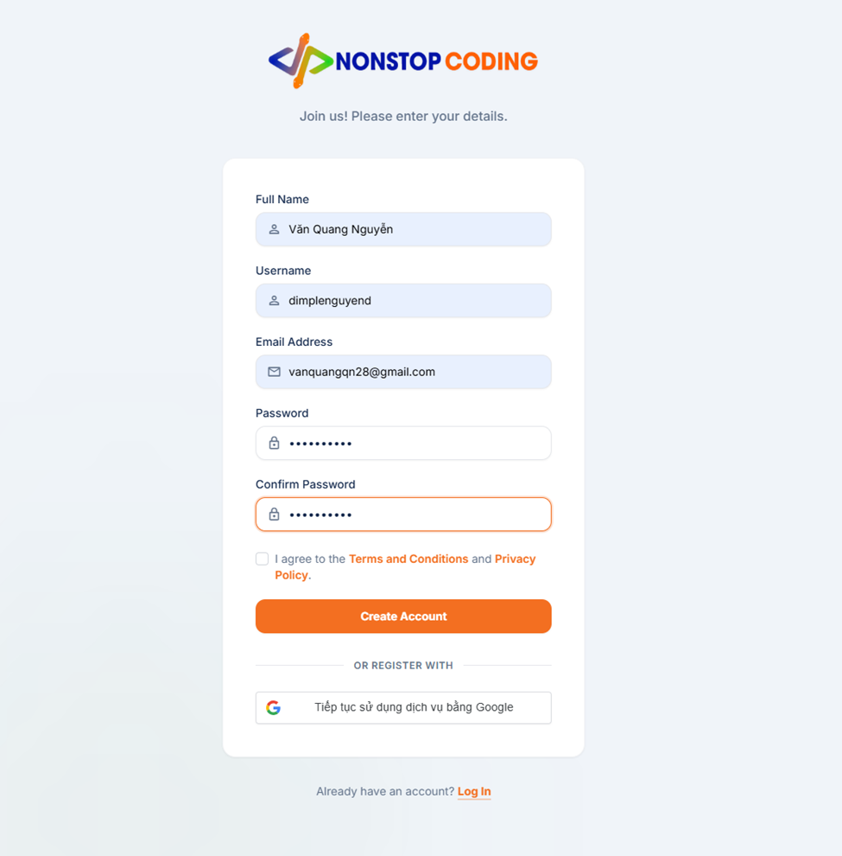

Field Name | Field Type | Description
Logo & Title | Image / Heading | Displays the platform logo: "NONSTOP CODING".
Subtitle | Text | Displays the instruction: "Join us! Please enter your details."
Full Name | Input field | Field to input the user's full name (mapped to displayname).
Username | Input field | Field to input a unique username.
Email Address | Input field | Field to input a valid email address.
Password | Input field (Password) | Field to input the account password.
Confirm Password | Input field (Password) | Field to re-enter the password for verification.
Terms & Privacy | Checkbox | A checkbox to confirm agreement with "Terms and Conditions" & "Privacy Policy".
Create Account | Button | The primary orange button to submit the registration form.
Register with Google | Button | A secondary button for quick sign-up using Google.
Log In | Link / Text | Text link: "Already have an account? Log In".

Database Access

Table | CRUD | Description
users | R | Check existence of username/email (using existsByUsername, existsByEmail).
roles | R | Retrieve default 'USER' role ID (roleRepository.findByName).
users | C | Insert user data (displayname, username, email, password_hash, status, avatarurl).
user_roles | C | Assign 'USER' role to the newly created account.
user_oauth_accounts | C | Insert OAuth provider details (Google).

SQL Statements

1. Normal Registration
Step 1.1: Check uniqueness
SELECT EXISTS (SELECT 1 FROM users WHERE username = ?);
SELECT EXISTS (SELECT 1 FROM users WHERE email = ?);
Step 1.2: Retrieve Role ID
SELECT id FROM roles WHERE name = 'USER';
Step 1.3: Insert Data
-- Insert User
INSERT INTO users (displayname, username, email, password_hash, status, created_at) VALUES (?, ?, ?, ?, 'ACTIVE', NOW()) RETURNING id;
-- Insert Role
INSERT INTO user_roles (user_id, role_id) VALUES (?, ?);

2. Google Registration
Step 2.1: Check unique username (generated from email)
SELECT EXISTS (SELECT 1 FROM users WHERE username = ?);
Step 2.2: Insert User, Role, and OAuth Link
-- Insert User
INSERT INTO users (displayname, username, email, avatarurl, status, created_at) VALUES (?, ?, ?, ?, 'ACTIVE', NOW()) RETURNING id;
-- Assign Role
INSERT INTO user_roles (user_id, role_id) VALUES (?, ?);
-- Store OAuth details
INSERT INTO user_oauth_accounts (user_id, provider, provider_user_id, created_at) VALUES (?, 'google', ?, NOW());

1.2 Login
Any user has account in the Platform, can access to the Platform by entering valid Username and password.

UI Design
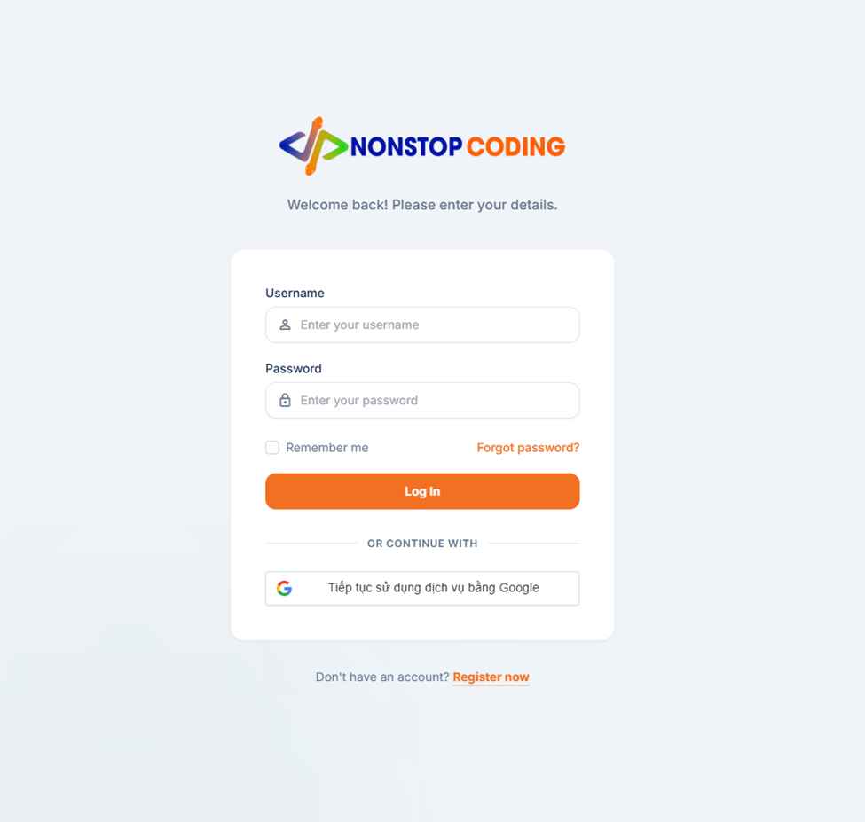

Field Name | Field Type | Description
Logo & Title | Image / Heading | Displays the platform logo: "NONSTOP CODING".
Subtitle | Text | Displays the instructional text: "Welcome back! Please enter your details."
Username | Input field | Field to input the user's registered username.
Password | Input field (Password) | Field to input the account password.
Remember me | Checkbox | Checkbox to persist the login session.
Forgot password? | Link / Text | Clickable link for password recovery.
Log In | Button | Primary button to submit credentials.
Continue with Google | Button | Secondary button for Google sign-in.
Register now | Link / Text | Text link: "Don't have an account? Register now".

Database Access
Table | CRUD | Description
users, wallets | R | Retrieve user info and wallet data via username (findByUsernameWithWallet).
user_oauth_accounts | R | Check if Google account is already linked (findByProviderAndProviderUserId).
users | R | Check if email exists for account linking if not previously linked (findByEmail).

SQL Statements

1. Normal Login (Verify via Username)
SELECT u.*, w.* FROM users u LEFT JOIN wallets w ON u.id = w.user_id
WHERE u.username = ?;
2. Google Authentication Logic
Step 2.1: Check if OAuth account is already linked
SELECT * FROM user_oauth_accounts WHERE provider = 'google' AND provider_user_id = ?;
Step 2.2: Link account if email exists (Case: Account not linked yet)
SELECT * FROM users WHERE email = ?;

1.3 Logout

UI Design
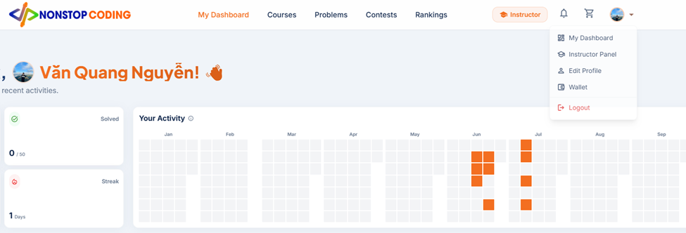
Log out of the Platform and securely invalidate the current session tokens (Access Token & Refresh Token) by adding them to a blacklist.

Field Name | Field Type | Description
User Avatar | Dropdown Trigger | A clickable profile picture in the top navigation bar to open the user menu.
My Dashboard | Menu Option | A navigation link to the user's main dashboard.
Instructor Panel | Menu Option | A navigation link to the instructor-specific management panel.
Edit Profile | Menu Option | A navigation link to update personal information.
Wallet | Menu Option | A navigation link to manage funds and transactions.
Logout | Menu Option / Button | A red-colored selectable option with an exit icon to terminate the session.

Database Access
Table | CRUD | Description
invalidated_tokens | R | Verify that the token has not already been invalidated (via existsByTokenJti).
invalidated_tokens | C | Insert JWT IDs (JTI) of both Access Token & Refresh Token into the blacklist.

SQL Statements

1. Security Filter: Verify token status before processing logout
SELECT id FROM invalidated_tokens WHERE token = ? FETCH FIRST 1 ROWS ONLY;
2. Logout Process: Invalidate Tokens
-- Invalidate Access Token
INSERT INTO invalidated_tokens (created_at, expiry_time, token) VALUES (?, ?, ?);
-- Invalidate Refresh Token
INSERT INTO invalidated_tokens (created_at, expiry_time, token) VALUES (?, ?, ?);

1.4 Forgot Password

1.5 View profile
Any user after login successfully can view their profile on the platform.

UI Design
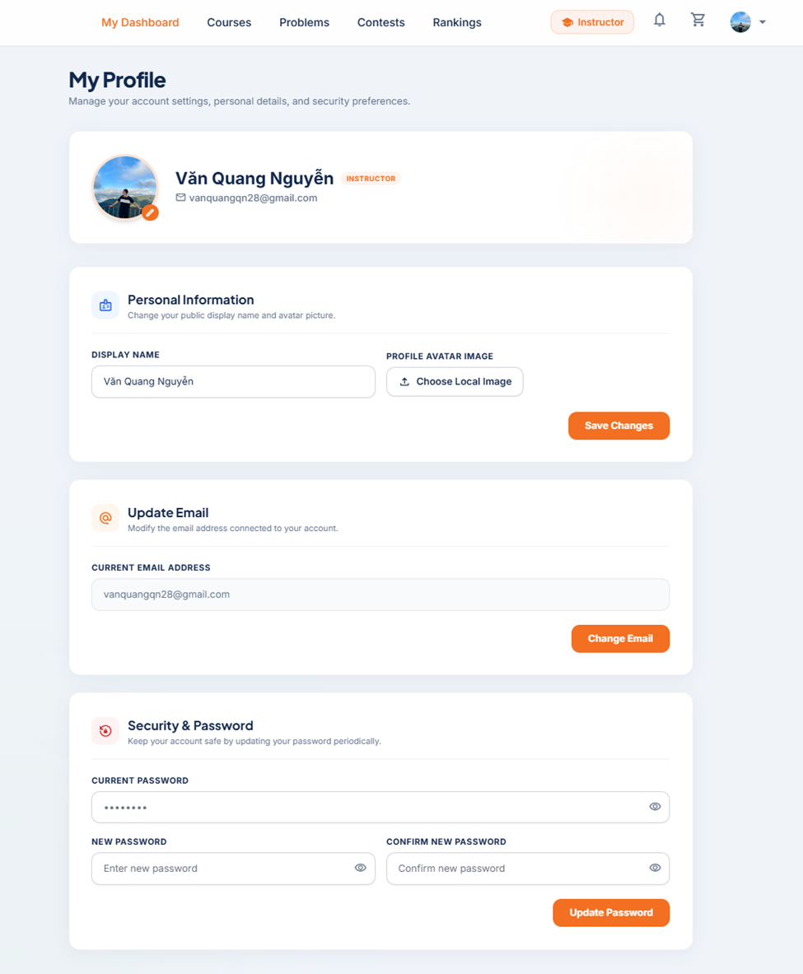

Field Name | Field Type | Description
Page Title | Heading | Displays "My Profile" and subtitle.
User Summary Card | Display Box | Shows the user's Avatar, Display Name, Role Badge, and Email at the top.
DISPLAY NAME | Input field | Pre-filled with the user's current display name.
CURRENT EMAIL ADDRESS | Input field | Pre-filled with the user's current email address.
CURRENT PASSWORD | Input field (Password) | Left blank for security reasons (only for updates).

Database Access
Table | CRUD | Description
users, roles, user_roles | R | Retrieve authenticated user's profile information and assigned roles by username.

SQL Statements

SELECT u.id, u.displayname, u.email, u.avatarurl, u.status, u.created_at, r.name as role_name FROM users u LEFT JOIN user_roles ur ON u.id = ur.user_id LEFT JOIN roles r ON ur.role_id = r.id WHERE u.username = ?;

1.6 Edit Personal Information
Allows the user to modify their public profile details (Display Name and Avatar) and save the changes to the system.

UI Design
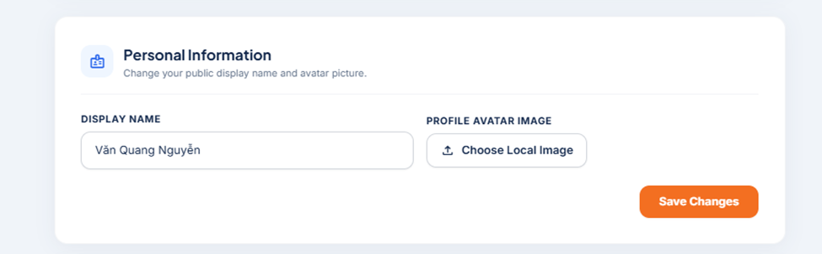

Field Name | Field Type | Description
DISPLAY NAME | Text Input | Field for the user to edit their current display name.
PROFILE AVATAR IMAGE | File Upload | Button to select and upload a new avatar image from the local device.
Save Changes | Button | Submits the new personal information to update the profile.

Database Access
Table | CRUD | Description
users | U | Update the displayname and avatarurl columns for the currently authenticated user.

SQL Statements

UPDATE users SET displayname = ?, avatarurl = ? WHERE id = ?;

1.7 Update Email

Allows the user to change their registered email address.

UI Design

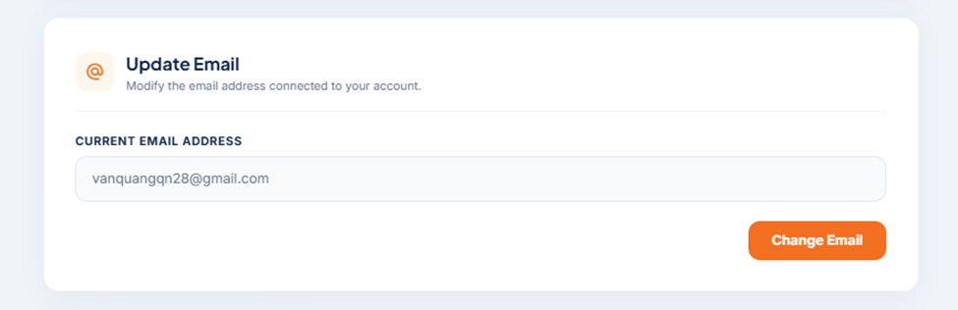
Field Name | Field Type | Description
CURRENT EMAIL ADDRESS | Text Input | Field for the user to input a new email address.
Change Email | Button | Submits the new email address to update the account.

Database Access
Table | CRUD | Description
users | R | Check if the new email already exists in the database to prevent duplicate accounts.
users | U | Update the email column for the currently authenticated user.

SQL Statements

1. Check for email duplication:

SELECT EXISTS (SELECT 1 FROM users WHERE email = ?);

2. Update to the new Email:

UPDATE users SET email = ? WHERE id = ?;

1.8. Change password

User can change their password if they want as long as they enter a valid old password.

UI Design

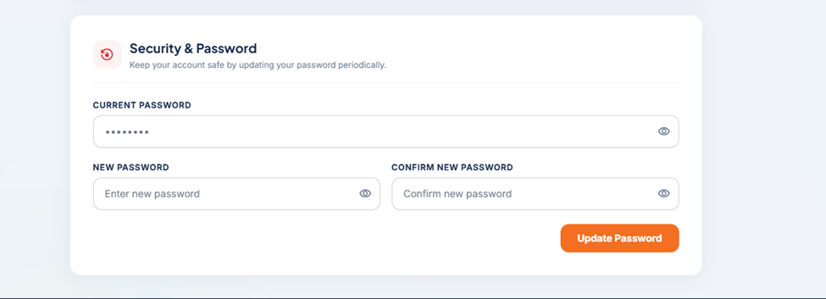

Field Name | Field Type | Description
Subtitle | Text | Instructional text: "Keep your account safe by updating your password periodically."
Current Password | Input field (Password) | Field to input the current account password for validation.
New Password | Input field (Password) | Field to enter the desired new password.
Confirm New Password | Input field (Password) | Field to re-type the new password for verification.
Update Password | Button | Primary orange button to submit and save the password update.

Database Access
Table | CRUD | Description
users | R | Retrieve authenticated user by username to verify the old password.
users | U | Update the password_hash column with the new, encoded password.

SQL Statements

1. Retrieve current user data

SELECT * FROM users WHERE username = ?;

2. Update password hash

UPDATE users SET password_hash = ? WHERE id = ?;

2. Guest UI

2.1 View Course List
Patient can book appoinment and don’t need to wait when patient come

UI Design

Field Name | Field Type | Description
Search Bar | Text Input | Input field to search for courses by keywords, topics, or titles.
Sort Filters | Dropdown | Allows sorting courses by Price, Rating, Popularity, or Release Date.
Category Tabs | Nav Links | Filters courses by categories (e.g., Web Development, Mobile Development).
Course Thumbnail | Image | Displays the visual cover image of the course (thumbnail_url).
Course Tags | Badges | Displays the level or category tags (e.g., General, Advanced).
Course Title | Text (Bold) | Displays the main title of the course.
Instructor Name | Text | Displays the display name of the course creator/instructor.
Rating & Reviews | Icon & Text | Displays the average_rating and total_reviews.
Enrolled Count | Icon & Text | Displays the number of students currently enrolled (total_enrolled).
Price | Text (Colored) | Displays the cost of the course in VND.
Add to Cart | Button (Icon) | The orange '+' button to add the course to the shopping cart.

Database Access
Table | CRUD | Description
courses | R | Retrieve list of courses with 'APPROVED' status, applying filters, search, and pagination.
users | R | Join with courses via instructor_id to retrieve the instructor's displayname.

SQL Statements

SELECT c.id,
c.thumbnail_url, c.title, c.short_description, c.price,c.average_rating, c.total_reviews,
c.total_enrolled,u.displayname AS instructor_name
FROM courses c
JOIN users u ON c.instructor_id = u.id
WHERE c.status = 'APPROVED'
AND (c.title ILIKE ? OR c.short_description ILIKE ?)
ORDER BY c.created_at DESC -- Varies based on Sort Dropdown selection
LIMIT ? OFFSET ?; -- Handles Pagination

2.2 View Course Detail
Allows users (including Guests) to view comprehensive information about a specific course, including its curriculum, requirements, and instructor details before making a purchase decision.

UI Design
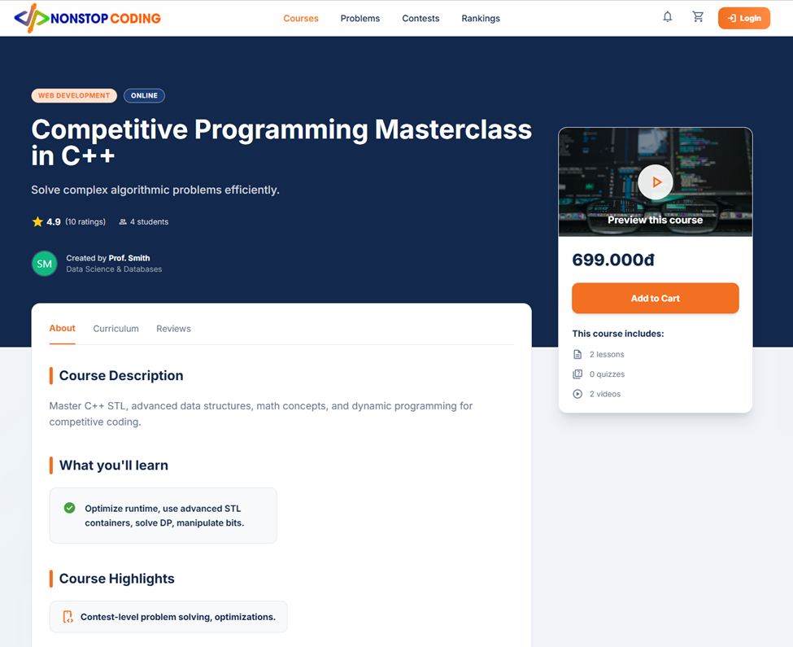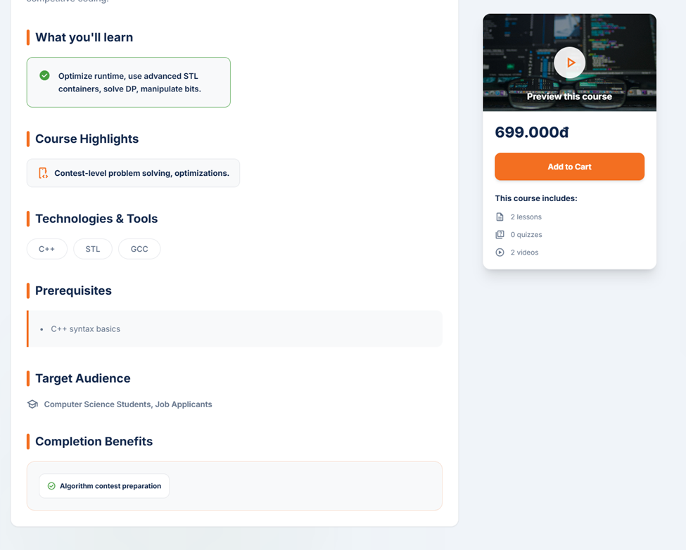
Field Name | Field Type | Description
Course Categories | Badges | Displays category or type tags (e.g., Web Development, Online).
Course Title | Main Heading | Displays the full title of the course (title).
Short Description | Text | A brief summary of the course's purpose (short_description).
Course Stats | Text & Icons | Displays average_rating, total ratings, and total_enrolled.
Instructor Info | Avatar & Text | Displays the course creator's avatar, name, and title.
Course Preview | Video/Image | A preview thumbnail or introductory video player.
Price | Text (Heading) | Displays the cost of the course (price).
Add to Cart | Button | The primary call-to-action button to add the course to the cart.
Course Includes | List | Displays aggregated course content stats (total_lessons, total_quizzes, total_videos).
Course Description | Text Block | Detailed information about the course (long_description).
What you'll learn | List (Boxed) | A checklist of skills students will acquire (what_you_learn).
Course Highlights | List (Boxed) | Key standout features of the course (course_highlight).

Database Access
Table | CRUD | Description
courses | R | Retrieve all detailed fields of the specific course by its ID.
users | R | Join with courses to fetch the instructor's displayname and avatarurl.

SQL Statements

SELECT
c.id,c.title,c.short_description,c.long_description,c.price,c.average_rating,
c.total_reviews,c.total_enrolled,c.total_lessons,c.total_quizzes,c.total_videos,
c.what_you_learn,c.course_highlight,c.technology_tool,c.prerequisites,
c.target_audience,c.completion_benefits,
u.displayname AS instructor_name,u.avatarurl AS instructor_avatar
FROM courses c
JOIN users u ON c.instructor_id = u.id
WHERE c.id = ?
AND c.status = 'APPROVED';

2.3 View Practice Problems (Online Judge)
Allows users to browse, search, and filter algorithmic coding challenges to practice and enhance their problem-solving skills.

UI Design
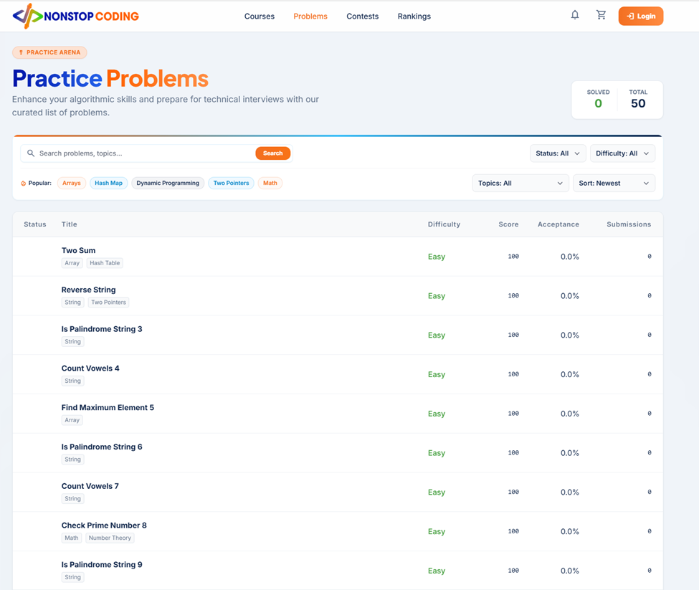
Field Name | Field Type | Description
Search Bar | Text Input | Input field to search for problems by title or keywords.
Status Filter | Dropdown | Filters problems by user's completion status (All, Solved, Unsolved).
Difficulty Filter | Dropdown | Filters problems by difficulty level (All, Easy, Medium, Hard).
Topics Filter | Dropdown | Filters problems by specific algorithm tags (e.g., Arrays, Math).
Sort By | Dropdown | Sorts the problem list (e.g., Newest, Highest Acceptance).
Problem Title | Text (Bold) | Displays the title of the coding problem.
Problem Tags | Badges | Displays the topics associated with the problem (e.g., String, Two Pointers).
Difficulty | Text (Colored) | Displays the difficulty level (e.g., green for Easy).
Score | Text | Displays the maximum points achievable for solving the problem.
Acceptance | Text (%) | Displays the percentage of successful submissions vs total submissions.
Submissions | Text | Displays the total number of times users have submitted code for this problem.

Database Access
Table | CRUD | Description
problems | R | Retrieve the list of active practice problems and their global statistics.
problem_versions | R | Join to fetch the latest text attributes (title, difficulty) via current_version_id.
problem_tags | R | Join via the mapping table to retrieve category tags.

SQL Statements

SELECT p.id, pv.title, pv.difficulty, p.score, p.total_accepted, p.total_submission FROM problems p JOIN problem_versions pv ON p.current_version_id = pv.id WHERE p.is_active = TRUE AND p.problem_scope = 'PRACTICE' AND (pv.title ILIKE ?) -- Handles the Search Bar input AND (pv.difficulty = ?) -- Handles the Difficulty Dropdown ORDER BY p.created_at DESC -- Handles the Sort Dropdown LIMIT ? OFFSET ?;

2.4 View Contests
Allows users to discover coding contests, view their rules, and see participant statistics. Contests are dynamically categorized into three time-based states: Ongoing, Upcoming, and Ended.

UI Design
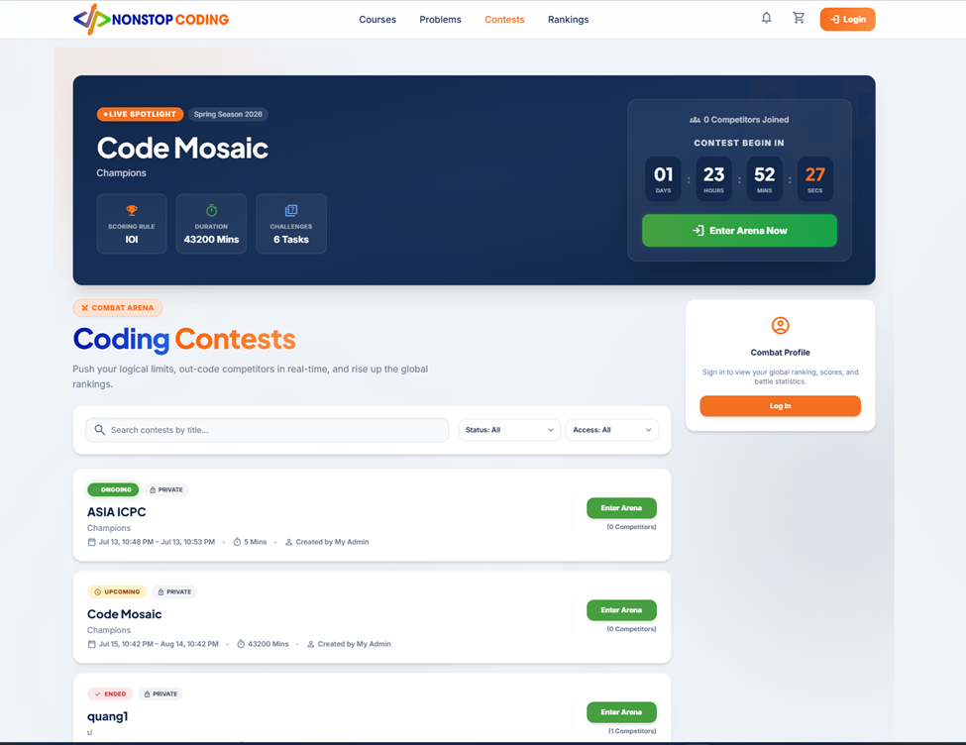
Field Name | Field Type | Description
Live Spotlight (Banner) | Text (Heading) | Displays the featured contest's title and description.
Scoring Rule | Icon & Text | Displays the evaluation format (e.g., IOI, ICPC).
Duration & Tasks | Icon & Text | Displays the total durations (mins) and total tasks.
Countdown Timer | Dynamic Timer | Calculates time remaining until start_time or end_time.
Search & Filters | Inputs & Dropdowns | Filter contests by title, time status, and privacy access.
Dynamic Time Status | Badge (Colored) | Shows ONGOING, UPCOMING, or ENDED status.
Access Tag | Badge | Indicates if the contest is PUBLIC or PRIVATE.
Time Range | Text | Displays the formatted start_time and end_time.
Creator Name | Text | Displays the admin or user who created the contest.
Enter Arena | Button | Primary action button to view contest details or join.

Database Access
Table | CRUD | Description
contest | R | Retrieve published contests, deriving the time state dynamically.
users | R | Join with contest via created_by to retrieve the creator's name.
contest_participants | R | Count the total number of users who have joined each contest.

SQL Statements

SELECT c.id,c.title, c.description,c.start_time, c.end_time, c.durations,
-- 1. Determine Access Type (Based on password)
CASE
WHEN c.password_hash IS NOT NULL THEN 'PRIVATE'
ELSE 'PUBLIC' END AS access_type,
-- 2. Determine Dynamic Time Status (Based on current time)
CASE
WHEN CURRENT_TIMESTAMP < c.start_time THEN 'UPCOMING'
WHEN CURRENT_TIMESTAMP BETWEEN c.start_time AND c.end_time THEN 'ONGOING'
ELSE 'ENDED'
END AS time_status,
u.displayname AS creator_name,
(SELECT COUNT(*) FROM contest_participants cp WHERE cp.contest_id = c.id) AS total_competitors
FROM public.contest c
JOIN public.users u ON c.created_by = u.id
WHERE c.status = 'PUBLISHED'
AND c.title ILIKE ?
ORDER BY c.start_time
DESC LIMIT ? OFFSET ?;

2.5 View Contest Overview
Allows users (including Guests) to view the detailed rules, schedule, and scoring system of a specific contest. Guests are prompted to log in if they wish to register and participate.

UI Design
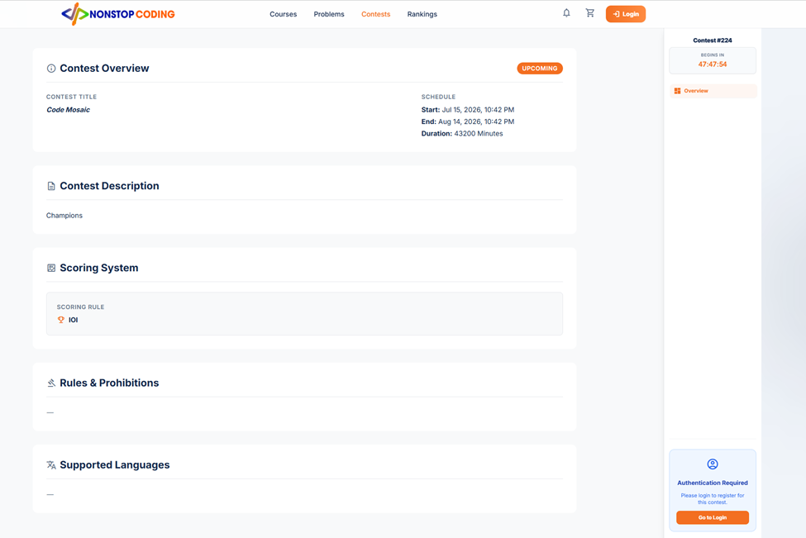

Field Name | Field Type | Description
Contest Overview | Section | Displays the title, formatted start_time, end_time, and durations.
Time Status | Badge | Dynamically displays UPCOMING, ONGOING, or ENDED based on the schedule.
Contest Description | Text Block | Displays the rich text description of the contest.
Scoring System | Section | Displays the evaluation rule (e.g., IOI, ICPC) from scoring_rule.
Rules & Prohibitions | Text Block | Displays specific guidelines for the contest.
Supported Languages | Text Block | Displays programming languages allowed.
Contest ID | Text | Displays the unique database ID of the contest (e.g., Contest #224).
Countdown Timer | Dynamic Timer | Calculates the remaining time until the contest begins or ends.
Navigation Menu | Links | Menu to switch between Overview, Problems, Submissions, etc.
Auth Prompt | Alert Box | Prompts the Guest to log in with a "Go to Login" button.

Database Access
Table | CRUD | Description
contest | R | Retrieve specific details (description, schedule, scoring rule) by ID and calculate dynamic time status.

SQL Statements

SELECT id,
title, description, scoring_rule, start_time, end_time, durations,
-- Calculate the dynamic status badge for the UI
CASE
WHEN CURRENT_TIMESTAMP < start_time THEN 'UPCOMING'
WHEN CURRENT_TIMESTAMP BETWEEN start_time AND end_time THEN 'ONGOING'
ELSE 'ENDED'
END AS time_status FROM public.contest WHERE id = ? AND status = 'PUBLISHED';

3. Customer UI

3.1 Student Dashboard
View learning progress, practice statistics, and monitor personal activities on the Platform.
UI Design
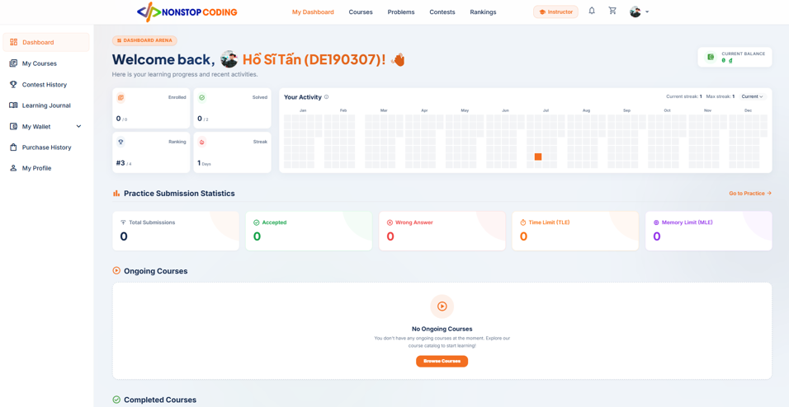

Field Name | Field Type | Description
Full Name & Student ID | Label / Text | Displays the welcome message along with the current user's display name and ID (e.g., Welcome back, Hồ Sĩ Tấn (DE190307)!).
Current Balance | Label / Number | Displays the current available balance in the student's e-wallet.
Enrolled | Label / Number | The total number of active courses the student is currently enrolled in.
Solved | Label / Number | The total number of programming problems the student has successfully solved (Verdict = 'ACCEPTED').
Ranking | Label / Number | The student's current global ranking based on their accumulated score.
Streak | Label / Number | The number of consecutive days the student has made a code submission.
Your Activity (Heatmap) | Chart / Graphic | A heatmap chart illustrating the frequency of the student's code submissions over the past year.
Total Submissions | Label / Number | The total number of code submissions made by the student to the Judge0 system.
Accepted | Label / Number | The total number of submissions that passed all test cases.
Wrong Answer | Label / Number | The total number of submissions that produced incorrect outputs or logic errors.
Time Limit (TLE) | Label / Number | The total number of submissions that exceeded the allowed execution time limit.
Memory Limit (MLE) | Label / Number | The total number of submissions that exceeded the allowed memory limit.
Field Name | Field Type | Description

Database Access
Table | CRUD | Description
users | R | Retrieving the user's displayname, avatarurl, and calculating the global ranking based on the score column.
wallets | R | Retrieving the current balance of the logged-in user.
enrollments | R | Counting the total number of courses the user is actively participating in (status = 'ACTIVE').
problem_submissions | R | Counting total submissions, categorizing them by verdict (Accepted, Wrong Answer, TLE, MLE), and grouping by submitted_at for the heatmap chart.

SQL Statements
1. Retrieving user's profile and wallet balance
SELECT u.displayname, u.avatarurl, w.balance FROM users u LEFT JOIN wallets w ON u.id = w.user_id WHERE u.id = ?
2. Retrieving global ranking based on score
SELECT RANK() OVER (ORDER BY score DESC) as rank FROM users WHERE id = ?
3. Counting active enrolled courses
SELECT COUNT(id) FROM enrollments WHERE user_id = ? AND status = 'ACTIVE'
4. Retrieving practice submission statistics
SELECT verdict, COUNT(*) FROM problem_submissions WHERE user_id = ? GROUP BY verdict
5. Retrieving activity data for the Heatmap
SELECT DATE(submitted_at), COUNT(*) FROM problem_submissions WHERE user_id = ? GROUP BY DATE(submitted_at)

3.2 My Courses
Track your progress, manage your certifications, and continue learning.
UI Design
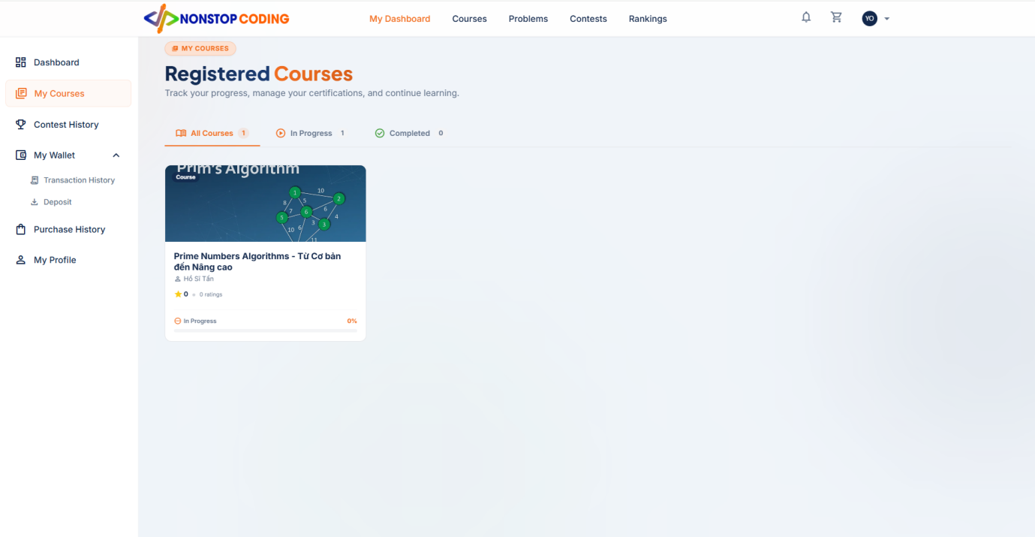

Field Name | Field Type | Description
All Courses (Tab) | Button / Link | Displays all registered courses regardless of their completion status.
In Progress (Tab) | Button / Link | Filters and displays only courses where the student has started learning but hasn't finished.
Completed (Tab) | Button / Link | Filters and displays only courses that the student has fully completed.
Course Thumbnail | Image | A graphical representation or cover image of the enrolled course.
Course Title | Label / Text | The full name of the course (e.g., Prime Numbers Algorithms - Từ Cơ bản đến Nâng cao).
Instructor Name | Label / Text | The full name of the instructor who teaches this course.
Rating | Label / Number | The average star rating and the total number of reviews submitted by students for this course.
Progress Status | Label / Text | Indicates the current status of the course (e.g., In Progress, Completed).
Progress Bar (%) | UI Graphic | A visual indicator calculating the percentage of completion based on finished lessons vs total lessons.

Database Access
Table | CRUD | Description
enrollments | R | Fetching the list of enrolled courses for the current user and filtering by status (ACTIVE or COMPLETED).
courses | R | Retrieving the course's title, thumbnail_url, average_rating, total_reviews, and total_lessons.
instructors | R | Fetching the full_name of the instructor mapped via instructor_id in the courses table.
completed_lessons_count | R | Retrieving the total number of completed lessons by the user to calculate the Progress Percentage.

SQL Statements
1. Retrieving all enrolled courses with instructor details
SELECT c.title, c.thumbnail_url, c.average_rating, c.total_reviews, i.full_name, e.status
FROM enrollments e
INNER JOIN courses c ON e.course_id = c.id
INNER JOIN instructors i ON c.instructor_id = i.id
WHERE e.user_id = ?;
2. Filtering enrolled courses by Status (e.g., In Progress / ACTIVE)
SELECT c.title, c.thumbnail_url, i.full_name
FROM enrollments e
INNER JOIN courses c ON e.course_id = c.id
INNER JOIN instructors i ON c.instructor_id = i.id
WHERE e.user_id = ? AND e.status = 'ACTIVE';
3. Calculating Course Progress Percentage
SELECT (clc.completed_lessons_count * 100.0 / c.total_lessons) AS progress_percentage
FROM completed_lessons_count clc
INNER JOIN courses c ON clc.course_id = c.id
WHERE clc.user_id = ? AND clc.course_id = ?;

3.3 Contest History
Track your competitive coding journey, review points, and view past contest standings.
UI Design
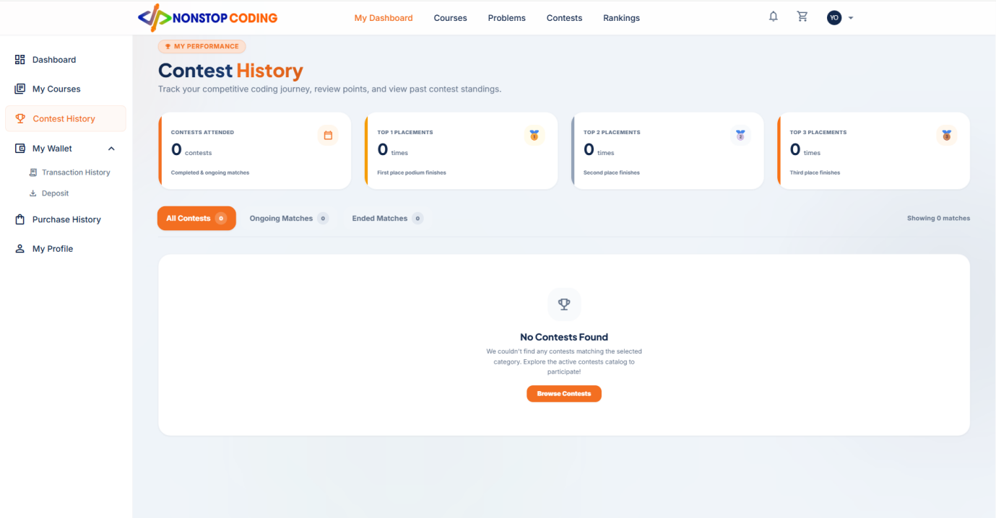

Database Access
Table | CRUD | Description
contest_participants | R | Counting the total number of contests the user is registered in to display Contests Attended.
contest | R | Fetching the contest details (title, start_time, end_time) and determining its active status by comparing end_time with the current time.
contest_rankings | R | Querying the ranking table to calculate the user's relative position (Rank) by comparing problems_solved and total_penalty against other participants in the same contest.

1. Retrieving total contests attended by the user
SELECT COUNT(*)
FROM contest_participants
WHERE user_id = ?;
2. Fetching user's placements (Top 1, Top 2, Top 3) in all attended contests
SELECT user_rank, COUNT(*) as placement_count
FROM (
SELECT user_id,
RANK() OVER(PARTITION BY contest_id ORDER BY problems_solved DESC, total_penalty ASC) as user_rank
FROM contest_rankings
) ranked_contests
WHERE user_id = ? AND user_rank <= 3
GROUP BY user_rank;
3. Retrieving Ongoing Matches for the current user:
SELECT c.title, c.start_time, c.end_time
FROM contest_participants cp
INNER JOIN contest c ON cp.contest_id = c.id
WHERE cp.user_id = ? AND c.end_time > CURRENT_TIMESTAMP;
4. Retrieving Ended Matches for the current user
SELECT c.title, c.start_time, c.end_time
FROM contest_participants cp
INNER JOIN contest c ON cp.contest_id = c.id
WHERE cp.user_id = ? AND c.end_time <= CURRENT_TIMESTAMP;

3.4 Transaction History
View your current wallet balance and review detailed records of all deposits, purchases, and internal transfers.
UI Design
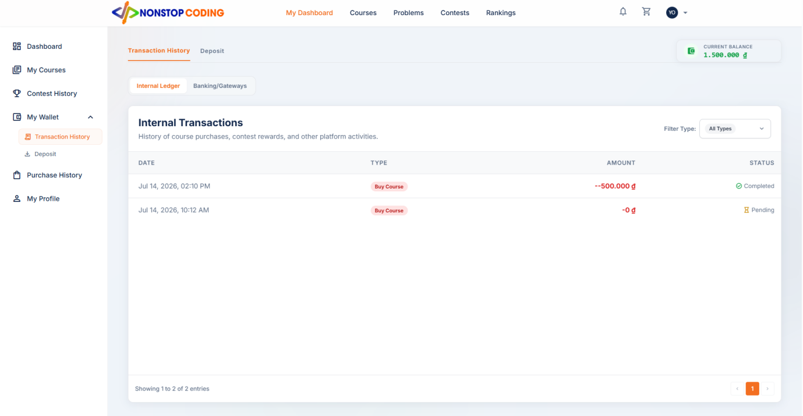

Field Name | Field Type | Description
Current Balance | Label / Number | Displays the current available balance (in VND) in the student's e-wallet.
Internal Ledger (Tab) | Button / Link | Filters the transaction list to show internal activities such as course purchases and contest rewards.
Banking/Gateways (Tab) | Button / Link | Filters the transaction list to show external fiat transactions such as deposits and withdrawals.
Filter Type | Dropdown | Allows users to filter transactions by specific types (e.g., Buy Course, Deposit, Refund, All Types).
Date | Label / DateTime | The exact date and time when the transaction occurred or was initiated.
Type | Label / Text | The category of the transaction (e.g., Buy Course, Deposit, Award).
Amount | Label / Number | The monetary value of the transaction. Negative values indicate deductions (purchases), positive values indicate additions (deposits).
Status | Label / Text | The current status of the transaction (e.g., Completed, Pending, Failed).

Database Access
Table | CRUD | Description
wallets | R | Fetching the current balance of the e-wallet belonging to the logged-in user.
wallet_transactions | R | Retrieving records for the "Internal Ledger" tab, including created_at, type, amount, and status.
payment_transactions | R | Retrieving records for the "Banking/Gateways" tab, including created_at, type, amount, and status.

SQL Statements
1. Retrieving current wallet balance
SELECT balance
FROM wallets
WHERE user_id = ?;
2. Retrieving Internal Ledger transactions (with optional Type filter)
SELECT created_at, type, amount, status
FROM wallet_transactions
WHERE wallet_id = (SELECT id FROM wallets WHERE user_id = ?)
-- AND type = ? (If a specific filter is selected in the dropdown)
ORDER BY created_at DESC;
3. Retrieving Banking/Gateways transactions
SELECT created_at, transaction_code, type, amount, status
FROM payment_transactions
WHERE wallet_id = (SELECT id FROM wallets WHERE user_id = ?)
ORDER BY created_at DESC;

3.5 Deposit
Top up your wallet balance by generating a dynamic payment QR code for quick banking transfers.
UI Design
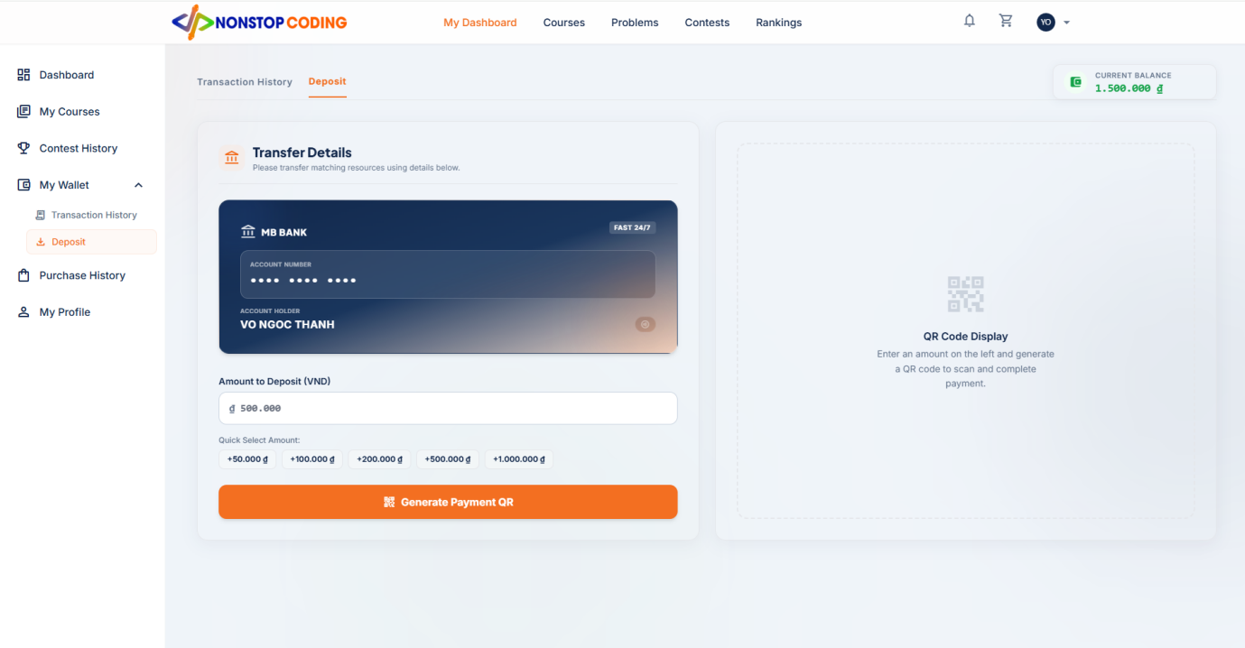

Field Name | Field Type | Description
Current Balance | Label / Number | Displays the current available balance (in VND) in the student's e-wallet.
Transfer Details Card | UI Graphic | A visual representation of the receiving bank account (e.g., MB Bank) including the masked Account Number and Account Holder name.
Amount to Deposit | Input / Number | A text field where the user can manually enter the specific amount of money they want to deposit.
Quick Select Amount | Button Group | Pre-defined preset buttons (e.g., +50k, +100k, +200k, etc.) to quickly populate the Amount input field.
Generate Payment QR | Button | Triggers the API call to the Payment Gateway (PayOS) to generate a unique transaction session.
QR Code Display | Image / Placeholder | Displays the generated VietQR code for the user to scan with their banking application.

Database Access
Table | CRUD | Description
wallets | R | Fetching the current balance of the e-wallet belonging to the logged-in user to display on the top right.
payment_transactions | C | Inserting a new transaction record with status = 'PENDING' when the user clicks Generate Payment QR.

SQL Statements
1. Retrieving current wallet balance
SELECT balance
FROM wallets
WHERE user_id = ?;
2. Creating a new Pending transaction when generating QR Code
INSERT INTO payment_transactions (amount, wallet_id, created_at, transaction_code, status, type)
VALUES (?, (SELECT id FROM wallets WHERE user_id = ?), CURRENT_TIMESTAMP, ?, 'PENDING', 'DEPOSIT')
RETURNING id;

3.6 Purchase History
Keep track of your course investments, invoices and payments.
UI Design

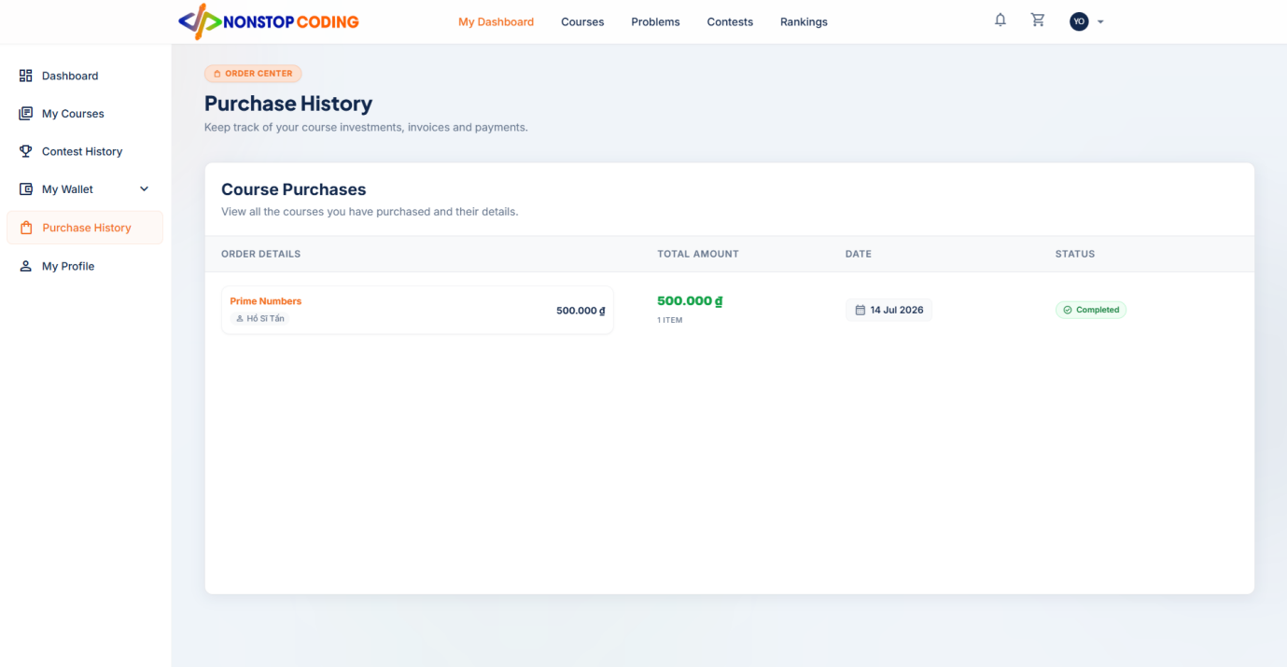

Field Name | Field Type | Description
Order Details | UI Block | A section displaying the individual courses within a specific order, including the course title, instructor's name, and the specific price of that course.
Total Amount | Label / Number | The final total price of the entire order (in VND) and the total number of items (courses) included in the invoice.
Date | Label / DateTime | The exact date when the purchase was successfully made.
Status | Label / Text | The current status of the order (e.g., Completed, Pending, Failed).

Database Access
Table | CRUD | Description
orders | R | Fetching the main invoice details including total_amount, created_at (Date), and status for the logged-in user.
order_items | R | Retrieving the specific items within an order to calculate the item count and fetch individual prices.
courses | R | Fetching the title of the purchased course mapped from the course_id in order_items.
instructors | R | Fetching the full_name of the instructor who teaches the purchased course.

SQL Statements
1. Retrieving Purchase History (Orders & Total Items count)
SELECT o.id as order_id, o.total_amount, o.created_at, o.status, COUNT(oi.id) as total_items
FROM orders o
LEFT JOIN order_items oi ON o.id = oi.order_id
WHERE o.user_id = ?
GROUP BY o.id, o.total_amount, o.created_at, o.status
ORDER BY o.created_at DESC;
2. Retrieving Order Details (Specific courses within an order)
SELECT c.title, i.full_name as instructor_name, oi.price
FROM order_items oi
INNER JOIN courses c ON oi.course_id = c.id
INNER JOIN instructors i ON c.instructor_id = i.id
WHERE oi.order_id = ?;

3.7 My Profile
Manage your account settings, personal details, and security preferences.
UI Design
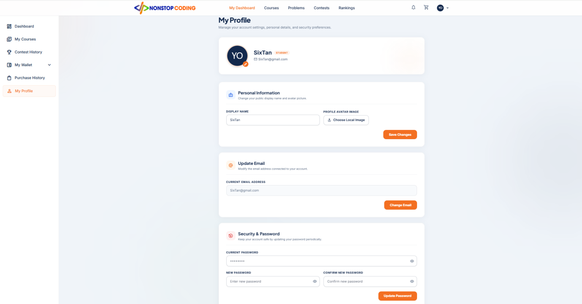

Field Name | Field Type | Description
Profile Header Card | UI Block | A summary card displaying the user's current Avatar, Display Name, Role badge (e.g., STUDENT), and connected Email.
Display Name | Input / Text | A text field where the user can update their public display name shown across the platform.
Profile Avatar Image | File Upload | Allows the user to select and upload a new image from their local device to change their avatar.
Save Changes | Button | Submits the updated Display Name and Avatar to the server.
Current Email Address | Input / Email | A text field where the user can request to change their primary email address.
Change Email | Button | Initiates the email change process (often involves sending an OTP or verification link).
Current Password | Input / Password | Requires the user to enter their current password to authenticate before making security changes.
New Password | Input / Password | The new password the user wishes to set.
Confirm New Password | Input / Password | Re-enter the new password to prevent typos.
Update Password | Button | Submits the new password payload and updates the encrypted password_hash in the database if the current password matches.

Database Access
Table | CRUD | Description
users | R, U | Read: Fetching displayname, email, avatarurl, and role name for the Profile Header.

SQL Statements
1. Retrieving current user profile data
SELECT displayname, email, avatarurl
FROM users
WHERE id = ?;
2. Updating Personal Information (Display Name & Avatar)
UPDATE users
SET displayname = ?, avatarurl = ?, updated_at = CURRENT_TIMESTAMP
WHERE id = ?;
3. Updating Email Address
UPDATE users
SET email = ?, updated_at = CURRENT_TIMESTAMP
WHERE id = ?;
4. Updating Password (after verifying Current Password matches hash)
UPDATE users
SET password_hash = ?, updated_at = CURRENT_TIMESTAMP
WHERE id = ?;

3.8 Course Learning - Theory Content
Read detailed textual explanations and theoretical concepts for the current lesson.
UI Design
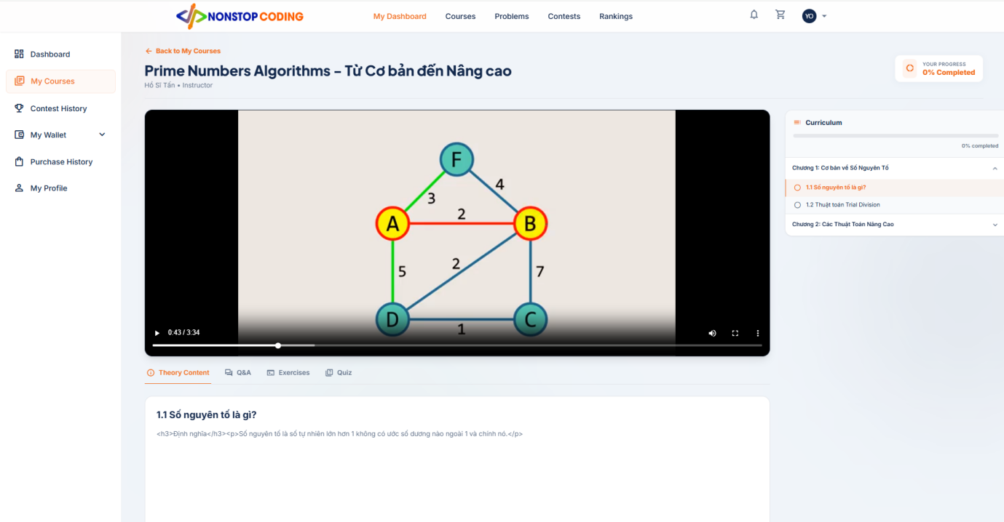

Field Name | Field Type | Description
Theory Content Tab | Button / Link | The navigation tab to switch the view to theoretical reading materials.
Lesson Title | Label / Text | Displays the title of the currently selected lesson (e.g., 1.1 Số nguyên tố là gì?).
Theory Text Block | Rich Text | Renders the HTML content or plain text fetched from the database containing definitions, formulas, and explanations.
Database Access
Table | CRUD | Description
lessons | R | Fetching the title and theory_content associated with the currently active lesson_id.

SQL Statements
1. Retrieving Theory Content for the current Lesson
SELECT title, theory_content
FROM lessons
WHERE id = ?;

3.9 Course Learning - Q&A
Engage with instructors and peers by asking questions and sharing thoughts about the lesson.
UI Design
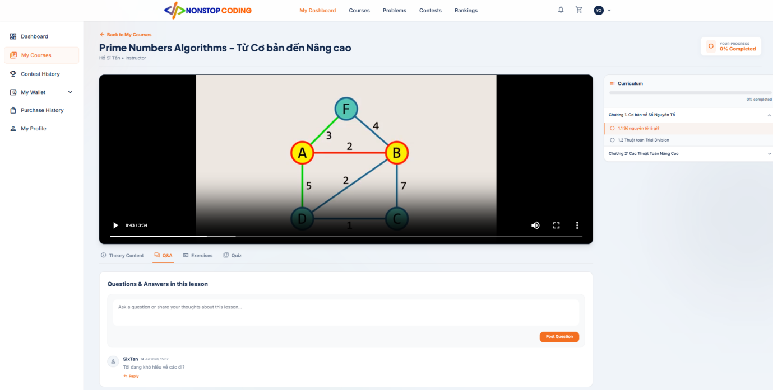

Field Name | Field Type | Description
Comment Input Area | Textarea | A text input box where the user can type their questions or thoughts regarding the current lesson.
Post Question | Button | Submits the content in the text area to the database as a new top-level comment.
User Avatar & Name | Image & Label | Displays the profile picture and display name of the user who posted the comment (e.g., SixTan).
Timestamp | Label / DateTime | Shows the exact date and time when the comment was posted (e.g., 14 Jul 2026, 15:07).
Comment Content | Text | The actual text or question posted by the user.
Reply | Button / Link | Opens a nested input field allowing users to reply directly to a specific comment, creating a threaded conversation.

Database Access
Table | CRUD | Description
lesson_comments | R, C | Read: Fetching all comments and replies (parent_comment_id) associated with the current lesson_id.  Create: Inserting a new record into lesson_comments when the user posts a question or replies to an existing one.
users | R | Fetching the displayname and avatarurl of the users who authored the comments.

SQL Statements
1. Retrieving all comments for the current lesson (ordered by newest first)
SELECT lc.id, lc.content, lc.created_at, lc.parent_comment_id, u.displayname, u.avatarurl
FROM lesson_comments lc
INNER JOIN users u ON lc.user_id = u.id
WHERE lc.lesson_id = ?
ORDER BY lc.created_at DESC;
2. Posting a new question (Top-level comment)
INSERT INTO lesson_comments (lesson_id, user_id, content, created_at, updated_at)
VALUES (?, ?, ?, CURRENT_TIMESTAMP, CURRENT_TIMESTAMP);
3. Replying to an existing comment (Nested comment)
INSERT INTO lesson_comments (lesson_id, user_id, parent_comment_id, content, created_at, updated_at)
VALUES (?, ?, ?, ?, CURRENT_TIMESTAMP, CURRENT_TIMESTAMP);

3.10 Course Learning - Exercises
Solve these algorithmic challenges to solidify your understanding of the lesson.
UI Design
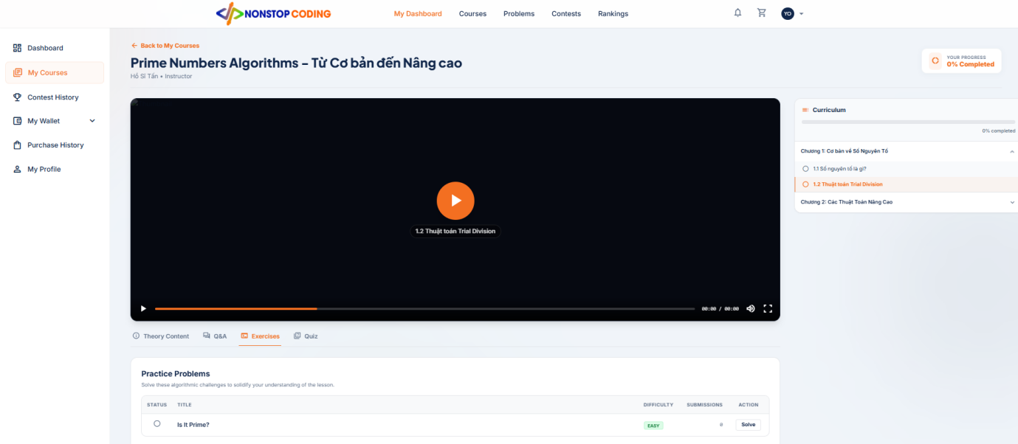

Field Name | Field Type | Description
Practice Problems List | Table | A table listing all algorithmic coding challenges associated with the current lesson.
Status Indicator | UI Graphic | An icon (e.g., empty circle, green checkmark) indicating whether the student has successfully solved the problem.
Problem Title | Label / Text | The name of the coding problem (e.g., Is It Prime?).
Difficulty | Badge | A colored badge indicating the difficulty level of the problem (e.g., EASY, MEDIUM, HARD).
Submissions | Label / Number | The total number of times the student has submitted code for this specific problem.
Action (Solve) | Button | Navigates the user to the coding workspace (IDE) to read the problem description and write their code.

Database Access
Table | CRUD | Description
lesson_problems | R | Fetching the mapping to see which problems belong to the current lesson_id.
problem_versions | R | Fetching the actual details of the problem including title and difficulty level.
problem_submissions | R | Read: Counting the total number of submissions made by the user, and checking if any submission has verdict = 'ACCEPTED' to update the Status Indicator.

SQL Statements
1. Retrieving the list of problems for the current lesson
SELECT pv.id as problem_version_id, pv.title, pv.difficulty
FROM lesson_problems lp
INNER JOIN problem_versions pv ON lp.problem_version_id = pv.id
WHERE lp.lesson_id = ?
ORDER BY lp.order_index ASC;
2. Calculating User Submissions and Solved Status for a specific problem
SELECT
COUNT(id) as total_submissions,
BOOL_OR(verdict = 'ACCEPTED') as is_solved
FROM problem_submissions
WHERE problem_version_id = ? AND user_id = ?;

3.11 Course Learning - Quiz
Test your understanding of the lesson through interactive multiple-choice questions and view detailed attempt results.
UI Design

Field Name | Field Type | Description
Results Banner | UI Block | A colored banner displaying the result of the latest attempt (e.g., Green for passing/perfect score).
Quiz Title | Label / Text | The title of the specific quiz for this lesson (e.g., Kiểm tra kiến thức cơ bản).
Submission Time | Label / DateTime | The exact time when the user submitted their most recent quiz attempt.
Score & Correct Answers | Label / Number | Displays the final percentage score (e.g., 100.0%) and the ratio of correct answers (e.g., 1/1).
Retake Quiz | Button | Allows the user to reset their answers and take the quiz again.
Question Text | Label / Text | The main content of the multiple-choice question.
Options List | Radio Buttons | A list of possible answers for the question. The selected option is highlighted.
Correct/Wrong Badge | UI Graphic | A visual indicator showing whether the chosen option was the correct answer.

Database Access
Table | CRUD | Description
quizzes | R | Fetching the quiz title associated with the current lesson_id.
quiz_attempts | R, C | Read: Fetching the latest score, correct_question, total_question, and submitted_at.  Create: Saving a new attempt record when the user submits their answers.
quiz_questions | R | Fetching the list of questions (question_text) belonging to the specific quiz_id.
quiz_options | R | Fetching the multiple-choice options (option_text) and determining which one is is_correct.

SQL Statements
1. Retrieving Quiz and Latest Attempt Results:
SELECT q.title, qa.score, qa.correct_question, qa.total_question, qa.submitted_at
FROM quizzes q
LEFT JOIN quiz_attempts qa ON q.id = qa.quiz_id AND qa.user_id = ?
WHERE q.lesson_id = ?
ORDER BY qa.submitted_at DESC
LIMIT 1;
2. Retrieving Quiz Questions and Options:
SELECT qq.id as question_id, qq.question_text, qo.id as option_id, qo.option_text, qo.is_correct
FROM quiz_questions qq
INNER JOIN quiz_options qo ON qq.id = qo.question_id
WHERE qq.quiz_id = ?;
3. Saving a new Quiz Attempt:
INSERT INTO quiz_attempts (quiz_id, user_id, score, correct_question, total_question, created_at, submitted_at, updated_at)
VALUES (?, ?, ?, ?, ?, CURRENT_TIMESTAMP, CURRENT_TIMESTAMP, CURRENT_TIMESTAMP)
RETURNING id;

3.12 Coding Workspace (IDE)
Read problem requirements, write code in multiple languages, and submit solutions for automated testing.
UI Design
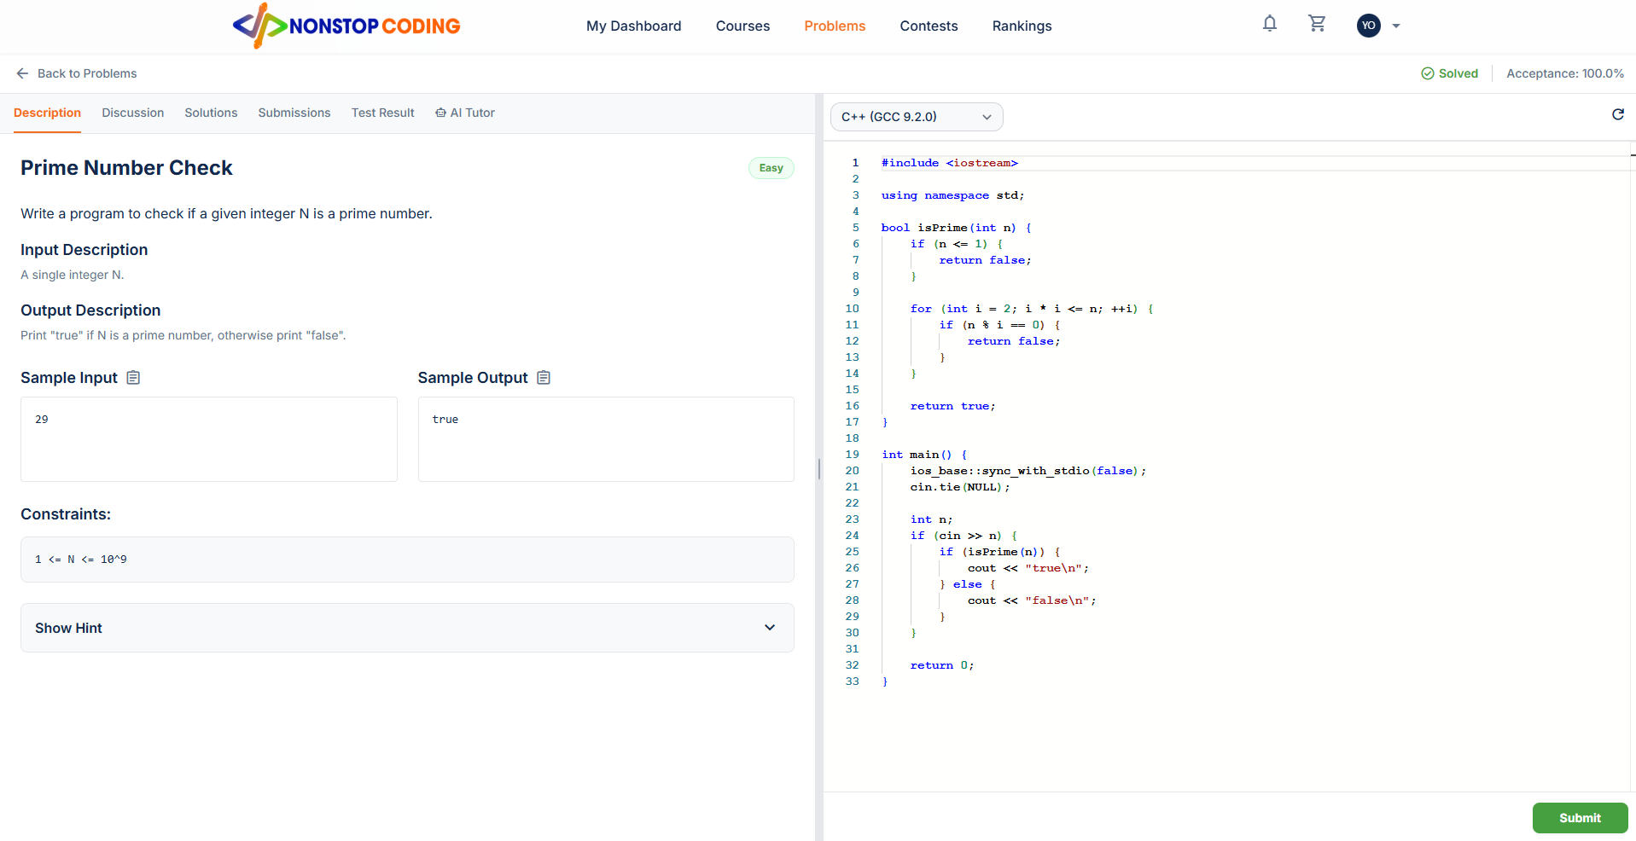

Field Name | Field Type | Description
Status & Acceptance | Label / Text | Displays whether the user has previously solved the problem (e.g., Solved) and the global acceptance rate.
Tabs Navigation | Button Group | Switches the left pane view between Description, Discussion, Solutions, Submissions, Test Result, and AI Tutor.
Problem Title & Badge | Label / Text | The name of the coding problem (e.g., Prime Number Check) and its difficulty badge (e.g., Easy).
Problem Description | Rich Text | Detailed explanation of the problem, including Input/Output formatting rules.
Sample I/O | Text Block | Example test cases provided to the user to understand the expected input and output formats.
Constraints & Hints | Text / Accordion | Boundary conditions for the variables and optional hints to guide the user's logic.
Language Selector | Dropdown | Allows the user to choose their preferred programming language environment (e.g., C++, Java, Python).
Code Editor | Monaco IDE Component | A built-in code editor with syntax highlighting where the user writes their algorithm.
Submit | Button | Sends the written source code to the remote grading server (Judge0) for compilation and execution against hidden test cases.

Database Access
Table | CRUD | Description
problems | R | Fetching global statistics (total_accepted and total_submission) to calculate the Acceptance Rate.
problem_versions | R | Fetching the active version of the problem, including title, description, input_description, output_description, example_input, example_output, constraints, hint, and difficulty.
problem_submissions | R, C | Read: Checking if the current user has any ACCEPTED submissions to display the "Solved" status.

SQL Statements
1. Retrieving Problem Content and Global Acceptance Rate
SELECT pv.title, pv.difficulty, pv.description, pv.input_description, pv.output_description,
pv.example_input, pv.example_output, pv.constraints, pv.hint,
(p.total_accepted * 100.0 / NULLIF(p.total_submission, 0)) AS acceptance_rate
FROM problem_versions pv
INNER JOIN problems p ON pv.problem_id = p.id
WHERE pv.id = ? AND pv.is_active = TRUE;
2. Checking if the user has already solved this problem
SELECT EXISTS (
SELECT 1
FROM problem_submissions
WHERE problem_version_id = ? AND user_id = ? AND verdict = 'ACCEPTED'
) as is_solved;
3. Saving a new Code Submission (When clicking Submit)
INSERT INTO problem_submissions (problem_id, problem_version_id, user_id, language_id, source_code, verdict, submitted_at)
VALUES (?, ?, ?, ?, ?, 'PENDING', CURRENT_TIMESTAMP)
RETURNING id;

3.13 Coding Workspace - Discussion
Engage with the community by asking questions, sharing hints, or discussing approaches to solve the problem.
UI Design
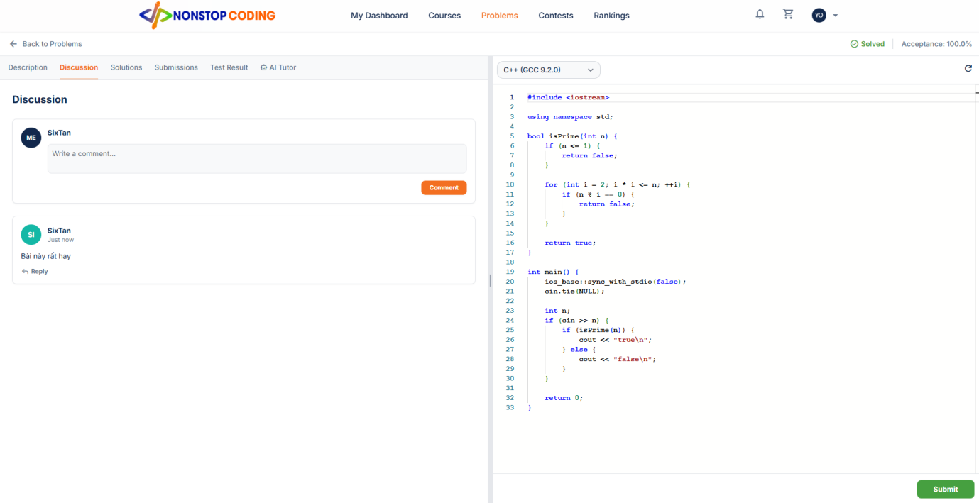

Field Name | Field Type | Description
Comment Input Box | Textarea | A text field where the user can write their thoughts or questions regarding the algorithmic problem.
Comment Button | Button | Submits the content in the textarea to the database to create a new top-level comment.
User Profile Summary | Image & Label | Displays the avatar and the display name of the user who authored the comment.
Timestamp | Label / DateTime | Indicates how long ago the comment was posted (e.g., Just now, 2 hours ago).
Comment Content | Text | The actual message posted by the user (e.g., Bài này rất hay).
Reply Button | Link | Opens a threaded input box to reply specifically to an existing comment.

Database Access
Table | CRUD | Description
problem_comments | R, C | Read: Fetching all top-level comments and nested replies (parent_id) for the current problem_id.  Create: Inserting a new comment or reply when the user clicks the Comment button.
users | R | Fetching the displayname and avatarurl to display alongside each comment.

SQL Statements
1. Retrieving all discussions for the current Problem
SELECT pc.id, pc.content, pc.created_at, pc.parent_id, u.displayname, u.avatarurl
FROM problem_comments pc
INNER JOIN users u ON pc.user_id = u.id
WHERE pc.problem_id = ?
ORDER BY pc.created_at DESC;
2. Posting a new top-level comment
INSERT INTO problem_comments (problem_id, user_id, content, created_at)
VALUES (?, ?, ?, CURRENT_TIMESTAMP)
RETURNING id;
3. Replying to an existing comment (Threaded):
INSERT INTO problem_comments (problem_id, user_id, parent_id, content, created_at)
VALUES (?, ?, ?, ?, CURRENT_TIMESTAMP)
RETURNING id;

3.14 Coding Workspace - Solutions
Review the official or most optimal solutions provided by the platform instructors to compare and improve your code.

UI Design
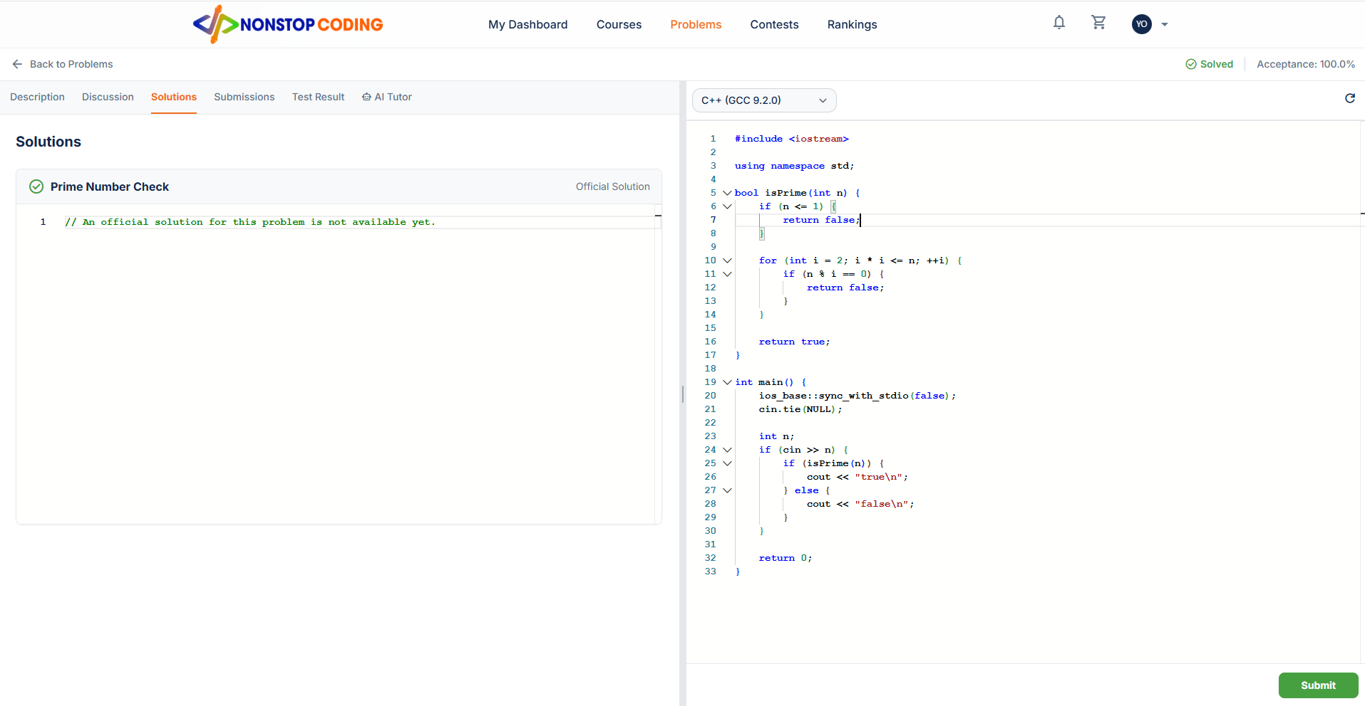

Field Name | Field Type | Description
Problem Title | Label / Text | The name of the algorithmic problem associated with the solution (e.g., Prime Number Check).
Official Solution Tag | Badge | A visual indicator marking the solution as officially provided by the platform rather than community-generated.
Solution Code Block | Read-only Code Editor | Displays the actual source code of the optimal solution. If no solution is provided yet, it displays a fallback message (e.g., "An official solution for this problem is not available yet.").

Database Access
Table | CRUD | Description
problem_versions | R | Fetching the title and the solutions field (which stores the official optimal code or explanation) for the active problem version.

SQL Statements
1. Retrieving the Official Solution for the current Problem
SELECT title, solutions
FROM problem_versions
WHERE id = ? AND is_active = TRUE;

3.15 Coding Workspace - Submissions
Keep track of your past code submissions, review execution metrics, and analyze your algorithmic performance.
UI Design
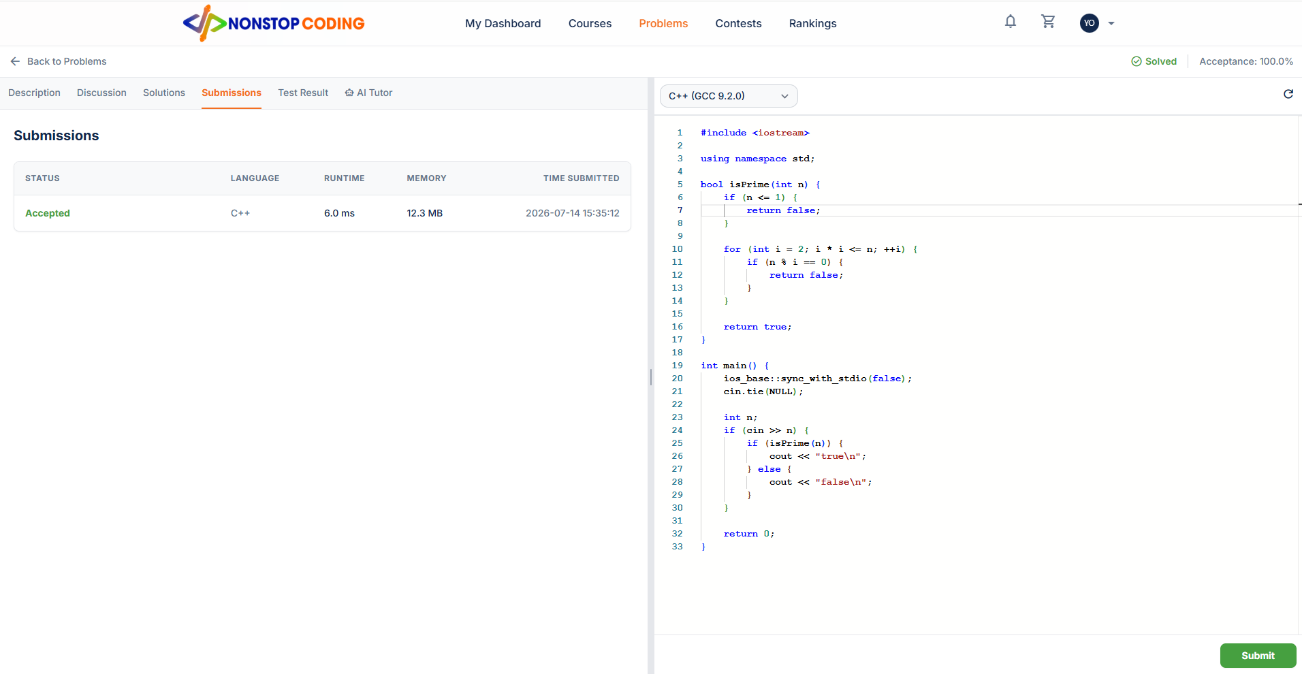

Field Name | Field Type | Description
Status (Verdict) | Label / Text | The final result returned by the grading server (e.g., Accepted, Wrong Answer, Time Limit Exceeded).
Language | Label / Text | The programming language environment used for that specific submission (e.g., C++).
Runtime | Label / Number | The total execution time of the code in milliseconds (ms).
Memory | Label / Number | The peak memory consumed by the program during execution in Megabytes (MB).
Time Submitted | Label / DateTime | The exact timestamp when the user submitted the code to the server.

Database Access
Table | CRUD | Description
problem_submissions | R | Fetching the historical submission records (verdict, language_id, execution_time, memory_used, submitted_at) for the logged-in user on the current problem.

SQL Statements
1. Retrieving Submission History for the current Problem
SELECT verdict, language_id, execution_time, memory_used, submitted_at
FROM problem_submissions
WHERE problem_version_id = ? AND user_id = ?
ORDER BY submitted_at DESC;

3.16 Coding Workspace - Test Result
Analyze the detailed execution results of your code against multiple testcases, comparing expected and actual outputs.
UI Design
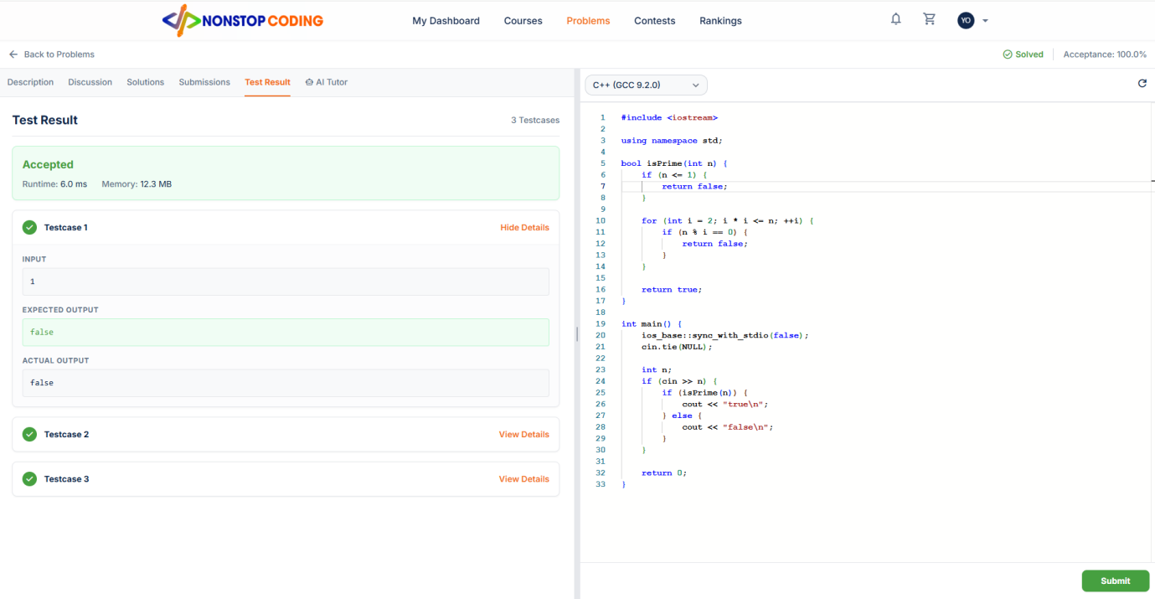

Field Name | Field Type | Description
Overall Verdict Banner | UI Block | A prominent banner displaying the final consolidated status (e.g., Accepted, Wrong Answer), along with total Runtime and Memory.
Testcase List | Accordion | A collapsible list of all test cases run against the user's code, showing individual success/fail status icons.
Input | Text Block | Displays the specific input data (stdin) fed into the program for a particular test case.
Expected Output | Text Block | Shows the correct output (stdout) that the algorithm was supposed to generate for the given input.
Actual Output | Text Block | Displays the actual output produced by the user's code during execution.

Database Access
Table | CRUD | Description
problem_submissions | R | Fetching the overall verdict, execution_time, and memory_used for the top banner.
problem_testcases | R | Fetching the input_data and expected_output for each specific test case.
problem_submission_details | R | Fetching the individual verdict (status icon) and stdout (Actual Output) corresponding to each test case executed.

SQL Statements
1. Retrieving Overall Submission Verdict
SELECT verdict, execution_time, memory_used
FROM problem_submissions
WHERE id = ?;
2. Retrieving Detailed Results for each Testcase
SELECT pt.order_index, pt.input_data, pt.expected_output,
psd.verdict, psd.stdout as actual_output
FROM problem_submission_details psd
INNER JOIN problem_testcases pt ON psd.testcase_id = pt.id
WHERE psd.submission_id = ?
ORDER BY pt.order_index ASC;

3.17 Coding Workspace - AI Tutor (Algorithm Visualizer)
Visually trace the execution of the algorithm step-by-step to deeply understand the underlying logic.

UI Design

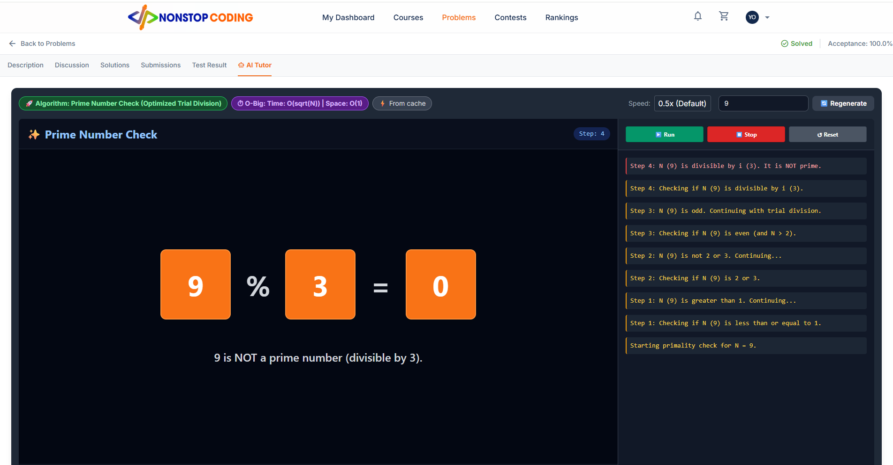

Field Name | Field Type | Description
Algorithm Overview | Badge | Displays the algorithm detected and generated by AI (e.g., Optimized Trial Division).
Complexity Tag | Badge | Shows the theoretical Time and Space complexity (Big-O notation) analyzed by AI.
Simulation Controls | Toolbar | Includes a Speed dropdown, a custom Input field, and a Regenerate button to trigger a new AI generation if needed.
Canvas / Visualizer | UI Graphic | The main dynamic area where variables and operations are visually animated (rendered from cached HTML/JSON content).
Playback Controls | Button Group | Buttons to Run, Stop/Pause, and Reset the animation timeline.
Execution Logs | List | A reverse-chronological list of detailed textual steps explaining what is happening at each exact step.

Database Access
Table | CRUD | Description
problem_visualizer_cache | R, C | Read: Fetching previously generated AI visualization data (detected_algorithm, time_complexity, html_content) to load instantly without calling the external AI API again.

SQL Statements
1. Retrieving cached AI Visualization data for the problem
SELECT detected_algorithm, time_complexity, html_content, generated_at
FROM problem_visualizer_cache
WHERE problem_id = ? AND user_id = ?
ORDER BY generated_at DESC
LIMIT 1;
2. Caching a newly generated AI Visualization (When clicking Regenerate)
INSERT INTO problem_visualizer_cache (id, problem_id, user_id, detected_algorithm, time_complexity, html_content, prompt_version, generated_at)
VALUES (?, ?, ?, ?, ?, ?, ?, CURRENT_TIMESTAMP);

3.18 Contest Problems
View the list of algorithmic challenges assigned to the current contest arena and track your participation status.
UI Design
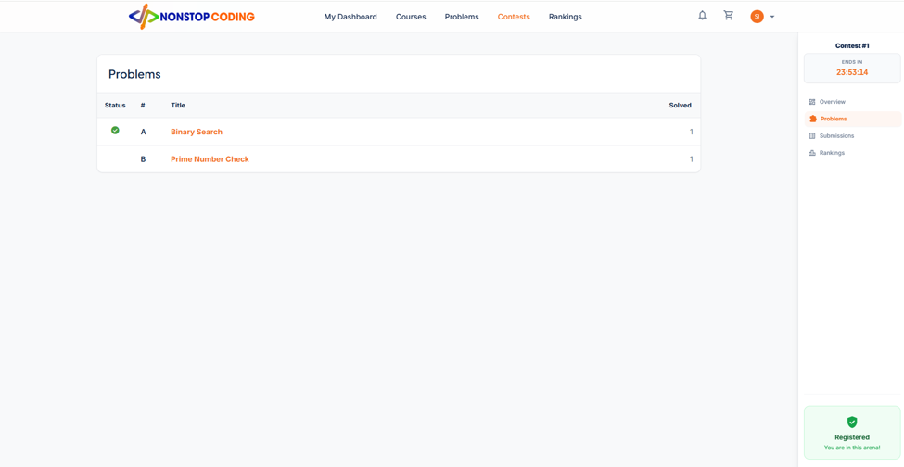

Field Name | Field Type | Description
Contest Title & Timer | Label / Countdown | Displays the name of the arena (e.g., Contest #1) and a real-time countdown timer indicating when the contest ends.
Navigation Sidebar | List / Links | Menu to switch between contest views: Overview, Problems, Submissions, and Rankings.
Registered Status | Badge | A visual indicator (green checkmark) confirming that the logged-in user has successfully joined this contest.
Problems Table | Table | A list of all algorithmic challenges included in this specific contest.
Problem Number (#) | Label / Text | An alphabetically ordered index (e.g., A, B, C) corresponding to the order_index of the problem in the contest.
Problem Title | Link | The name of the challenge (e.g., Binary Search). Clicking it navigates to the Coding Workspace.
Solved Count | Label / Number | The total number of participants who have successfully solved this specific problem during the contest timeframe.

Database Access
Table | CRUD | Description
contest | R | Fetching the title and calculating the countdown timer using end_time.
contest_participants | R | Checking if there is a record for the current user_id to display the "Registered" badge.
contest_problems | R | Fetching the list of problems mapped to this contest, sorting by order_index to map to letters (A, B, C...).
problem_versions | R | Fetching the title of the problem associated with the problem_version_id.
contest_problem_attempts | R | Counting how many distinct users have is_solved = true for each problem to display the Solved Count.

SQL Statements
1. Retrieving Contest Meta-data and User Registration Status
SELECT c.title, c.end_time,
EXISTS(SELECT 1 FROM contest_participants WHERE contest_id = c.id AND user_id = ?) as is_registered
FROM contest c
WHERE c.id = ?;
2. Retrieving the Problems List and Solved Counts
SELECT cp.order_index, pv.title,
(SELECT COUNT(cpa.id) FROM contest_problem_attempts cpa WHERE cpa.contest_id = ? AND cpa.problem_id = cp.problem_id AND cpa.is_solved = TRUE) as total_solved
FROM contest_problems cp
INNER JOIN problem_versions pv ON cp.problem_version_id = pv.id
WHERE cp.contest_id = ?
ORDER BY cp.order_index ASC;

3.19 Contest - Coding Workspace
Read the contest problem statement and submit your solution under strict time constraints without access to external help features.
UI Design
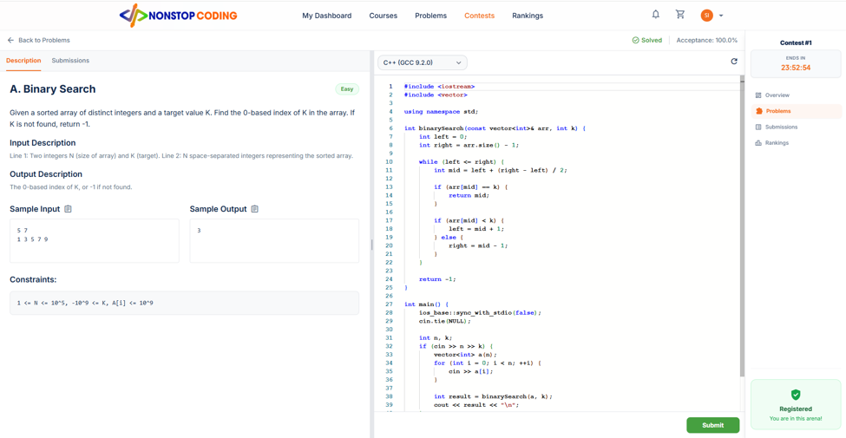

Field Name | Field Type | Description
Contest Sidebar | Panel | The persistent right-side panel showing the contest timer, navigation links, and registration status.
Restricted Tabs | Button Group | Only the 'Description' and 'Submissions' tabs are available. Community features (Discussion) and Hints (Solutions, AI Tutor) are disabled during the contest.
Problem Title & Index | Label / Text | The title of the problem prefixed by its contest index (e.g., A. Binary Search).
Problem Description | Rich Text | The full algorithmic problem statement including Sample Input/Output and Constraints.
Code Editor & Submit | IDE Component | The workspace where the user writes and submits code. Submissions made here are specifically tagged with the contest_id.

Database Access
Table | CRUD | Description
contest | R | Fetching the contest timer (end_time) to enforce strict submission deadlines.
problem_versions | R | Fetching the full problem description (title, description, input_description, output_description, example_input, constraints).
contest_problems | R | Fetching the order_index to display the 'A', 'B', 'C' prefix next to the problem title.
problem_submissions | R, C | Create: Saving the code submission. Crucially, the contest_id column must be populated so the system knows this submission belongs to a contest, not regular practice.  Read: Calculating the user's current Acceptance Rate for this specific problem during the contest.
contest_problem_attempts | R, U | Read/Update: Tracking the number of failed_attempts_count and recording the solved_at_seconds if the user gets an 'ACCEPTED' verdict to calculate leaderboard rankings later.

SQL Statements
1. Retrieving the Problem Content for the Contest Workspace
SELECT cp.order_index, pv.title, pv.difficulty, pv.description,
pv.input_description, pv.output_description, pv.example_input, pv.example_output, pv.constraints
FROM contest_problems cp
INNER JOIN problem_versions pv ON cp.problem_version_id = pv.id
WHERE cp.contest_id = ? AND cp.problem_id = ?;
2. Submitting Code within a Contest context (Saving the submission)
INSERT INTO problem_submissions (problem_id, problem_version_id, user_id, contest_id, language_id, source_code, verdict, submitted_at)
VALUES (?, ?, ?, ?, ?, ?, 'PENDING', CURRENT_TIMESTAMP)
RETURNING id;

3.20 Contest - Submissions (Workspace)
Review your past code submissions and their grading verdicts specifically within the context of the current contest.
UI Design
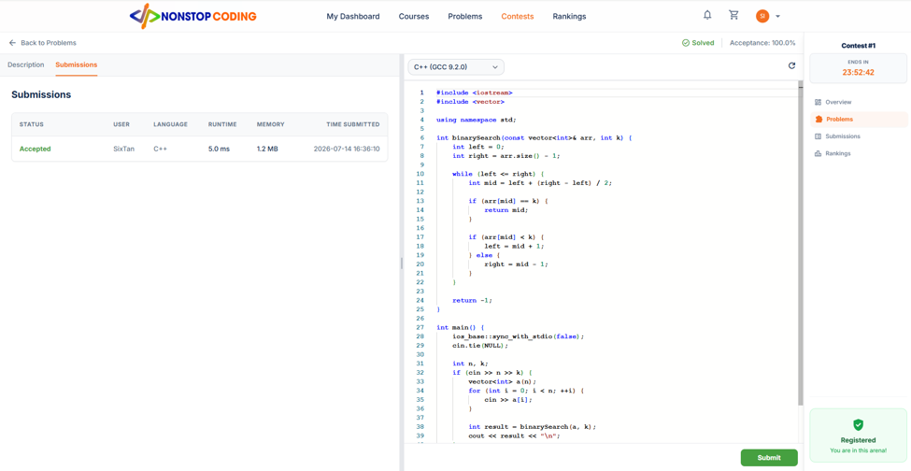

Field Name | Field Type | Description
Status (Verdict) | Label / Text | The final evaluation result from the grading server (e.g., Accepted, Wrong Answer).
User | Label / Text | The display name of the participant who made the submission (e.g., SixTan).
Language | Label / Text | The programming language environment used for the submission (e.g., C++).
Runtime & Memory | Label / Number | The execution time (ms) and peak memory usage (MB) of the code.
Time Submitted | Label / DateTime | The exact timestamp when the code was submitted during the contest.
Bottom Result Badge | UI Graphic | A quick-glance badge appearing next to the Submit button in the IDE, summarizing the latest execution result (e.g., Accepted | 5.0ms | 1.2MB).

Database Access
Table | CRUD | Description
problem_submissions | R | Fetching the historical submission records (verdict, language_id, execution_time, memory_used, submitted_at) for the logged-in user on the current problem, strictly filtered by contest_id.
users | R | Fetching the displayname of the user associated with the submission.

SQL Statements
1. Retrieving Submission History for the current Problem within the Contest
SELECT ps.verdict, u.displayname, ps.language_id, ps.execution_time, ps.memory_used, ps.submitted_at
FROM problem_submissions ps
INNER JOIN users u ON ps.user_id = u.id
WHERE ps.problem_id = ?
AND ps.user_id = ?
AND ps.contest_id = ?
ORDER BY ps.submitted_at DESC;

3.21 Contest - Global Submissions
View a feed of all code submissions made during the contest across all problems
UI Design

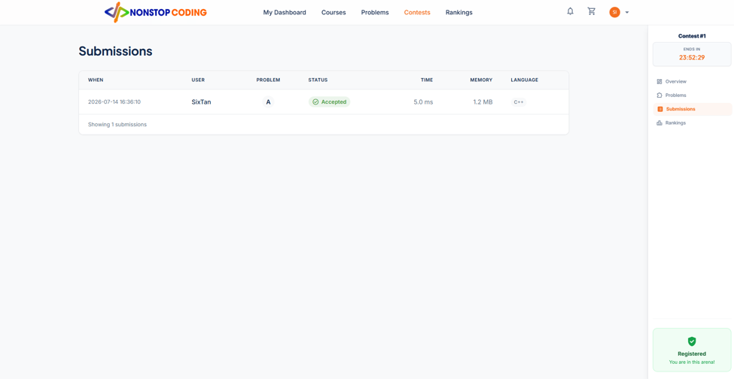

Field Name | Field Type | Description
Contest Sidebar | Panel | The persistent right-side panel showing the contest timer, navigation links, and registration status.
Global Submissions Table | Table | A list displaying all submission records within the current contest.
When | Label / DateTime | The exact timestamp when the submission was recorded.
User | Label / Text | The display name of the participant who submitted the code.
Problem (#) | Label / Text | The indexed letter (e.g., A, B) representing which problem the submission was for.
Status (Verdict) | Badge | The evaluation result (e.g., Accepted, Wrong Answer) highlighted with corresponding colors.
Time & Memory | Label / Number | The execution runtime (ms) and peak memory (MB) used by the code.
Language | Label / Text | The programming language environment used for the submission.

Database Access
Table | CRUD | Description
problem_submissions | R | Fetching the historical submission records (submitted_at, verdict, execution_time, memory_used, language_id) strictly filtered by contest_id.
users | R | Fetching the displayname of the participant who made the submission.
contest_problems | R | Fetching the order_index (to convert into letters A, B, C...) by joining problem_id and contest_id.

SQL Statements
1. Retrieving Global Submission Feed for the Contest
SELECT ps.submitted_at, u.displayname, cp.order_index, ps.verdict,
ps.execution_time, ps.memory_used, ps.language_id
FROM problem_submissions ps
INNER JOIN users u ON ps.user_id = u.id
INNER JOIN contest_problems cp ON ps.problem_id = cp.problem_id AND ps.contest_id = cp.contest_id
WHERE ps.contest_id = ?
ORDER BY ps.submitted_at DESC;

3.22 Contest Rankings (Scoreboard)
Track real-time contest standings with a stepwise progression chart and a detailed ICPC-style scoreboard.
UI Design
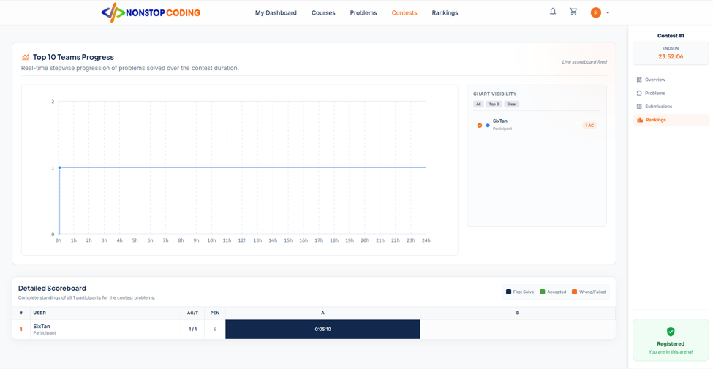

Field Name | Field Type | Description
Progress Chart | Line Chart | A visual graph plotting the number of solved problems against the contest timeline (hours/minutes) for the top 10 teams.
Chart Visibility | Legend | Allows toggling the visibility of specific users' lines on the graph.
Detailed Scoreboard | Matrix Table | A grid displaying the complete standings, user stats, and individual problem results.
Rank (#) | Label / Number | The current position of the user, sorted by Solved Count (descending) and Penalty (ascending).
User | Label / Text | The display name and role of the participant.
AC/T (Accepted/Total) | Label / Text | The ratio of problems solved successfully versus total problems attempted (e.g., 1/1).
PEN (Penalty) | Label / Number | Total time penalty accumulated (in minutes), factoring in solve times and incorrect attempts.
Problem Status Cells | Colored UI Block | Individual grid cells for each problem (A, B, etc.). Colors indicate status: Dark Blue (First Solve), Green (Accepted), Orange (Wrong/Failed). Displays the exact time it was solved (e.g., 0:05:10).

Database Access
Table | CRUD | Description
contest_rankings | R | Fetching the overall problems_solved and total_penalty for each user to determine their Rank and populate the AC/T and PEN columns.
users | R | Fetching the displayname of the participants for the Scoreboard.
contest_problem_attempts | R | Fetching the detailed attempt history (is_solved, failed_attempts_count, solved_at_seconds) to render the Problem Status Cells and generate data points for the Progress Chart.

SQL Statements
1. Retrieving Overall Rankings (Sorted by ICPC rules)
SELECT u.displayname, cr.problems_solved, cr.total_penalty
FROM contest_rankings cr
INNER JOIN users u ON cr.user_id = u.id
WHERE cr.contest_id = ?
ORDER BY cr.problems_solved DESC, cr.total_penalty ASC;
2. Retrieving Detailed Problem Cell Data for a User
SELECT cp.order_index, cpa.is_solved, cpa.failed_attempts_count, cpa.solved_at_seconds
FROM contest_problem_attempts cpa
INNER JOIN contest_problems cp ON cpa.problem_id = cp.problem_id AND cpa.contest_id = cp.contest_id
WHERE cpa.contest_id = ? AND cpa.user_id = ?;

4. Instructor UI

4.1 Instructor Dashboard
Provides the instructor with a high-level overview of their teaching performance, including key metrics, revenue trends, student engagement, and recent activities.

UI Design
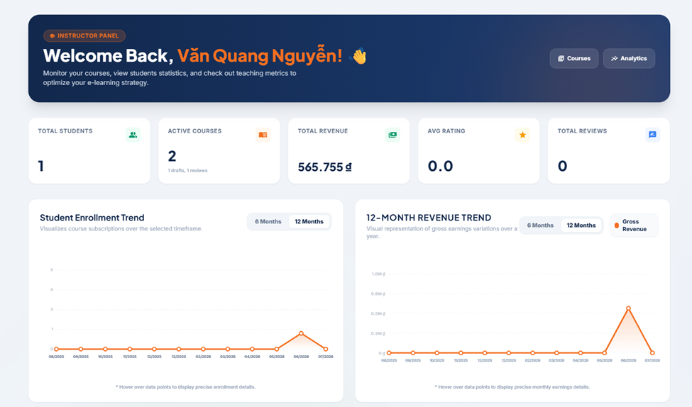
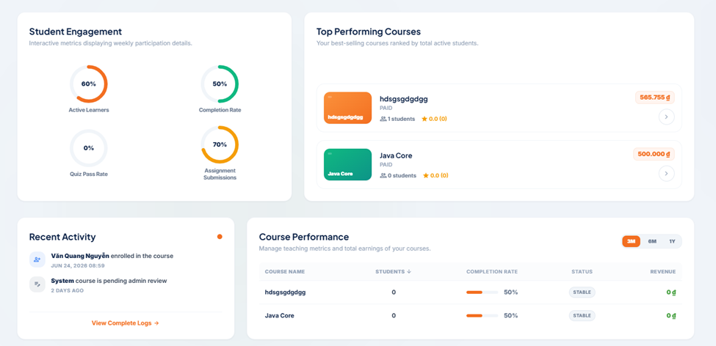
Field Name | Field Type | Description
Total Students | KPI Metric | Total unique students enrolled across all of the instructor's courses.
Active Courses | KPI Metric | Total published courses (along with a sub-count for drafts and pending reviews).
Total Revenue | KPI Metric | Total gross earnings from course sales, displayed in VND.
Avg Rating | KPI Metric | The overall average rating across all the instructor's courses.
Total Reviews | KPI Metric | Total number of feedback reviews received from students.
Enrollment Trend | Line Chart | Visualizes the number of new student subscriptions over 6 or 12 months.
Revenue Trend | Line Chart | Visualizes gross earnings variations over a selected timeframe.
Student Engagement | Donut Charts | Displays percentages for Active Learners, Completion Rate, Quiz Pass Rate, and Assignments.
Top Courses | List / Cards | Ranks the instructor's best-selling courses based on active students and revenue.
Recent Activity | Timeline List | System notifications (e.g., student enrollments, admin review updates).
Course Performance | Data Table | Detailed breakdown of each course's students, completion rate, status, and revenue.

Database Access
Table | CRUD | Description
courses | R | Fetch all courses belonging to instructor_id to aggregate totals and list Top Performing Courses.
enrollments | R | Calculate unique student counts and build the monthly "Enrollment Trend" chart.
orders | R | Aggregate successful payments to build the "Total Revenue" KPI and Revenue Trend chart.
notifications/logs | R | Retrieve the most recent events for the "Recent Activity" timeline.

SQL Statements

1. Calculate KPI Metrics:
SELECT
COUNT(id) AS total_courses,
SUM(CASE WHEN status = 'APPROVED' THEN 1 ELSE 0 END) AS active_courses,
SUM(CASE WHEN status = 'DRAFTS' THEN 1 ELSE 0 END) AS draft_courses,
SUM(total_reviews) AS total_reviews,
AVG(average_rating) AS overall_avg_rating,
SUM(price * total_enrolled) AS estimated_total_revenue
FROM public.courses
WHERE instructor_id = ?;

2. Retrieve Top Performing Courses:
SELECT id, title, type, status, total_enrolled, average_rating, total_reviews, (price * total_enrolled) AS course_revenue
FROM public.courses
WHERE instructor_id = ?
ORDER BY total_enrolled DESC LIMIT 5;

3. Data for 12-Month Enrollment Trend:
SELECT DATE_TRUNC('month', e.created_at) AS enrollment_month,
COUNT(e.id) AS new_students
FROM public.enrollments e
JOIN public.courses c ON e.course_id = c.id
WHERE c.instructor_id = ?
AND e.created_at >= CURRENT_DATE - INTERVAL '12 months'
GROUP BY enrollment_month
ORDER BY enrollment_month ASC;

4.2 Create Course

Allows an instructor to create a new learning module by providing essential details, uploading media, and defining the course specifications. Upon submission, the course enters a "Pending" or "Draft" state.

UI Design
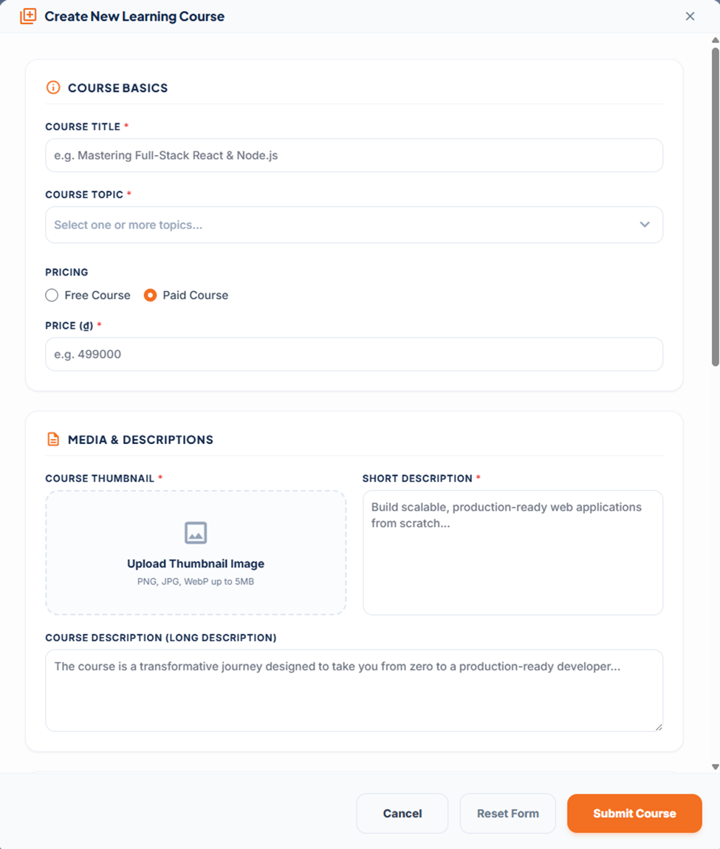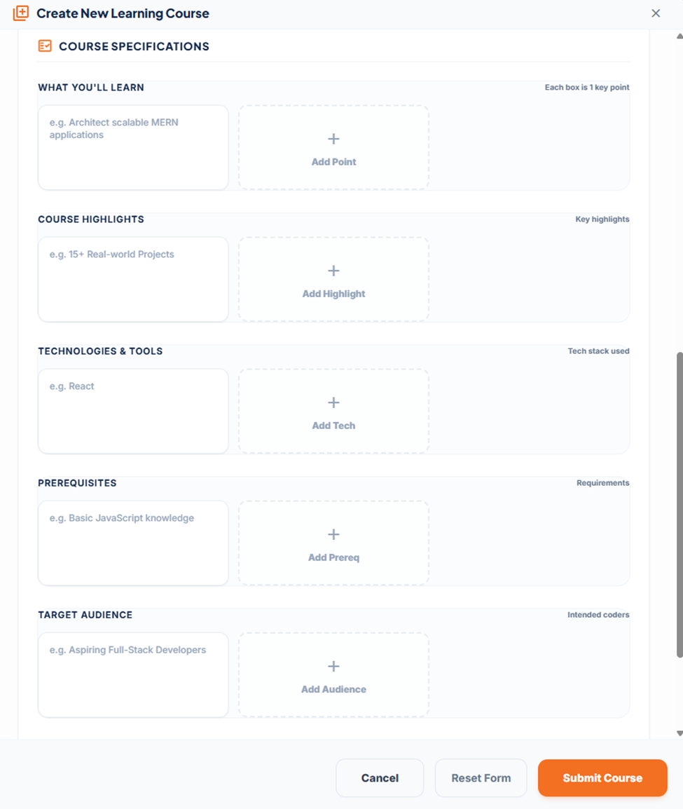

Field Name | Field Type | Description
Course Title * | Text Input | The main name of the course (title). Required.
Course Topic * | Multi-Select | Dropdown to select one or more categories/tags for the course.
Pricing | Radio Buttons | Toggle between a "Free Course" or a "Paid Course".
Price (đ) * | Number Input | The cost of the course (price). Required if "Paid" is selected.
Course Thumbnail * | File Upload | Area to upload the cover image (PNG, JPG, WebP).
Short Description * | Text Area | A brief summary of the course (short_description).
Long Description | Rich Text Area | The detailed overview of the course (long_description).
What you'll learn | Dynamic List | Input boxes to add key learning outcomes (what_you_learn).
Course Highlights | Dynamic List | Input boxes to add standout features (course_highlight).
Technologies & Tools | Dynamic List | Input boxes to list the tech stack used (technology_tool).
Prerequisites | Dynamic List | Input boxes for required prior knowledge (prerequisites).
Target Audience | Dynamic List | Input boxes specifying the intended learners (target_audience).
Submit Course | Button | Saves the data to the database and creates the course record.

Database Access
Table | CRUD | Description
courses | C | Insert a new record containing all descriptions, pricing, and thumbnail_url. Status defaults to PENDING_ADMIN.
course_category_mappings | C | Insert records linking the newly generated course_id to selected category_id values.

SQL Statements

1. Create the Main Course Record:

INSERT INTO public.courses ( title, price, short_description, long_description, thumbnail_url, what_you_learn, course_highlight, technology_tool, prerequisites, target_audience, status, instructor_id, created_at, updated_at, average_rating, total_enrolled, total_reviews, total_lessons, total_quizzes, total_videos ) VALUES ( ?, ?, ?, ?, ?, ?, ?, ?, ?, ?, 'PENDING_ADMIN', ?, CURRENT_TIMESTAMP, CURRENT_TIMESTAMP, 0, 0, 0, 0, 0, 0 ) RETURNING id;

2. Map the Selected Topics (Categories):
INSERT INTO public.course_category_mappings (course_id, category_id) VALUES (?, ?);

4.3 Revenue Analytics

Allows instructors to track their financial performance, including gross revenue, net payouts after platform fees and taxes, course-specific earnings, and detailed transaction histories.

UI Design
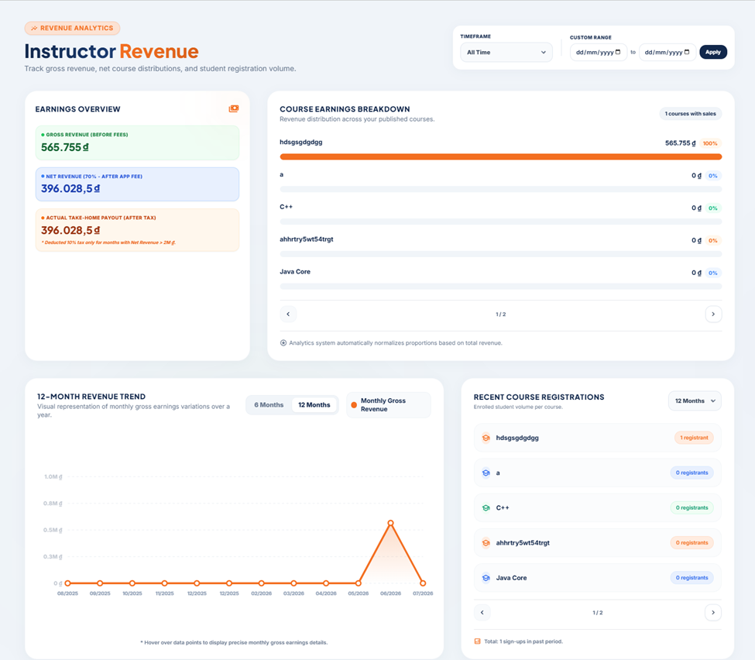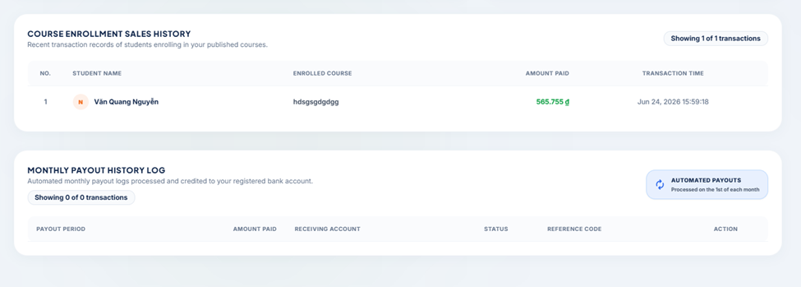
Field Name | Field Type | Description
Timeframe / Date Range | Pickers | Filters all analytics data by a specific period (e.g., All Time, custom dates).
Gross Revenue | Highlight Box | Total earnings before any deductions.
Net Revenue | Highlight Box | Earnings after deducting the 30% App/Platform fee.
Actual Take-Home | Highlight Box | Final payout amount after deducting an additional 10% tax (if Net Revenue > 2M VND).
Course Earnings Breakdown | Progress Bars | Visualizes the revenue proportion generated by each published course.
12-Month Revenue Trend | Line Chart | Monthly gross earnings trend over the past year.
Recent Registrations | List | Displays the volume of students enrolled per course.
Sales History | Table | Detailed log of every student purchase (Student Name, Course, Amount, Timestamp).
Payout History Log | Table | Automated monthly payout records to the instructor's bank account.

Database Access
Table | CRUD | Description
orders | R | Aggregate successful payment transactions for revenue calculations and Sales History.
courses | R | Group order data for Course Earnings Breakdown and registration volume.
users | R | Join with orders to retrieve Student Name for Sales History.
payout_requests | R | Retrieve automated payout logs for the Monthly Payout History Log.

SQL Statements

1. Calculate Overall Earnings (Applying Business Rules):

SELECT SUM(o.amount) AS gross_revenue, (SUM(o.amount) * 0.7) AS net_revenue, -- Deducting 30% App Fee CASE WHEN (SUM(o.amount) * 0.7) > 2000000 THEN (SUM(o.amount) * 0.7 * 0.9) -- 10% Tax if > 2M ELSE (SUM(o.amount) * 0.7) END AS actual_take_home FROM public.orders o JOIN public.courses c ON o.course_id = c.id WHERE c.instructor_id = ? AND o.status = 'SUCCESS';
2. Retrieve Course Enrollment Sales History:

SELECT u.displayname AS student_name, c.title AS enrolled_course, o.amount AS amount_paid, o.created_at AS transaction_time FROM public.orders o JOIN public.courses c ON o.course_id = c.id JOIN public.users u ON o.user_id = u.id WHERE c.instructor_id = ? AND o.status = 'SUCCESS' ORDER BY o.created_at DESC LIMIT ? OFFSET ?;

3. Retrieve Monthly Payout History:

SELECT pr.payout_period, pr.amount, pr.receiving_account, pr.status, pr.reference_code FROM public.payout_requests pr WHERE pr.instructor_id = ? ORDER BY pr.created_at DESC;
ORDER BY created_at DESC

4.4 Edit Course Landing Page & Overview

Allows instructors to modify an existing course’s details, update marketing information, and change its publishing status (e.g., Save as Draft vs. Submit for Review).

UI Design
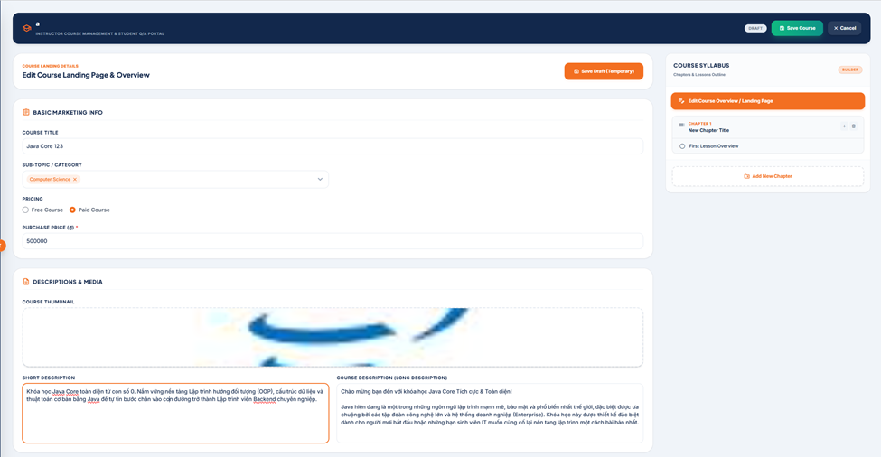
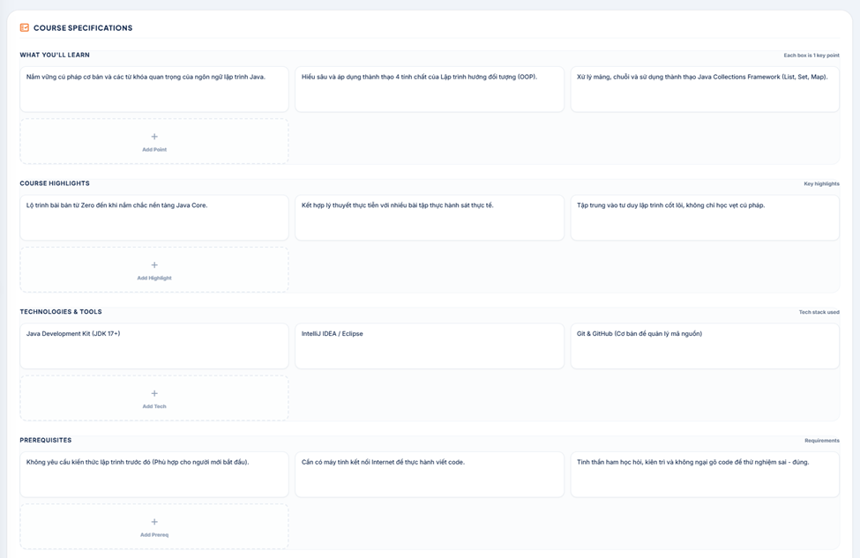
Field Name | Field Type | Description
Status Badge | Badge | Displays the current state of the course (e.g., DRAFT).
Save Draft | Button | Saves progress without publishing or submitting for admin review.
Save Course | Button | Saves the course and updates status to PENDING_ADMIN.
Marketing Info | Inputs | Editable fields for title, Category mappings, Pricing, and price.
Descriptions & Media | Inputs | Editable fields for thumbnail_url, short_description, and long_description.
Course Specifications | Dynamic Lists | Pre-populated, editable lists for learning outcomes and requirements.
Chapters & Lessons | Accordion/List | Read-only outline of the course structure.
Add New Chapter | Button | Action to open the Curriculum Builder interface.
Course Rating | Read-only | Displays aggregated rating and star breakdown.

Database Access
Table | CRUD | Description
courses | R, U | Read course details; Update fields and status upon saving.
course_category_mappings | R, C, D | Delete old mappings and Create new ones if categories are updated.
chapters & lessons | R | Read syllabus hierarchy to provide context.
course_reviews | R | Read aggregated rating data.

SQL Statements

1. Retrieve Existing Course Data:

SELECT * FROM public.courses WHERE id = ? AND instructor_id = ?;

2. Update Course Data:

UPDATE public.courses
SET
title = ?, price = ?, thumbnail_url = ?, short_description = ?, long_description = ?, what_you_learn = ?, course_highlight = ?, technology_tool = ?, prerequisites = ?, target_audience = ?, completion_benefits = ?, status = ?, updated_at = CURRENT_TIMESTAMP
WHERE id = ? AND instructor_id = ?;

3. Update Categories:

-- Step A: Clear old categories:
DELETE FROM public.course_category_mappings WHERE course_id = ?;

-- Step B: Insert new selections
INSERT INTO public.course_category_mappings (course_id, category_id) VALUES (?, ?);

4.5 Create Lesson Theory Content

Reception watch and control process in derma clinic

UI Design
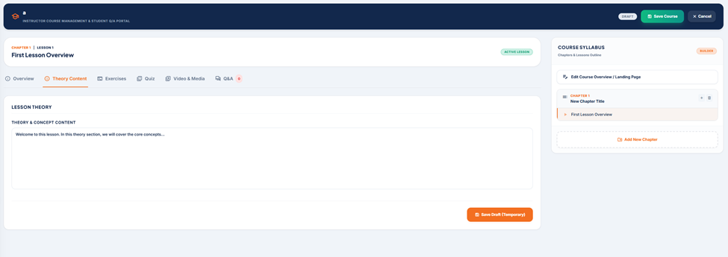

Field Name | Field Type | Description
Lesson Context | Text | Displays the current Chapter and Lesson sequence (e.g., CHAPTER 1 | LESSON 1).
Lesson Title | Heading | Displays the title of the lesson currently being edited.
Content Tabs | Nav Links | Switches between the lesson's components: Overview, Theory Content, Exercises, Quiz, Video, Q&A.
Theory & Concept Content | Rich Text Area | The primary editor where the instructor types the theoretical material for the lesson.
Save Draft | Button | Saves the text content specifically to this lesson without submitting the whole course.
Syllabus Navigation | Interactive List | Highlights the current lesson. Clicking other items switches the editing context dynamically.

Database Access
Table | CRUD | Description
lessons | R, U | Read existing theory_content to populate the editor; update theory_content upon saving.

SQL Statements

1. Retrieve Existing Theory (On Tab Load):

SELECT id, title, theory_content FROM public.lessons WHERE id = ? AND chapter_id = ?;

2. Update Theory Content (On Save):

UPDATE public.lessons SET theory_content = ?, updated_at = CURRENT_TIMESTAMP WHERE id = ?;

4.6 Create Lesson Coding Exercise

Allows instructors to create algorithmic coding problems directly inside a lesson, defining the problem statement, constraints, and test cases for the Online Judge to evaluate student submissions.

UI Design
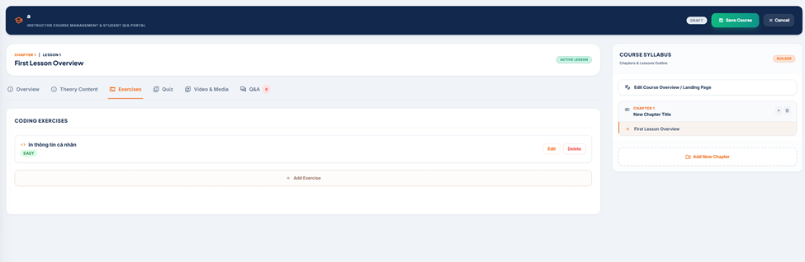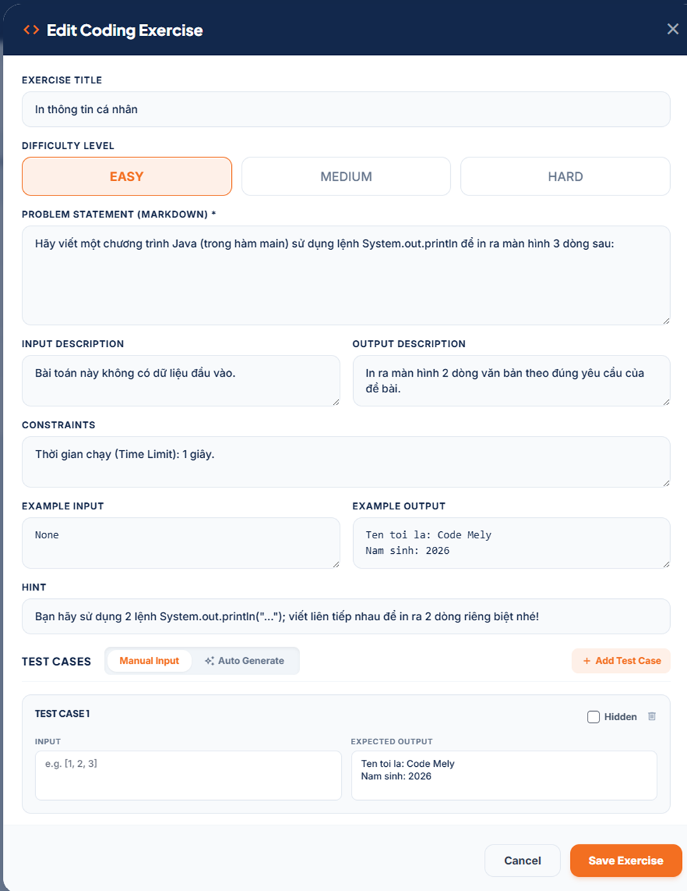

Field Name | Field Type | Description
Exercise Title | Text Input | The name of the coding problem.
Difficulty Level | Button Toggle | Sets the difficulty: EASY, MEDIUM, or HARD.
Problem Statement | Rich Text Area | Markdown-supported field for the core problem description.
Input / Output Desc. | Text Areas | Instructions detailing the format of the expected input and output.
Constraints & Hints | Text Areas | Limits (e.g., Time Limit, Memory Limits) and helpful tips.
Example In / Out | Text Areas | Sample inputs and outputs to help the student understand the format.
Test Case Toggle | Switch | Switch between Manual Input and Auto Generate (AI/logic generation).
Add Test Case | Button | Adds a new test case block.
Input & Expected Output | Text Areas | The raw data passed to the compiler and the exact expected result.
Hidden | Checkbox | If checked, the test case is used for evaluation but not shown to the student.

Database Access

Table | CRUD | Description
problems | C | Create a root record for the new problem with problem_scope = 'LESSON'.
problem_versions | C | Insert textual details as a new version, linked to the problems table.
problem_testcases | C | Insert multiple test case records associated with this specific problem version.
lesson_problems | C | Map the newly created problem_id to the current lesson_id.

SQL Statements

1. Create the Root Problem & Link to Lesson:

-- Step A: Create root problem
INSERT INTO public.problems ( is_active, is_public, score, total_accepted, total_submission, total_testcase, created_by, problem_scope, created_at, updated_at )
VALUES ( TRUE, FALSE, 100, 0, 0, ?, ?, 'LESSON', CURRENT_TIMESTAMP, CURRENT_TIMESTAMP ) RETURNING id;
-- Step B: Map to the current Lesson INSERT INTO public.lesson_problems (lesson_id, problem_id) VALUES (?, ?);

2. Create the Problem Version (Text Details):

INSERT INTO public.problem_versions ( problem_id, version_number, title, difficulty, description, input_description, output_description, constraints, example_input, example_output, hint, problem_scope, is_public, memory_limit_kb, time_limit_ms, created_at ) VALUES ( ?, 1, ?, ?, ?, ?, ?, ?, ?, ?, ?, 'LESSON', FALSE, 256000, 1000, CURRENT_TIMESTAMP ) RETURNING id;

3. Insert Test Cases (Batch Operation):

INSERT INTO public.problem_testcases ( problem_version_id, input_data, expected_output, is_hidden, created_at ) VALUES ( ?, ?, ?, ?, CURRENT_TIMESTAMP );

4.7 Create / Edit Multiple Choice Quiz
Allows instructors to build interactive quizzes to test student comprehension at the end of a lesson. Instructors can define multiple questions, provide several options for each, and mark the correct answers.

UI Design
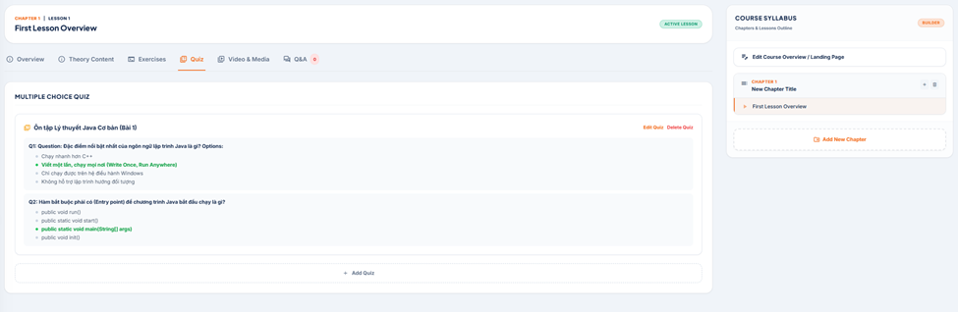
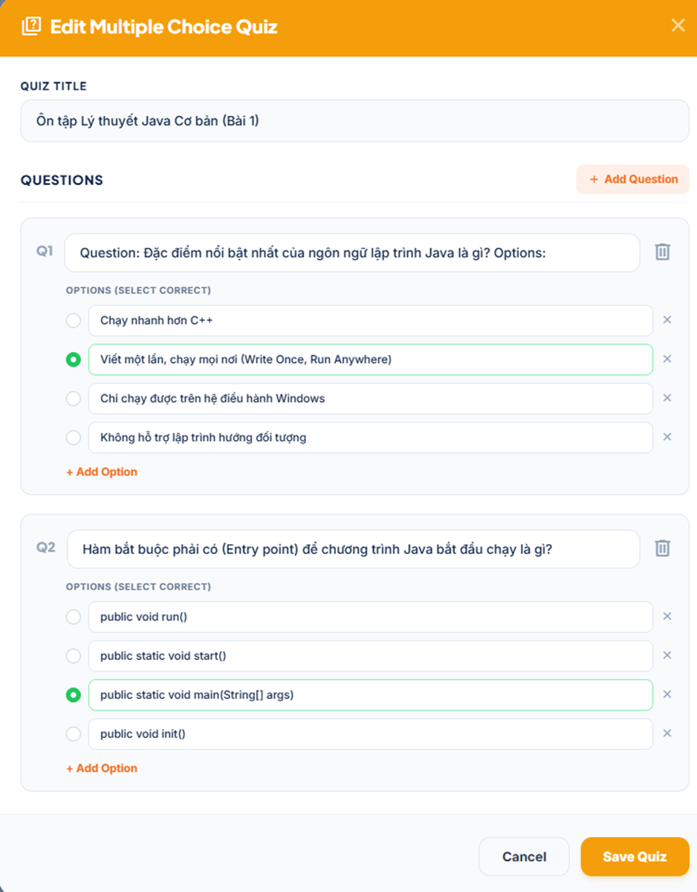
Field Name | Field Type | Description
Quiz Title | Text Input | The main name of the quiz.
Add Question | Button | Appends a new question block to the form.
Question Text | Text Input | The prompt or question asked to the student.
Delete Question | Icon Button | Removes the entire question block from the quiz.
Add Option | Button | Appends a new answer option to the current question.
Select Correct | Radio Button | Marks this specific option as the correct answer.
Option Text | Text Input | The text for the multiple-choice answer.
Delete Option | Icon Button | Removes this specific option from the list.
Save Quiz | Button | Submits the entire nested structure to the database.

Database Access
Table | CRUD | Description
quizzes | C, U | Create or update the root quiz record, linked to the lesson_id.
quiz_questions | C, D | Insert new questions linked to quiz_id.
quiz_options | C, D | Insert multiple options for each question_id, specifying is_correct.

SQL Statements
1. Create or Update the Root Quiz:

INSERT INTO public.quizzes (title, lesson_id, created_at, updated_at) VALUES (?, ?, CURRENT_TIMESTAMP, CURRENT_TIMESTAMP)
RETURNING id;

2. Insert Questions:

INSERT INTO public.quiz_questions (quiz_id, question_text, created_at, updated_at) VALUES (?, ?, CURRENT_TIMESTAMP, CURRENT_TIMESTAMP) RETURNING id;

3. Insert Options:

INSERT INTO public.quiz_options (question_id, option_text, is_correct) VALUES (?, ?, ?);

4.8 Upload Lesson Video & Media
Allows instructors to attach video content to a specific lesson. The UI provides a video preview player and the ability to upload a new video or replace an existing one.
UI Design
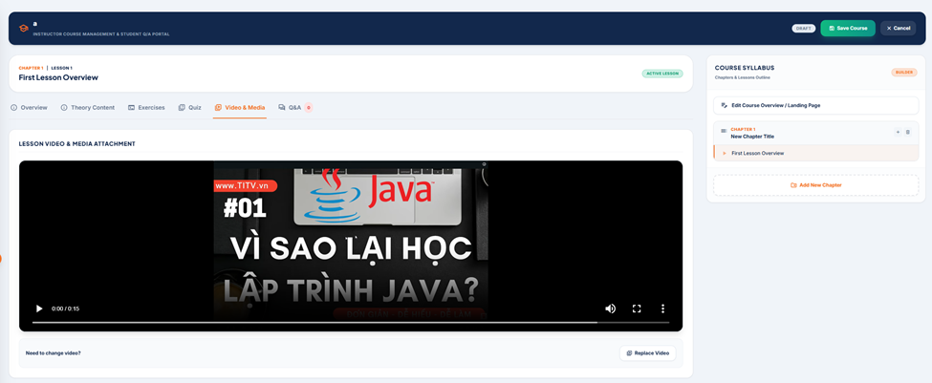

Field Name | Field Type | Description
Lesson Context | Text | Displays the current Chapter and Lesson sequence.
Content Tabs | Nav Links | Switches between components (Overview, Theory, Video, etc.).
Video Preview Player | HTML5 Player | Embedded player to preview the uploaded video with standard playback controls.
Upload / Replace Video | File Input / Button | Opens a file picker to select an MP4 or supported video file for upload.
Syllabus Navigation | Interactive List | Highlights the current lesson, maintaining context within the course structure.

Database Access
Table | CRUD | Description
lessons | R, U | Read existing video_url for preview; Update video_url after successful file upload.

SQL Statements

1. Retrieve Existing Video (On Tab Load):

SELECT id, title, video_url FROM public.lessons WHERE id = ? AND chapter_id = ?;

2. Update Video URL (On Successful Upload):

UPDATE public.lessons SET video_url = ?, updated_at = CURRENT_TIMESTAMP WHERE id = ?;

5. Admin UI

5.1 System Control Dashboard - Metrics & Charts
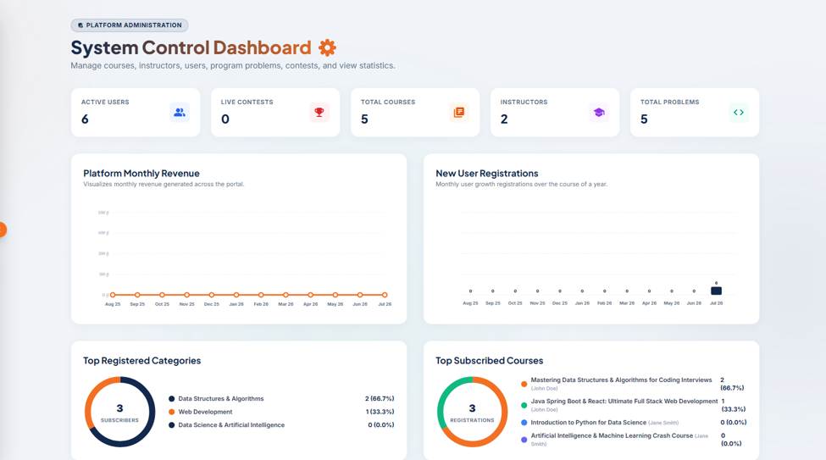

Provides the system administrator with a visual overview of platform health and statistics. Displays primary KPI cards (Active Users, Live Contests, Total Courses, Instructors, Total Problems), followed by a 12-month revenue line chart, monthly registrations bar chart, and category/course subscriber donut charts.

UI Design
Field Name | Field Type | Description
Platform Administration Badge | Badge Label | A top-left banner label displaying the current portal segment: 'Platform Administration'.
Active Users Card | KPI Metric Card | Displays total count of active users currently registered on the platform. Displays value '6' with a group icon.
Live Contests Card | KPI Metric Card | Displays total count of ongoing active contests. Displays value '0' with a trophy icon.
Total Courses Card | KPI Metric Card | Displays total count of approved courses in the database. Displays value '5' with a folders icon.
Instructors Card | KPI Metric Card | Displays total count of approved instructors. Displays value '2' with a cap icon.
Total Problems Card | KPI Metric Card | Displays total count of coding problems in the repository. Displays value '5' with a code icon.
Platform Monthly Revenue Chart | Line Chart | Displays gross monthly revenue variations generated across the portal over 12 months.
New User Registrations Chart | Bar Chart | Displays user growth registrations over the course of a year (month-by-month bar metrics).
Top Registered Categories | Donut Chart | Shows proportion and student subscriber count grouped by category (e.g. Data Structures, Web Dev).
Top Subscribed Courses | Donut Chart | Shows registration distributions and enrollment counts for best-selling courses.

Database Access
Table | CRUD | Description
users | R | Count active accounts (countByStatus) and query registration records over time.
contest | R | Count published contests using time range matching (countActiveContests).
courses | R | Count total courses, rank top courses and aggregate instructor profiles.
instructors | R | Count total instructors profile entries.
problems | R | Count total coding problems in database.

SQL Statements
-- 1. Count active users
SELECT COUNT(*) FROM users WHERE status = 'ACTIVE';

-- 2. Count active contests
SELECT COUNT(*) FROM contest WHERE status = 'PUBLISHED' AND start_time <= NOW() AND end_time >= NOW();

-- 3. Count total courses
SELECT COUNT(*) FROM courses WHERE status = 'APPROVED';

-- 4. Count total instructors
SELECT COUNT(*) FROM instructors WHERE status = 'ACTIVE';

-- 5. Count total problems
SELECT COUNT(*) FROM problems WHERE is_active = TRUE AND is_deleted = FALSE;

5.2 System Control Dashboard - Activity Logs & Pending Approvals
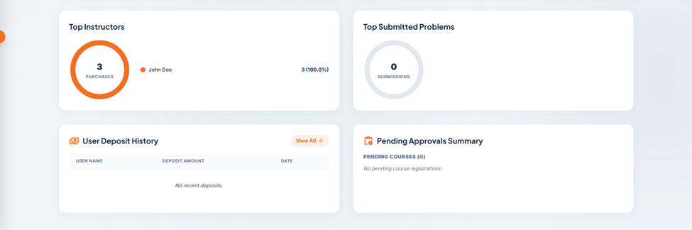
Provides the system administrator with real-time operational alerts, including top instructor rankings, problem submission donut charts, wallet deposit records history, and a pending course approvals card summary.

UI Design
Field Name | Field Type | Description
Top Instructors | Donut Chart | Ranks the best-selling instructors on the platform based on total course purchases (e.g. John Doe: 3, 100%).
Top Submitted Problems | Donut Chart | Ranks the most active coding challenges based on total submissions.
User Deposit History Table | Data Table | Lists recent student wallet deposits with columns: User Name, Deposit Amount, Date.
View All Deposits | Button / Link | Clickable link directing to the full financial deposit history list.
Pending Approvals Summary | Section Card | Displays a summary list of items awaiting admin moderation, categorized by item types (e.g. PENDING COURSES).
Pending Course Card | Info Card | Displays details of the course (Title, Instructor Name) waiting for admin approval.
Review Button | Button | Orange action button on the pending course card to open the Course Moderation Review player directly.

Database Access
Table | CRUD | Description
courses | R | Query courses pending admin review (where status = 'PENDING_ADMIN').
instructors | R | Resolve instructor profile details and compute top course sales statistics.
wallet_transactions | R | Query successful deposit history logs (username, amount, created_at date).

SQL Statements
-- 1. Retrieve courses pending admin review
SELECT id, title, instructor_id, status FROM courses WHERE status = 'PENDING_ADMIN' ORDER BY created_at ASC;

-- 2. Fetch recent successful wallet deposits
SELECT wt.id, u.displayname, wt.amount, wt.created_at
FROM wallet_transactions wt
JOIN wallets w ON wt.wallet_id = w.id
JOIN users u ON w.user_id = u.id
WHERE wt.transaction_type = 'DEPOSIT' AND wt.status = 'SUCCESS'
ORDER BY wt.created_at DESC LIMIT 5;

5.3 Course Administration - Platform Courses Management

Allows administrators to filter and manage the platform's courses. Displays courses categorized by lifecycle states (Approved, Pending Admin, Pending AI, Rejected) in a responsive grid card layout, showing brief metrics and a moderation access button.

UI Design
Field Name | Field Type | Description
Page Header | Text Heading | Displays 'Course Administration' with sub-description 'Review and approve instructor course submissions, curriculum, and settings.'.
Status Tabs | Tab List Group | Interactive filters: APPROVED, PENDING_ADMIN (active/orange), PENDING_AI, REJECTED.
Course Card Grid | Card Container | Lists courses matching the selected status filter in a card list.
Thumbnail Image | Image Banner | Displays the course cover thumbnail image.
Waiting Admin Badge | Status Badge | Orange badge overlay displaying the current review state: 'WAITING ADMIN'.
Course Title & Description | Text Labels | Displays course title name and short description snippet.
Instructor Details | Avatar & Text | Displays instructor avatar icon and display name (e.g. John Doe).
Metrics Badges | Labels Grid | Displays course stats: Enrolled (count), Price (in USD, red), Chapters, Lessons, and Ratings.
Review & Approve Button | Button | Orange action button opening the detailed curriculum review player screen.

Database Access
Table | CRUD | Description
courses | R | Query course records matching selected status filter (findAllByStatus).
instructors | R | Join with courses to retrieve full name and avatar details.

SQL Statements
-- Fetch courses pending admin approval
SELECT c.id, c.title, c.short_description, c.price, c.total_lessons, c.total_chapters, i.full_name AS instructor_name
FROM courses c
JOIN instructors i ON c.instructor_id = i.id
WHERE c.status = 'PENDING_ADMIN'
ORDER BY c.created_at DESC;

5.4 Course Administration - Review Mode & Content Player
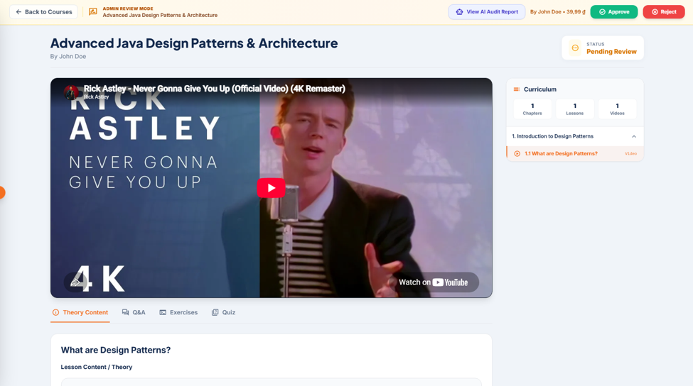
An interactive moderation workspace where admin audits course contents. Features a video player playing lesson trials, tabs showing theory/quiz contents, a curriculum tree outline sidebar, and primary buttons to approve or reject the submission.

UI Design
Field Name | Field Type | Description
Back to Courses Button | Button Link | Returns the administrator to the main Platform Courses Management page.
Admin Review Mode Badge | Header Badge | Gold banner showing review status and active course title.
View AI Audit Report | Button (Outline) | Launches a modal displaying automated safety, spam, and policy reports.
Approve Course Button | Button (Green) | Submits positive moderation, updating status to APPROVED (check icon).
Reject Course Button | Button (Red) | Submits negative moderation, updating status to REJECTED (close icon).
Status Info Badge | Pill Badge | Displays 'Status: Pending Review' (orange highlight).
Video Player | Iframe Player | Plays the selected lesson's video stream (integrating YouTube embed code).
Theory Content Tab | Tab Menu Item | Displays formatted text theory contents and notes for the selected lesson.
Syllabus Tree Sidebar | Accordion Sidebar | Lists chapters and lesson details, marking video/theory types (e.g. 1.1 What are Design Patterns?).

Database Access
Table | CRUD | Description
courses | R, U | Read active course metadata and update status status upon moderation.
chapters | R | Retrieve curriculum chapters outline structure.
lessons | R | Retrieve lesson video URLs and theory content data.

SQL Statements
-- Fetch syllabus chapters and lessons details
SELECT ch.id, ch.title, l.id AS lesson_id, l.title AS lesson_title, l.video_url, l.theory_content
FROM chapters ch
LEFT JOIN lessons l ON ch.id = l.chapter_id
WHERE ch.course_id = ?
ORDER BY ch.order_index ASC, l.order_index ASC;

-- Approve course submission
UPDATE courses SET status = 'APPROVED', updated_at = NOW() WHERE id = ?;

-- Reject course submission
UPDATE courses SET status = 'REJECTED', updated_at = NOW() WHERE id = ?;

5.5 Problem Management - Coding Arena Problems Repository
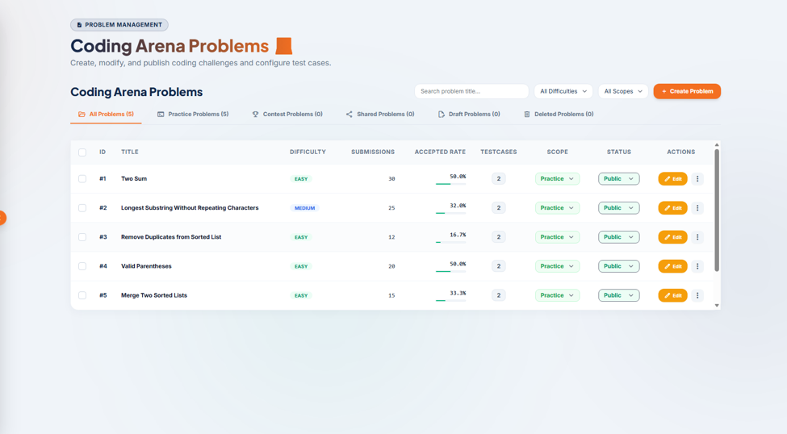
Provides administrators with a control workspace to manage programming challenges in the repository. Admins can search by keywords, filter by difficulties or scopes, create new challenges, and view a grid table listing submission counts, acceptance rates, test cases, and status codes.

UI Design
Field Name | Field Type | Description
Page Header | Text Heading | Displays 'Coding Arena Problems' and subtitle 'Create, modify, and publish coding challenges and configure test cases.'.
Search Input | Text Input | Input box to search coding challenge titles (Search problem title...).
Difficulty Filter | Dropdown Menu | Filters list by difficulty levels (All, Easy, Medium, Hard).
Scope Filter | Dropdown Menu | Filters list by scope types (All, Practice, Contest, Lesson, Shared).
Create Problem Button | Button (Orange) | Action button opening the problem creation form.
Repository Tabs | Tab List Group | Filters by status: All Problems, Practice, Contest, Shared, Draft, Deleted.
Problems Grid Table | Data Table | Columns: [x] Checkbox, ID, Title, Difficulty, Submissions, Accepted Rate (with progress bar), Testcases, Scope, Status, Actions.
Edit Button | Button (Orange) | Launches the problem modification screen.
Actions Dropdown | Button | Dropdown menu representing actions (e.g. Manage Testcases, Clone, Delete).

Database Access
Table | CRUD | Description
problems | R, U, D | Fetch active problems, edit status flags, soft delete records.
problem_versions | R | Join with problem to retrieve current version title, description, and difficulty.

SQL Statements
-- Retrieve active problems list for admin table
SELECT p.id, pv.title, pv.difficulty, p.total_submission, p.total_accepted, p.total_testcase, p.problem_scope, p.is_public
FROM problems p
JOIN problem_versions pv ON p.current_version_id = pv.id
WHERE p.is_deleted = FALSE
ORDER BY p.id ASC;

5.6 Problem Management - Create Programming Problem
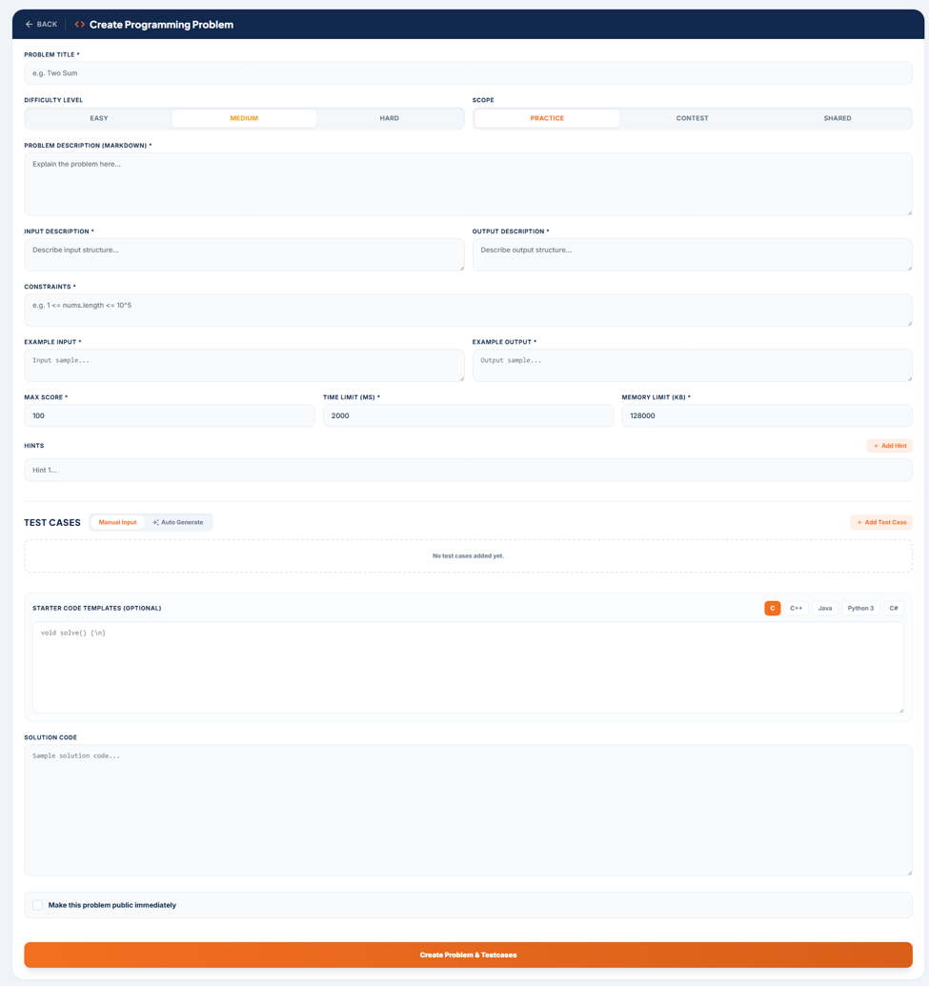
Allows administrators to create and configure a new coding challenge. Admin specifies problem metadata (Title, Difficulty level, Access Scope), detailed markdown descriptions, input/output structures, constraints, examples, execution parameters (max score, time and memory limits), hints, starter code templates for various languages (C, C++, Java, Python, C#), manual test cases, and solution code.

UI Design
Field Name | Field Type | Description
Back Button (<- BACK) | Button | Action button to cancel creation and return to the main problems repository list.
Problem Title | Text Input | Required input field to specify the name of the programming problem (e.g., 'Two Sum').
Difficulty Level | Segmented Toggle | Required selector to classify difficulty: EASY, MEDIUM (active), or HARD.
Scope | Segmented Toggle | Required selector to classify problem usage: PRACTICE (active), CONTEST, or SHARED.
Problem Description | Text Area | Required markdown editor area to write the full problem statement explanation.
Input Description | Text Area | Required text area describing the format and data types of inputs.
Output Description | Text Area | Required text area describing the expected format and value of outputs.
Constraints | Text Area | Required text area specifying time, space, and size boundaries of variables (e.g. 1 <= nums.length <= 10^5).
Example Input | Text Area | Required text area providing a sample input example for student validation.
Example Output | Text Area | Required text area providing the expected output corresponding to the sample input.
Max Score | Number Input | Required input setting the maximum score points awarded for solving (defaults to 100).
Time Limit (ms) | Number Input | Required input setting the execution time threshold limit per testcase (defaults to 2000 ms).
Memory Limit (kb) | Number Input | Required input setting the memory limit allocation for code execution (defaults to 128000 KB).
Hints List | Dynamic Inputs | Allows writing multiple hints. Features a '+ Add Hint' button to dynamically append text fields.
Test Cases Tab Group | Tab Filter List | Filters between Manual Input and Auto Generate testcase wizards. Features a '+ Add Test Case' button.
Starter Code Templates | Tabbed Code Editor | Allows inputting optional starting code skeletons for languages: C (active), C++, Java, Python 3, C#.
Solution Code | Code Editor | Required code editor block to input model solution code for judging validation.
Make Public Checkbox | Checkbox | Optional checkbox flag to make the problem visible in the public repository immediately.
Create Problem Button | Button (Orange) | Action button to submit the form, validate inputs, and save the problem details to the database.

Database Access
Table | CRUD | Description
problems | C | Insert the primary problem entity record (problem_scope, execution limits, is_active=false, created_by).
problem_versions | C | Insert the initial version metadata containing descriptions, constraints, examples, templates, and solutions.
problem_testcases | C | Link and insert manual/auto-generated testcases if added.

SQL Statements
-- 1. Insert main problem metadata
INSERT INTO problems (problem_scope, is_active, is_public, score, total_testcase, time_limit_ms, memory_limit_kb, created_by, created_at, updated_at)
VALUES ('PRACTICE', FALSE, FALSE, 100, 0, 2000, 128000, ?, NOW(), NOW()) RETURNING id;

-- 2. Insert problem details version
INSERT INTO problem_versions (problem_id, version_number, title, description, input_description, output_description, constraints, example_input, example_output, hint, starter_templates, solutions, difficulty, created_by, created_at)
VALUES (?, 1, ?, ?, ?, ?, ?, ?, ?, ?, ?, ?, 'MEDIUM', ?, NOW()) RETURNING id;

-- 3. Update current_version_id reference in problems
UPDATE problems SET current_version_id = ? WHERE id = ?;

5.7 Problem Management - Edit Programming Problem
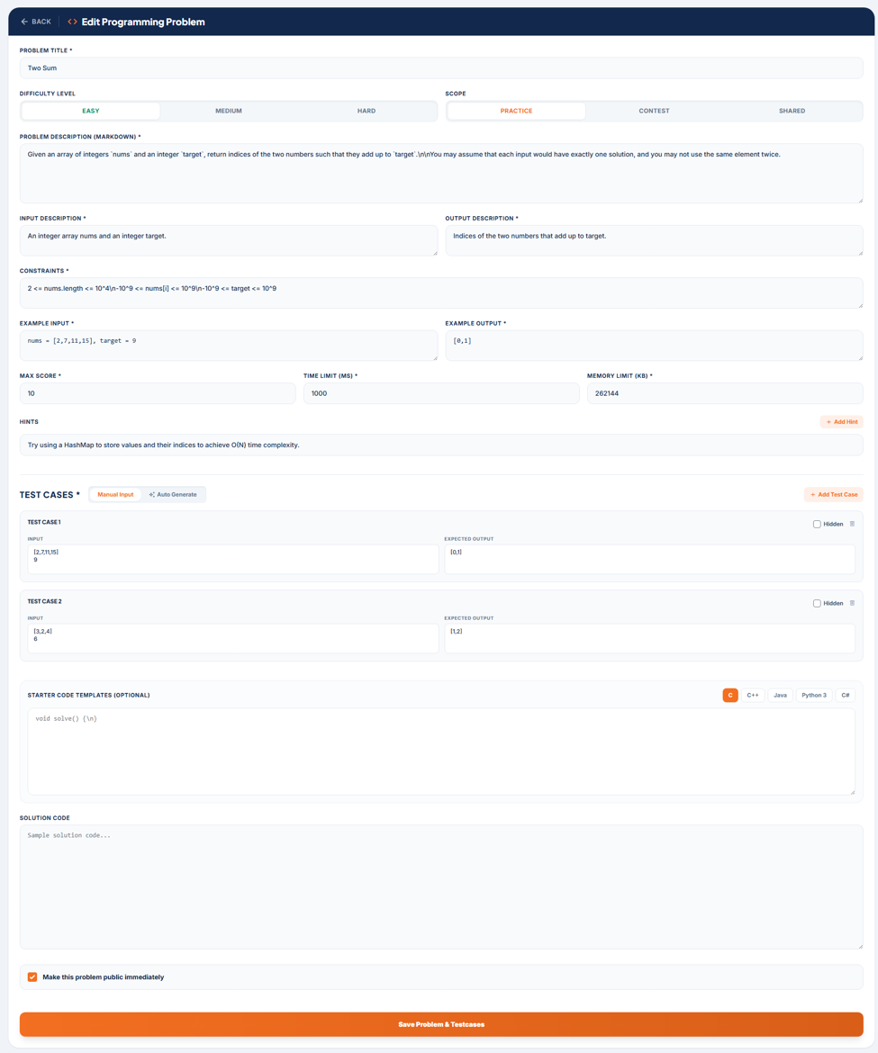
Allows administrators to modify an existing coding challenge. The fields are pre-filled with the active version's metadata, statement, and limits. Upon saving, the system creates a new problem version record for auditing history, updates the current version pointer, deletes old test cases, and saves the updated testcase list.

UI Design
Field Name | Field Type | Description
Back Button (<- BACK) | Button | Action button to cancel editing and return to the main problems repository list.
Problem Title | Text Input | Pre-filled text input showing the problem's title (e.g., 'Longest Substring Without Repeating Characters').
Difficulty Level | Segmented Toggle | Pre-selected segmented toggle showing current difficulty (e.g., MEDIUM active).
Scope | Segmented Toggle | Pre-selected segmented toggle showing current scope (e.g., PRACTICE active).
Problem Description | Text Area | Pre-filled markdown text area containing the detailed problem statement description.
Input Description | Text Area | Pre-filled text area containing the input details (e.g., 'A string s.').
Output Description | Text Area | Pre-filled text area containing output details (e.g., 'The length of the longest...').
Constraints | Text Area | Pre-filled constraints area defining space and variable limits (e.g. 0 <= s.length <= 5 * 10^4).
Example Input | Text Area | Pre-filled example input (e.g. s = "abcabcbb").
Example Output | Text Area | Pre-filled example output (e.g. 3).
Max Score | Number Input | Pre-filled numeric input representing the problem's maximum score points (e.g. 20).
Time Limit (ms) | Number Input | Pre-filled numeric input setting execution time limit per testcase (e.g. 1000 ms).
Memory Limit (kb) | Number Input | Pre-filled numeric input setting memory execution limit (e.g. 262144 KB).
Hints Input | Text Input / List | Pre-filled hints (e.g. 'Use a sliding window approach with a hash set.').
Test Case Containers | Dynamic Rows | Displays rows representing added testcases (e.g., TEST CASE 1, TEST CASE 2).
Test Case Input | Text Area | Shows input data for the test case (e.g. 'abcabcbb').
Test Case Expected Output | Text Area | Shows expected output for the test case (e.g. '3').
Hidden Checkbox | Checkbox | Checkbox to toggle testcase visibility from student submission reports.
Delete Testcase Button | Button (Icon) | Action button to delete the corresponding test case row.
Make Public Checkbox | Checkbox | Checked checkbox indicating if the problem is immediately visible in the public repository.
Save Problem & Testcases Button | Button (Orange) | Action button to submit the modifications, write a new version to the database, and save updated test cases.

Database Access
Table | CRUD | Description
problems | U | Update current version pointer, maximum score, limits, and public flags.
problem_versions | C | Insert a new problem version record, incrementing the version number.
problem_testcases | C, D | Delete historical test cases and insert the updated list of testcases.

SQL Statements
-- 1. Create a new problem version record
INSERT INTO problem_versions (problem_id, version_number, title, description, input_description, output_description, constraints, example_input, example_output, hint, starter_templates, solutions, difficulty, created_by, created_at)
VALUES (?, (SELECT COALESCE(MAX(version_number), 0) + 1 FROM problem_versions WHERE problem_id = ?), ?, ?, ?, ?, ?, ?, ?, ?, ?, ?, 'MEDIUM', ?, NOW()) RETURNING id;

-- 2. Update active problem limits and version pointers
UPDATE problems SET current_version_id = ?, score = ?, time_limit_ms = ?, memory_limit_kb = ?, is_public = ?, updated_at = NOW() WHERE id = ?;

-- 3. Delete existing test cases
DELETE FROM problem_testcases WHERE problem_version_id = ?;

-- 4. Insert updated test cases
INSERT INTO problem_testcases (problem_version_id, order_index, input_data, expected_output, is_hidden)
VALUES (?, ?, ?, ?, ?);

5.8 Contest Management - Contests & Competitions List
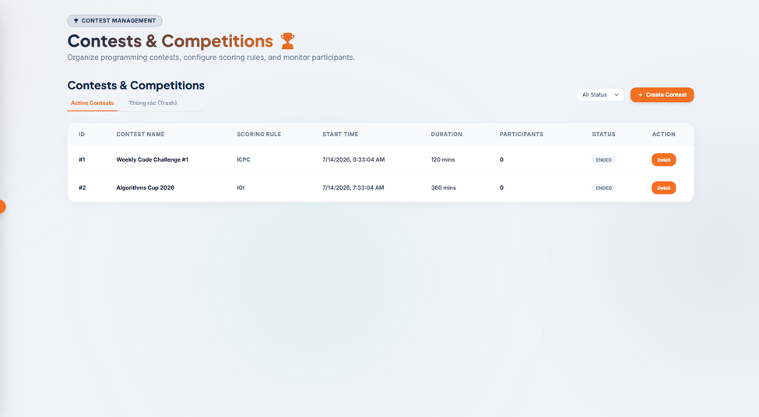
Allows administrators to organize, monitor, and configure competitive coding events. Admin can view a complete list of active or soft-deleted contests, filter them by status, track participant counts, see duration/scheduling details, and access detail pages or launch the contest creator.

UI Design
Field Name | Field Type | Description
Contest Management Badge | Badge Label | A top-left banner label showing the active context: 'Contest Management'.
Page Title | Text Heading | Displays 'Contests & Competitions' with subtext 'Organize programming contests, configure scoring rules, and monitor participants.'.
Create Contest Button | Button (Orange) | Action button opening the new contest configuration modal dialog.
Status Filter Dropdown | Dropdown Menu | Filters contests list by event status (All Status, Draft, Upcoming, Ongoing, Ended, Deleted).
Sub-tabs Bar | Tab List Group | Toggles grid listing between Active Contests (active) and Thùng rác (Trash) list.
Contests Table | Data Table | Columns: ID, Contest Name, Scoring Rule, Start Time, Duration, Participants, Status, Action.
Status Badge | Status Label | Pill-badge displaying the event time state: ENDED (grey), ONGOING (green), or UPCOMING (blue).
Detail Button | Button (Orange) | Action button opening the contest's detailed workspace panel.

Database Access
Table | CRUD | Description
contest | R | Retrieve event details, statuses, rules, and durations (getContests).
contest_participants | R | Count total registered competitors associated with each contest ID.

SQL Statements
-- 1. Fetch active contests list for admin
SELECT c.id, c.title AS contest_name, c.scoring_rule, c.start_time, c.durations AS duration, c.status,
(SELECT COUNT(*) FROM contest_participants cp WHERE cp.contest_id = c.id) AS participants
FROM contest c
WHERE c.is_deleted = FALSE
ORDER BY c.start_time DESC;

5.9 Contest Management - Contest Admin Dashboard (Overview & Problems)
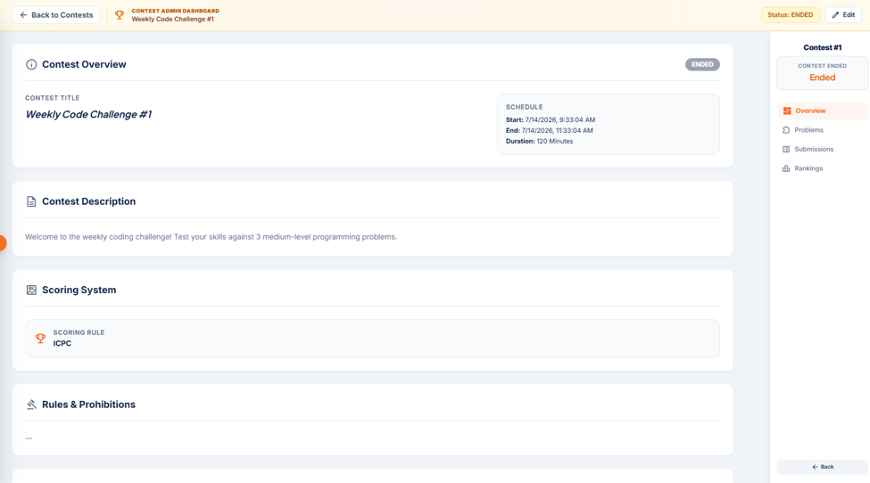
Provides administrators with a workspace to audit and configure a specific contest. Features a right-hand sidebar menu to toggle between Overview (showing scheduling, description, scoring rules, rules & prohibitions) and Problems (a data table to add or remove programming tasks mapping to the contest).

UI Design
Field Name | Field Type | Description
Back to Contests Button | Button | Action button in the top bar to return to the main competitions repository list.
Contest Header Status Badge | Badge Label | Displays the contest time state (e.g. Status: ENDED).
Edit Button | Button | Top-right action button to modify contest scheduling, settings, or parameters.
Contest Overview Header | Text Heading | Displays active contest name (e.g. 'Weekly Code Challenge #1') and detailed schedule box (Start, End, Duration).
Contest Description Box | Text Block | Displays rich text detailing the contest instructions and welcome information.
Scoring System Card | Info Card | Displays active scoring rules (e.g., ICPC, IOI).
Rules & Prohibitions Block | Text Area | Displays guidelines and cheating policies (shows '-' if empty).
Sidebar Tab Menu | Navigation Menu | Right-hand sidebar indicating Contest ID and tab links (Overview, Problems, Submissions, Rankings) with a '<- Back' button at the bottom.
Contest Problems Table | Data Table | Displays mapped problems with columns: # (Order letter A, B), Title, Success Rate, Total Submissions, Accepted Teams, and Action.
Remove Problem Button | Button (Icon) | Red trash icon button to delete the problem association from the contest.
Add Problems Button | Button (Orange) | Action button below the table to open problem selection modal and map new tasks.

Database Access
Table | CRUD | Description
contest | R, U | Retrieve contest properties and update settings.
contest_problems | R, C, D | Query, link, or remove coding challenges associated with the contest ID.
problems | R | Join and fetch problem execution statistics (total_submission, total_accepted).

SQL Statements
-- 1. Retrieve specific contest details
SELECT * FROM contest WHERE id = ?;

-- 2. Fetch problems linked to a contest
SELECT cp.id AS link_id, cp.order_index, pv.title, p.id AS problem_id
FROM contest_problems cp
JOIN problems p ON cp.problem_id = p.id
JOIN problem_versions pv ON p.current_version_id = pv.id
WHERE cp.contest_id = ?
ORDER BY cp.order_index ASC;

-- 3. Remove a problem association from contest
DELETE FROM contest_problems WHERE contest_id = ? AND problem_id = ?;

-- 4. Add a problem to contest
INSERT INTO contest_problems (contest_id, problem_id, problem_version_id, order_index)
VALUES (?, ?, ?, ?);

5.10 Instructor Management - Platform Instructors List
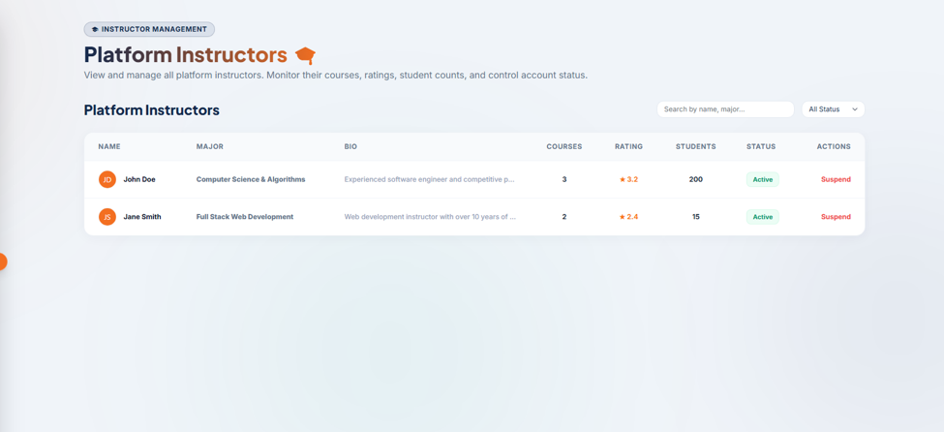
Allows administrators to view, search, filter, and manage approved instructors. Displays details about their major specialization, bio, number of published courses, average student rating, total students taught, active status, and a button to suspend their account.

UI Design
Field Name | Field Type | Description
Instructor Management Badge | Badge Label | A top-left banner label showing active context: 'Instructor Management'.
Page Title | Text Heading | Displays 'Platform Instructors' with sub-description 'View and manage all platform instructors. Monitor their courses, ratings, student counts, and control account status.'.
Search Instructor | Text Input | Search box to filter instructors by name or major keywords (Search by name, major...).
Status Filter Dropdown | Dropdown Menu | Filters list by status (All Status, Active, Suspended).
Instructors Table | Data Table | Columns: Name, Major, Bio, Courses count, Rating (with star), Students count, Status, Actions.
Status Badge | Status Label | Pill-badge displaying active state: Active (green badge).
Suspend Button | Button (Red Text) | Action button in the table to suspend the instructor account (toggling status).

Database Access
Table | CRUD | Description
instructors | R, U | Query instructor profile list and modify status (ACTIVE / SUSPENDED).

SQL Statements
-- 1. Fetch instructors list matching search name
SELECT * FROM instructors WHERE full_name ILIKE ? ORDER BY created_at DESC;

-- 2. Suspend instructor account
UPDATE instructors SET status = 'SUSPENDED', updated_at = NOW() WHERE id = ?;

5.11 User Account Management - User Control Panel
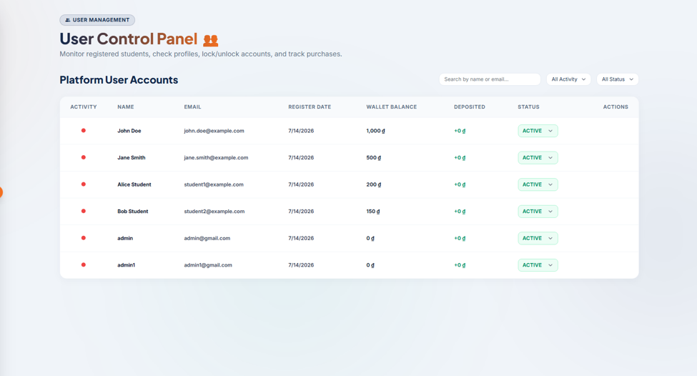
Provides administrators with account control capabilities over registered users. Displays a visual online/offline presence indicator, account registration details, wallet balances, accumulated deposit totals, and account statuses (Active, Locked).

UI Design
Field Name | Field Type | Description
User Management Badge | Badge Label | A top-left banner label showing active context: 'User Management'.
Page Title | Text Heading | Displays 'User Control Panel' with sub-description 'Monitor registered students, check profiles, lock/unlock accounts, and track purchases.'.
Search User | Text Input | Search box to filter user list by name or email keywords (Search by name or email...).
Activity Dropdown | Dropdown Menu | Filters user records by online presence status: All Activity, Online, Offline.
Status Dropdown | Dropdown Menu | Filters user records by status state: All Status, Active, Locked.
Users Table | Data Table | Columns: Activity, Name, Email, Register Date, Wallet Balance, Deposited, Status, Actions.
Activity Indicator | Icon Dot | Visual dot representing presence: green dot for online, red dot for offline.
Status Selector | Dropdown Status | A green dropdown badge representing active status (ACTIVE). Allows locking account.
Action column | Buttons | Allows auditing detail profiles, locking or unlocking accounts.

Database Access
Table | CRUD | Description
users | R, U | Retrieve user accounts list and toggle lock status (setUserLockStatus).
wallets | R | Query wallet balances and deposit transaction history totals.

SQL Statements
-- 1. Fetch users with wallet balance details
SELECT u.id, u.displayname AS name, u.email, u.created_at AS register_date, u.status, w.balance
FROM users u
LEFT JOIN wallets w ON u.id = w.user_id
ORDER BY u.created_at DESC;

-- 2. Lock user account
UPDATE users SET status = 'LOCKED', lock_reason = ?, updated_at = NOW() WHERE id = ?;

5.12 Financial Stats - Financial Insights & Audits
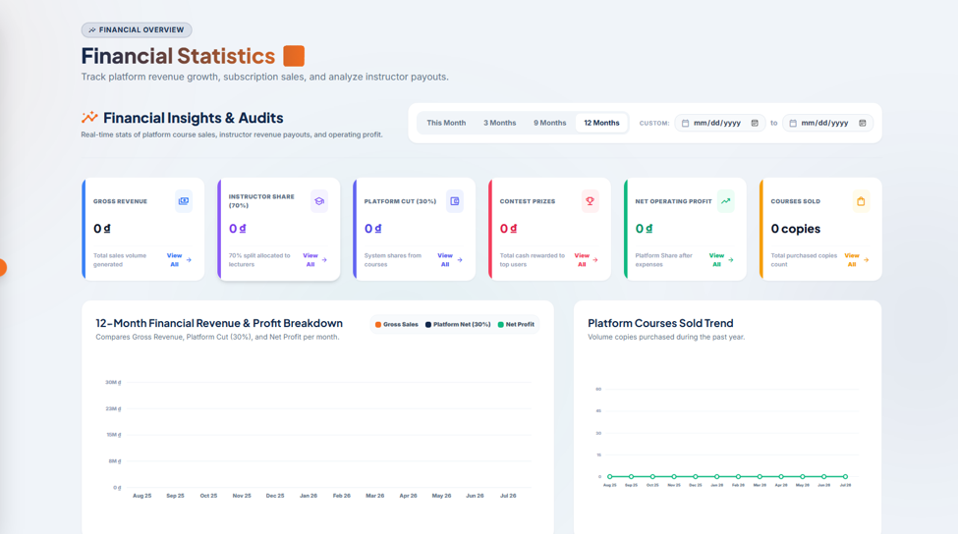
Admin audits platform financial performance. Displays a timeframe segmented filter (This Month, 3 Months, 9 Months, 12 Months, Custom date pickers), followed by six metrics cards (Gross Revenue, Instructor Share, Platform Cut, Contest Prizes, Net Operating Profit, Courses Sold) and graphs comparing gross sales, net cuts, and course sold trends over 12 months.

UI Design
Field Name | Field Type | Description
Financial Overview Badge | Badge Label | A top-left banner label showing active context: 'Financial Overview'.
Page Title | Text Heading | Displays 'Financial Statistics' with subtext 'Track platform revenue growth, subscription sales, and analyze instructor payouts.'.
Insights Description | Text Block | Displays section header: 'Financial Insights & Audits - Real-time stats of platform course sales, instructor revenue payouts, and operating profit.'.
Timeframe Segmented Control | Segmented Button | Segmented choices: This Month, 3 Months, 9 Months, 12 Months (active), Custom date range pickers.
Gross Revenue Card | Metric Card | Displays total course sales volume generated with a link 'View All'.
Instructor Share Card | Metric Card | Displays 70% share allocated to lecturers with a link 'View All'.
Platform Cut Card | Metric Card | Displays 30% system share cut with a link 'View All'.
Contest Prizes Card | Metric Card | Displays total cash rewards paid out to users with a link 'View All'.
Net Operating Profit Card | Metric Card | Displays platform share profit after contest expenses with a link 'View All'.
Courses Sold Card | Metric Card | Displays total copies count of purchased courses with a link 'View All'.
12-Month Financial Graph | Double Line Graph | Compares monthly Gross Sales, Platform Net (30%), and Net Profit.
Courses Sold Trend Graph | Line Graph | Displays monthly copy volumes purchased over the past year.

Database Access
Table | CRUD | Description
orders | R | Retrieve course purchases records and sum total amounts paid (Gross, Instructor share, Platform Cut).
wallet_transactions | R | Retrieve rewards transactions (Contest Prizes).

SQL Statements
-- 1. Calculate Gross Revenue in timeframe
SELECT COALESCE(SUM(total_amount), 0) FROM orders WHERE status = 'COMPLETED' AND created_at >= ?;

-- 2. Calculate total Cash Rewards paid to users (Contest Prizes)
SELECT COALESCE(SUM(amount), 0) FROM wallet_transactions WHERE transaction_type = 'REWARD' AND status = 'SUCCESS' AND created_at >= ?;

IV: NON-FUNCTIONAL REQUIREMENTS

1. External Interfaces

1.1. User Interfaces
- Responsive Design: The platform is web-based, ensuring full compatibility and optimal display across Desktop, Laptop, and Tablet devices (utilizing Tailwind CSS).
- Coding Workspace: The UI features an intuitive split-screen layout. The left panel displays the problem description and sample test cases, while the right panel contains the Code Editor and Terminal. It supports flexible drag-to-resize functionality for user customization.
- Code Editor: Integration of a professional code editor (Monaco Editor) featuring syntax highlighting, auto-indentation, and Dark/Light mode toggling.
- Interactive UX/UI: The system provides smooth Skeleton Loading effects while awaiting grading results. Test case feedback is highly visual (Green for AC - Accepted, Red for WA - Wrong Answer, Yellow for TLE - Time Limit Exceeded).

1.2. Hardware Interfaces
- Client-side: As a web-based application, it requires no specialized hardware. Users only need a personal device with an Internet connection and a modern web browser (Chrome, Safari, Edge).
- Server-side: Requires a multi-core CPU and sufficient RAM capacity to manage submission queues and heavy continuous I/O connections during Contests. Recommended: SSD/NVMe storage for high-speed read/write access to large test case files.

1.3. Software Interfaces
- Database: The backend application (Spring Boot) communicates with the database (MySQL/PostgreSQL) via ORM technology (Hibernate/Spring Data JPA) using standard TCP/IP protocols.
- Online Judge Engine: Communicates securely with a third-party platform (Judge0 API) via RESTful API to compile and execute user source code.
- Payment Gateway: Integrates payOS to generate VietQR codes. The backend must configure a Webhook Endpoint to listen for and process successful transaction callbacks from the payOS server.

1.4. Communications Interfaces
- HTTPS: All data transmitted between the Client and Server (including passwords, personal data, and invoice details) must be strictly encrypted using the HTTPS (SSL/TLS) protocol.
- RESTful API: The primary protocol for Frontend (React) and Backend (Spring Boot) communication and CRUD operations. Data is standardized in JSON format.
- WebSocket / SSE: Utilized for features requiring real-time notifications, such as receiving instant grading results from the Judge Engine, updating the Leaderboard, or broadcasting successful payment statuses without requiring page reloads.

2. Quality Attribute

2.1. Security
- Prevent RCE (Remote Code Execution): A critical requirement. User source code must NEVER be executed directly on the main server. Code must be routed to the Judge0 system for execution within completely isolated Sandbox (Docker) environments, strictly constrained by Time Limits and Memory Limits.
- Authentication & Authorization: Secure session management is handled using JSON Web Tokens (JWT). The system must enforce strict Role-Based Access Control (RBAC) to differentiate privileges among Students, Teachers, and Admins.
- Financial Data Security: payOS Webhook data must undergo strict signature validation (checksum) to absolutely prevent fake payment requests. System passwords must be hashed using BCrypt prior to database storage.
- Anti-Web Attacks: The backend must implement defense mechanisms against common vulnerabilities, including SQL Injection, Cross-Site Scripting (XSS), and Cross-Site Request Forgery (CSRF).

2.2. Performance
- Response Time: Standard operations (e.g., loading course lists, viewing lesson details, accessing profiles) require a response time of < 1 second. For code submissions, the turnaround time from clicking "Submit" to receiving the result should range between 2 - 5 seconds (dependent on Judge0 API processing time).
- Concurrency: The Contest system and Leaderboard must be architected to withstand heavy traffic. It must handle 200+ Concurrent Users (CCU) submitting code simultaneously without causing server crashes or severe latency.

2.3. Reliability & Availability
- Fault Tolerance: To prevent lost submissions during peak traffic (e.g., during a contest), the backend must route incoming submissions into a Message Queue / Pooling system for sequential grading, ensuring no exam submissions are dropped from the processing pipeline.
- Data Integrity: Sensitive data, including Contest Scores and Payment Invoice statuses, must strictly adhere to ACID properties (Atomicity, Consistency, Isolation, Durability) when committed to the database.

2.4. Usability
- Familiarity: The Coding Workspace layout adopts a familiar split-screen paradigm (similar to popular platforms like LeetCode or HackerRank) to minimize the user's learning curve.
- Visual Feedback: The application must provide continuous feedback for all system states. Examples include using Skeleton Loading instead of blank screens during data fetching, and displaying clear learning statistics via interactive charts (Circular Progress Bars/Pie Charts) on the Profile page.

2.5. Maintainability & Extensibility
- Flexible Architecture: Strict decoupling of the Frontend (React) and Backend (Spring Boot) ensures that each component can be modified, upgraded, or debugged independently.
- Language Extensibility: The grading module's API-driven design allows for rapid integration of new programming languages in the future (beyond C++, Java, Python) without altering the core system architecture.
- Source Code Management: The development team must strictly adhere to a Git Workflow. Standardized branch naming conventions (e.g., feature/..., bugfix/...) and Commit Message rules (Conventional Commits) are mandated to streamline operations, code reviews, and project handovers.

V: REQUIREMENT APPENDIX

1. Business Rules
ID | Rule Definition
BR-COM-01 | Username Length Constraint: A newly registered account's username must have a minimum length of 8 characters.
BR-COM-02 | Password Length Constraint: A newly registered account's password and password confirmation must have a minimum length of 8 characters.
BR-COM-03 | Password Match Verification: The password and the password confirmation provided during registration must match exactly.
BR-COM-04 | Username Uniqueness Constraint: The chosen username must be unique across the entire system database.
BR-COM-05 | Email Uniqueness Constraint: The registered email address must be unique across the entire system database.
BR-COM-06 | Password Encryption Protocol: User passwords must be hashed using the BCrypt one-way encryption algorithm before database insertion.
BR-COM-07 | Password Change Validation: Changing the password requires providing a correct old password. The new password must be at least 8 characters, differ from the old password, and match the new password confirmation.
BR-COM-08 | Locked Account Access Restrictions: Accounts flagged as LOCKED or DISABLED are blocked from executing any business APIs, except viewing the home page and submitting appeal requests.
BR-COM-09 | Secure Session Token Handling: Sessions use short-lived Access Tokens and long-lived Refresh Tokens. Refresh Tokens must be transmitted via Http-Only and Secure cookies to mitigate XSS attacks.
BR-COM-10 | Token Blacklisting on Logout: Logging out invalidates the active Access Token by adding it to the invalidated_tokens blacklist repository to prevent reuse before expiration.
BR-COM-11 | Instructor Application Role Restriction: Accounts already possessing the INSTRUCTOR role are prohibited from submitting new instructor application forms.
BR-COM-12 | Instructor Application Limit: A user can only have at most one instructor application at a time in the PENDING state. Submitting a new application is blocked until the previous one is processed.
BR-COM-13 | Instructor Resume Upload Specifications: Resumes uploaded for instructor applications must be in PDF format with a maximum file size of 5MB and contain readable textual content for AI indexing.
BR-COM-14 | Automatic Rejected CV Cleanup Job: A daily background cron job at 00:00 automatically deletes local PDF CV files and corresponding database records of instructor applications that have been in REJECTED status for more than 7 days.
BR-COM-15 | Daily Active Learning Streak Calculation: If a user is active today, the system checks for activity yesterday (activity_date = CURRENT_DATE - 1). If present, the learning streak increments by 1 (streak = streak_yesterday + 1). Otherwise, the streak resets to 1.
BR-COM-16 | Suspended Instructor Restrictions: A suspended Instructor is immediately blocked from creating new courses and their revenue withdrawal features are frozen until the suspension is lifted.
BR-COM-17 | Suspended Course Availability: Students who have already purchased or enrolled in a course from a suspended Instructor must permanently retain access to the course materials to protect learners' rights (unless explicitly revoked by the Admin for legal reasons).
BR-COM-18 | Suspended Instructor Policy: Students who have already purchased a course from a suspended Instructor must retain access to the course materials. A suspended Instructor cannot create new courses and their revenue withdrawal is frozen until the issue is resolved.
BR-EDU-01 | Lesson Completion Prerequisite: Users cannot mark a lesson progress status as COMPLETED unless they have an active enrollment record for the corresponding course.
BR-EDU-02 | Inactive Lesson Access Blocking: Users are blocked from viewing details or watching videos of lessons flagged as INACTIVE or PENDING_UPDATE.
BR-EDU-03 | Lesson Theoretical Content Integrity: Every created lesson must contain a non-empty title and a non-empty theoretical text body.
BR-EDU-04 | Trial Lesson Guest Access Rule: Unauthenticated guests can only view lesson content and resources if the lesson has the trial flag set to true (is_trial = true).
BR-EDU-05 | Default Course State: Newly created courses are initialized with the DRAFTS status by default.
BR-EDU-06 | Course Publication Lifecycle: A course is only published and displayed for sale after its status is updated to APPROVED following an AI automated evaluation and manual admin validation.
BR-EDU-07 | Course Review Submission Limit: Each enrolled student is permitted to rate and write a text review for a purchased course at most once.
BR-EDU-08 | Discussion Thread Nesting Depth Limit: Comments on lesson materials allow a maximum nesting depth of 1 level (replies can only be added to root comments).
BR-EDU-09 | Quiz Structural Integrity: A quiz must contain at least one question, and each question must have at least one option configured as the correct answer (is_correct = true).
BR-EDU-10 | Quiz Correct Answer Masking: Prior to a student's initial quiz submission, the API must hide all correct answer indicators (isCorrect = null) from quiz retrieval payloads.
BR-EDU-11 | Quiz Grading Metric: The quiz score is automatically graded out of 100 points based on correct answers: Score = (Correct Answers / Total Questions) * 100.
BR-EDU-12 | Audio Quality Moderation Rejection: Course videos containing bad audio quality or speech errors (system flags [SYSTEM_ERROR: AUDIO_QUALITY_TOO_BAD]) trigger automated rejection of the course review submission.
BR-EDU-13 | Course Plagiarism Detection Threshold: Textual course descriptions are vectorized using gemini-embedding-001. If the cosine similarity with any existing course exceeds 90%, it is automatically rejected.
BR-EDU-14 | Locked Lesson Content Read-only Constraint: Lessons that are inactive or locked under review cannot have their associated media files modified by instructors.
BR-EDU-15 | Integrity - Theory Check: Every lesson must contain a non-empty theory document. Empty theory is flagged as a MISSING_THEORY violation.
BR-EDU-16 | Relevance Check: The video transcripts and lesson theories must be relevant to the lesson and course titles. Unrelated or purely entertaining content is flagged as an IRRELEVANT_CONTENT violation.
BR-EDU-17 | Audio Quality Check: Transcripts containing system errors ([SYSTEM_ERROR: AUDIO_QUALITY_TOO_BAD]) or senseless repetitive phrases are flagged as a BAD_AUDIO violation.
BR-EDU-18 | Compliance & Safety: Course content, video transcripts, and quiz questions must not contain profanities, political issues, or inappropriate materials. Violations are flagged as PROFANITY.
BR-ECO-01 | API Pagination Range Limit: API listing pagination must have a page index greater than or equal to 0, and the maximum allowed page size is capped at 20 items per page (page_size <= 20).
BR-ECO-02 | payOS Checksum Security Verification: Requesting deposit payment links requires creating a secure SHA256 signature containing: amount, cancelUrl, description, orderCode, and returnUrl using the system gateway secret key.
BR-ECO-03 | Idempotent Wallet Update Locking (Pessimistic Lock): Processing payment webhook events requires acquiring a database pessimistic lock on the user's wallet (findByUserIdWithLock) to prevent race conditions from duplicate callbacks.
BR-ECO-04 | Stuck Deposit Reconciliation Background Job: An hourly background cron job scans pending deposits older than 24 hours, queries the payOS API, updates paid transactions to SUCCESS, and cancels expired ones.
BR-ECO-05 | Course Purchase Eligibility Constraint: Courses are only eligible for checkout if they are currently in the APPROVED (active) status.
BR-ECO-06 | Duplicate Course Enrollment Block: Users cannot purchase a course if they already have an active or completed enrollment (ACTIVE or COMPLETED) for that course.
BR-ECO-07 | Cart Checkout Deduplication: Order checkout inputs must filter course IDs to distinct values to prevent duplicate course purchases in a single transaction.
BR-ECO-08 | Negative Balance Prevention: Wallet balances must be non-negative (balance >= 0.00). If a wallet balance is less than the checkout order total, the transaction is aborted with an INSUFFICIENT_BALANCE error.
BR-ECO-09 | Post-Purchase State Synchronization: A successful purchase transaction atomically deducts the wallet balance, saves a COMPLETED order, logs a BUY_COURSE transaction, registers an ACTIVE enrollment, and increments total_enrolled for the courses.
BR-ECO-10 | Course Revenue Sharing Split: Upon a successful course sale, the author instructor receives a 70% share (Instructor Share), and the system retains a 30% share as a platform fee (Platform Cut).
BR-ECO-11 | Payment Gateway Transaction Fee accounting: The system accounts for payment gateway services at a flat rate of 2% of the gross sale revenue for financial auditing reports.
BR-ECO-12 | Instructor Payout Verification: Payout requests must be greater than 0, less than or equal to the wallet balance, and require valid banking details (account number, account name, bank BIN).
BR-ECO-13 | Automatic Wallet Initialization: Creating a new user account automatically initializes a digital wallet with a starting balance of 0.00 in the ACTIVE status.
BR-OJ-01 | Programming Problem Testcase Validity: Testcases created for coding tasks must not contain empty input data or empty expected output strings.
BR-OJ-02 | Problem Activation Requirement: A programming task is marked isActive = true and opened for submissions only when it has at least 1 validated testcase.
BR-OJ-03 | Solution Sample Visibility Protection: Official solutions for coding problems are locked and hidden until the user successfully submits a correct solution with an ACCEPTED verdict for that problem.
BR-OJ-04 | Submission Parameters Completeness: Code execution requests sent to the compiler must specify a valid problem ID, language ID, and a non-empty source code string.
BR-OJ-05 | Judge0 Sandbox Execution Limits: Coding submissions must execute within isolated sandboxes, restricted to a maximum execution time limit of 1000ms and a memory limit of 256MB.
BR-OJ-06 | Contest Submission Timing Rule: Submissions for contest tasks are accepted only if the contest is active (start_time <= current_time <= end_time) and the correct room password is authenticated.
BR-OJ-07 | Contest Post-AC Submission Ignoring Rule: Once a participant solves a contest problem (receives an ACCEPTED verdict), subsequent submissions for that problem by the same user in that contest are ignored.
BR-OJ-08 | Contest Compilation Error Penalty Exemption: Code submissions that fail to compile (COMPILATION_ERROR) are recorded but do not incur the contest time penalty.
BR-OJ-09 | ICPC Contest Penalty Computation: Rankings are determined by problems solved. Ties are resolved by total penalty minutes. The penalty for each solved problem is calculated as: Penalty = (Elapsed time from contest start to AC in minutes) + (Number of incorrect attempts prior to AC * 20).
BR-OJ-10 | Contest Scoreboard Unfreezing Rule: The contest scoreboard automatically unfreezes and reveals real-time rankings once the contest end timestamp has elapsed.
BR-OJ-11 | Contest Problem Scope Restrictions: Coding problems assigned to contests must have their scope set to ProblemScope.CONTEST or ProblemScope.SHARED.
BR-OJ-12 | Source Code Plagiarism Flagging: The system flags submissions as is_plagiarized = true if the source code is identical to another user's solution within the same challenge context.
BR-OJ-13 | Incorrect Testcase Detail Disclosure Limit: Users submitting code for practice problems are only shown detailed inputs/outputs for the first 2 failed test cases to prevent task reverse-engineering.
BR-AI-01 | HTML Safety: The generated HTML visualizer must start with <!doctype html>, include </html> and <script> tags, and must not contain any <iframe> tags to protect against XSS vulnerabilities.
BR-AI-02 | Contest Scope Lock: The AI Tutor feature is disabled if the coding problem is currently part of an ongoing contest (ProblemScope.CONTEST) to prevent cheating.
BR-AI-03 | Daily Rate Limit: Each Customer is limited to a maximum of 5 new AI generation requests per day to prevent spam and control API token costs.

2. Application Messages List
Message  code | Message  Type | Context | Context
MSG01 | In red, under text | A required form field is left empty by the user | All fields are required.
MSG02 | In red, under text | Email format validation fails on input | Invalid email format. Please try again.
MSG03 | In line | Registration email already exists in the system database | Email addresses already exist. Please try again.
MSG04 | In red, under text | Username input is shorter than 8 characters | Username must be at least 8 characters.
MSG05 | In red, under text | Password input is shorter than 8 characters | Passwords must be at least 8 characters.
MSG06 | In red, under text | Confirm password does not match password input | Confirm password does not match.
MSG07 | In line | Registration username already exists in the database | Username already exists. Please try again.
MSG08 | In line | Sign-in fails due to incorrect credentials | Incorrect username or password.
MSG09 | In line | User attempts sign-in on a locked account | This account has been locked. Please contact support.
MSG10 | Toast message | Successful sign-in authentication | Signed in successfully.
MSG11 | Toast message | Successful user logout from the system | Logged out successfully.
MSG12 | In line | User cancels Google OAuth authorization | Login with Google was cancelled.
MSG13 | In line | Google OAuth token is invalid or has expired | Google authorization expired. Please try again.
MSG14 | In line | User attempts action with an expired session token | Session expired. Please log in again.
MSG15 | In line | Missing or invalid authorization header payload | Authentication error. Please log in.
MSG16 | Toast message | New account registration completed successfully | Account registered successfully! Welcome aboard.
MSG17 | Toast message | Verification link sent to user's email address | Verification email has been sent to {email}.
MSG18 | In line | User attempts to verify email with invalid token | Email verification link is invalid or has expired.
MSG19 | In red, under text | Incorrect old password provided during password change | Old password does not match.
MSG20 | In red, under text | New password is identical to the old password | New password cannot be the same as your old password.
MSG21 | Toast message | Password updated successfully in user settings | Password changed successfully.
MSG22 | Toast message | Password reset verification code sent to email | Password reset code sent successfully.
MSG23 | Toast message | Profile information updated successfully | Profile updated successfully.
MSG24 | Toast message | Profile avatar image file uploaded successfully | Avatar updated successfully.
MSG25 | In line | File format for avatar upload is not supported | Invalid file format. Only JPG, JPEG, and PNG are allowed.
MSG26 | In line | Uploaded image size exceeds the system limit (5MB) | File is too large. Maximum size allowed is 5MB.
MSG27 | Toast message | Account appeal request submitted successfully | Your appeal has been submitted and is under review.
MSG28 | In line | Empty reason text provided in appeal form | Please enter a valid reason for appeal.
MSG29 | In line | Accessing course details that do not exist | This course does not exist.
MSG30 | In line | Accessing lesson content for an inactive lesson | This lesson is currently unavailable.
MSG31 | In line | User attempts to study lesson without enrolling in the course | You must purchase or enroll in this course to view lessons.
MSG32 | Toast message | Progress marked completed for the active lesson | Lesson completed.
MSG33 | In line | Accessing lesson video when video file failed to load | Unable to load video. Please try again later.
MSG34 | In line | Accessing lesson documents when file is missing | Resource document not found.
MSG35 | In line | Submitting review for a course that user did not buy | You can only review courses you have enrolled in.
MSG36 | In line | User attempts to submit a duplicate review | You have already reviewed this course.
MSG37 | Toast message | Course review and rating submitted successfully | Review submitted successfully. Thank you!
MSG38 | Toast message | Comment added to lesson Q&A thread | Comment posted successfully.
MSG39 | In line | Replying to a sub-comment exceeding nesting limits | Replies are only allowed on primary comments.
MSG40 | Toast message | Comment deleted by the author user | Comment removed successfully.
MSG41 | Toast message | Draft course created successfully by instructor | Course draft saved successfully.
MSG42 | Toast message | Course details updated successfully by instructor | Course updated successfully.
MSG43 | In line | Lesson missing mandatory title during creation | Lesson title cannot be empty.
MSG44 | In line | Lesson missing mandatory theoretical text content | Theory content is required before saving.
MSG45 | Toast message | Course submitted to moderation review queue | Course submitted for review. AI evaluation in progress...
MSG46 | In line | Quiz has no questions defined during saving | Cannot publish a quiz. A quiz must have at least one question.
MSG47 | In line | Quiz question is missing a designated correct option | Each question must have at least one correct option.
MSG48 | Toast message | Quiz submit successfully completed | Quiz submitted successfully.
MSG49 | In line | Error fetching previous quiz attempt statistics | Failed to load quiz statistics. Please try again.
MSG50 | Toast message | Quiz question option saved in drafting | Quiz draft saved.
MSG51 | In line | AI scanner detects plagiarism similarity > 90% | Course rejected: Content similarity with existing courses exceeds 90%.
MSG52 | In line | AI scanner detects poor audio speech quality in videos | Course rejected: Audio speech quality is too low or contains errors.
MSG53 | Toast message | Lesson order index updated successfully | Lesson order updated.
MSG54 | Toast message | Course deleted successfully by instructor | Course deleted successfully.
MSG55 | Toast message | Course added to shopping cart successfully | Course added to cart.
MSG56 | In line | User attempts to add already enrolled course to cart | You already own this course. Purchase blocked.
MSG57 | In line | Course already exists in user's shopping cart | This course is already in your cart.
MSG58 | Toast message | Course removed from shopping cart | Course removed from cart.
MSG59 | Toast message | Cart contents cleared successfully | Cart cleared.
MSG60 | In line | Checkout contains inactive or draft courses | One or more courses in your cart are no longer available.
MSG61 | In line | Wallet balance is lower than total order value | Insufficient wallet balance. Please deposit funds.
MSG62 | Toast message | Cart checkout completed and courses unlocked | Checkout successfully! Courses added to your learning list.
MSG63 | Toast message | Creating payOS deposit transaction record | Creating a payment link, please wait...
MSG64 | Toast message | Redirecting user to payOS secure gateway link | Redirecting to the payment gateway...
MSG65 | Toast message | Deposit request cancelled by the user | Payment request cancelled.
MSG66 | Toast message | Webhook verification of payOS payment signature fails | Security alert: Invalid transaction checksum signature.
MSG67 | Toast message | Wallet balance credited after successful deposit | Deposit successfully! {amount} credits added to your wallet.
MSG68 | In line | Cron job fails to reconcile pending deposit | Payment reconciliation error. Checking gateway status...
MSG69 | Toast message | Refund transaction processed successfully | Refund issued successfully.
MSG70 | In line | Deposit amount is below the minimum limit | Minimum deposit amount is 10,000 VND.
MSG71 | In line | Deposit amount exceeds the maximum limit | Maximum deposit amount per transaction is 50,000,000 VND.
MSG72 | In line | Payout amount requested is 0 or negative value | Payout amount must be greater than zero.
MSG73 | In line | Payout amount exceeds available wallet balance | Payout amount exceeds your current wallet balance.
MSG74 | In line | Payout missing banking account number | Bank account number is required.
MSG75 | In line | Payout missing banking account holder name | Bank account holder name is required.
MSG76 | In line | Payout missing banking routing destination (BIN) | Please select a valid bank.
MSG77 | Toast message | Payout request submitted to admin review queue | Payout request submitted successfully. Processing time: 1-3 days.
MSG78 | Toast message | Payout request processed and approved by admin | Payout request approved and funds transferred.
MSG79 | Toast message | Payout request rejected by admin with feedback | Payout request rejected: {reason}.
MSG80 | In line | Programming task lookup returns no results | Coding problem not found.
MSG81 | In line | Empty code submission source payload sent to judge | Source code cannot be empty.
MSG82 | In line | Code submission sent for an inactive task | Submissions are not accepted for this problem.
MSG83 | Toast message | Code submitted to Judge0 compiler queue | Code submitted. Compiling and running tests...
MSG84 | In line | Judge0 returns compilation output error (CE verdict) | Compilation Error. Please check your compiler outputs.
MSG85 | In line | Code execution exceeds task time limit (TLE verdict) | Time Limit Exceeded. Execution time exceeded 1000ms.
MSG86 | In line | Code execution exceeds memory buffer limit (MLE verdict) | Memory Limit Exceeded. Execution memory exceeded 256MB.
MSG87 | In line | Code fails verification on assertion (WA verdict) | Wrong Answer. One or more test cases failed.
MSG88 | In line | Code execution encounters a runtime error (RE verdict) | Runtime Error during execution.
MSG89 | In line | Code successfully passes all test cases (AC verdict) | Accepted! All test cases passed successfully.
MSG90 |  | Official solution accessed when task is not solved | This solution is locked. You must solve the problem first.
MSG91 | In line | Testcase input/expectedOutput is left empty | Testcase input and expected output fields are required.
MSG92 | In line | User attempts to join contest prior to start time | This contest has not started yet.
MSG93 | In line | User attempts to submit contest code after end time | The contest has ended. Submissions are closed.
MSG94 | In line | Incorrect contest access password provided | Incorrect contest password. Access denied.
MSG95 | Toast message | Successful contest registration and entrance | Joined the contest successfully.
MSG96 | In line | Submitting code for already solved contest problem | You have already solved this problem. Submission ignored.
MSG97 | In line | Scoreboard lookup during active scoreboard freeze | The contest scoreboard is currently frozen.
MSG98 | Toast message | Scoreboard unfrozen after contest end | The contest ended. The final scoreboard is now public.
MSG99 | In line | Plagiarism similarity scanner flags matching code | Academic Integrity Alert: Plagiarism detected in your submission.
MSG100 | Toast message | General backend server error alert placeholder | A system error occurred. Please try again later.

